# PROJECT REPORT

**ON**

**Airline Management (System)**

**Shree M.N. Kampani Arts & A.K. Shah Commerce Collage, Mangrol**

**In BCA Semester 5 (Department of Computer Science) For the Academic Year 2024-25**

### Developed By :-

Bukhari Adnan R.

Belim Nizamudinkhan R.

Belim Aadilkhan H.

**Under Guidance of :-** MR. CHIRAG JADAV



**ACKNOWLADGEMENT**

Keeping in with the syllabus as prescribed the Shree BKNM university, Junagadh. We the student of ***BCA SEM-5*** were allowed to do our project work on ***“Collage Management (System)”*** using ***JAVA(J2EE)*** and ***MySQL Server***, in our ***Shree M. N. Kampani Arts & A. K. Shah Commerce Collage, Mangrol.***

We are Thanksful to my collage under whose guidance, we have successfully completed with all valuable suggestions.

***Specially thanks to,***

***MR. CHIRAG JADAV*** (coordinator) of the ***Shree M. N. Kampani Arts & A. K. Shah Commerce Collage, Mangrol.*** They stood by us during the whole course of action concerned with us this project and provided us knowledgeable information.

We are Grateful to our faculty ***MR. CHIRAG JADAV*** for this endless and great support in our project work. We also confess that without their valuable help, we will not be able to complete our project.

We would like to thank our dear friends for their whole hearted support to help us accomplish our goal. Finally, we sincerely hope that our first venture in this field is appreciated and applause.

###### Your Faithfully

###### Bukhari Adnan R.

###### Belim Nizamudinkhan R.

###### Belim Aadil khan H.

In a student’s academic journey, undertaking a project is more than just a curriculum requirement—it is a live, hands-on experience that bridges the gap between theoretical learning and practical application. Projects provide an opportunity to apply the concepts learned in classrooms to real-world scenarios, thereby enhancing understanding and competence.

For the **BCA Semester-5**, the project is designed to give students exposure to the practical aspects of the IT industry. It enables us to explore real-world challenges and develop solutions that are applicable outside the academic environment. The focus is not only on coding or system development but also on planning, analysis, design, implementation, and testing of a complete system.

Our project, the **Airline Management System**, is a comprehensive application that simulates the operations of an airline. It allows students to understand how an airline handles customer management, flight scheduling, ticket booking, and other operational tasks in a systematic manner. By working on this project, we are able to practically implement the concepts of database management, user interface design, Java programming, and software development lifecycle.

The primary aim of this project is to provide **hands-on experience** in designing a software solution that solves real-world problems efficiently. Through this project, we expand our perspective on the practical use of our theoretical knowledge and gain insight into how professional airline management systems function. It also fosters skills like problem-solving, logical thinking, teamwork, and project documentation, which are essential for any software development career.

Overall, this project not only enhances our technical capabilities but also prepares us for industry challenges, making us ready for future professional endeavours. The **Airline Management System** stands as a practical embodiment of our learning, reflecting how theory can be transformed into a fully functional, user-friendly software application.

# A.N.wings Airline

# Project-> Airline management (system)

A Project Report Submitted For

Bachelor in Computer Application In

Department of Computer Science By

1. BUKHARI ADNAN R.
2. BELIM NIZAMUDINKHAN R.
3. BELIM AADILKHAN H.

In Which **JAVA** Used as a **FRONT-END**

#### And

**MySQL** and Used as a **BACK-END**. Which

was guided by

### MR. CHIRAG JADAV

**Operating System :-** Windows 11 pro (64bit)

**Language :-** JAVA (J2EE)

**Back end Tools :-** MySQL Server.

### Hardware Specification of Machine Used

|  |  |
| --- | --- |
| **Processor :-** | AMD Ryzen 5 5600H with Radeon Graphics (3.30 GHz) |
| **Mother bord :-** | INTEL |
| **RAM :-** | 8 GB |
| **HDD :-** | 1 TB |
| **SSD :-** | 512 GB |
| **CD Drive :-** | **-** |
| **Key Board :-** | Logitech |
| **Mouse :-** | Logitech |

##### Feasibility Study :

The main aim of feasibility study is to determine whether developing the product is financial and technically feasible. The feasibility study involves analysis of the problem and collection of the data which would be input to the system the processing required to be carried out on these data, the output data required to be produced by the system, as well as study of various constrains on the behavior of the system.

##### Requirement Analysis & Specification :

The goal of requirement analysis and specification phase to clearly understand the exact requirement of proprietor and to systematically organize these requirements into specific document.

Requirement analysis involve obtained a clear and through understanding of the developed with view to removing all ambiguities and inconsistencies from the initial client perception of the problem.



**Information Gathering**

1. The Very basic Requirement is to collect Information about the Product/Things and its requirements.
2. So, we use online platform (AI-ChatGPT) for our Requirements.
3. Also, we met to our friend, who is Android Developer and also, he has experience of 5 to 7 year of his career.

Developer Responsibilities

1. Developer has to download and install latest version of below software

into Client’s system first.

* + NetBeans 12.6, (For Front-End)
  + PhpMyAdmin SQL Database , (For Back-End)

1. Developer has to provide/give User Manual to Client.
2. Developer has to Describe the System Interface in a step-by-step manor to work on it, and also provide some photos/videos to the Client/User for more information/support.
3. Developer has to Conduct some Live User Training or Demo Testing Training of their system with Client/Users if require.
4. Also, Developer has to provide some Periodic Maintenance or General Service Maintenance of their system at Client Location.
5. Developer has to provide some Update of Latest Version of their system when requirement for Update any of above Software.

Sofrware Requirement

### Functional Requirement

The functional requirements of

the system documented in SRS document should Cleary described each function which the system would support along with the corresponding input and output data set.

### Non functional Requirement

The non-functional requirements deal with the characteristics of the system that cannot be expressed as function.

It includes aspect concerning maintainability, portability and usability and also include reliability issues, accuracy of results, human computer interface and constraints on the system implementation.

# The goal of implementation is to provide general guidelines and practical steps for developing the software system as defined in the SRS document. It includes the following key phases:

# Design The purpose of the design phase is to transform the requirement specifications into a well-structured solution that can be implemented in a programming language. During this phase, the overall software architecture is derived from the SRS to ensure that all functional and non-functional requirements are addressed.

# Coding and Unit Testing This phase focuses on the actual software development. Each component of the design is implemented as a separate program module. After implementation, every module undergoes unit testing to detect and correct errors. Debugging and proper documentation are also carried out to maintain code quality.

# Integration and Testing In this phase, the tested modules are systematically integrated to form the complete system. Integration is performed step by step, rather than all at once, to easily identify and resolve issues. After integration, system testing verifies that the software meets the specified requirements.

# Maintenance Maintenance activities are performed after the software has been deployed. They include:

# Corrective Maintenance: Fixing errors that were not discovered during development or testing.

# Adaptive Maintenance: Modifying the software to work in a new environment (e.g., different hardware or operating system).

# Perfective Maintenance: Enhancing system functionality or improving performance based on client feedback or evolving requirements.

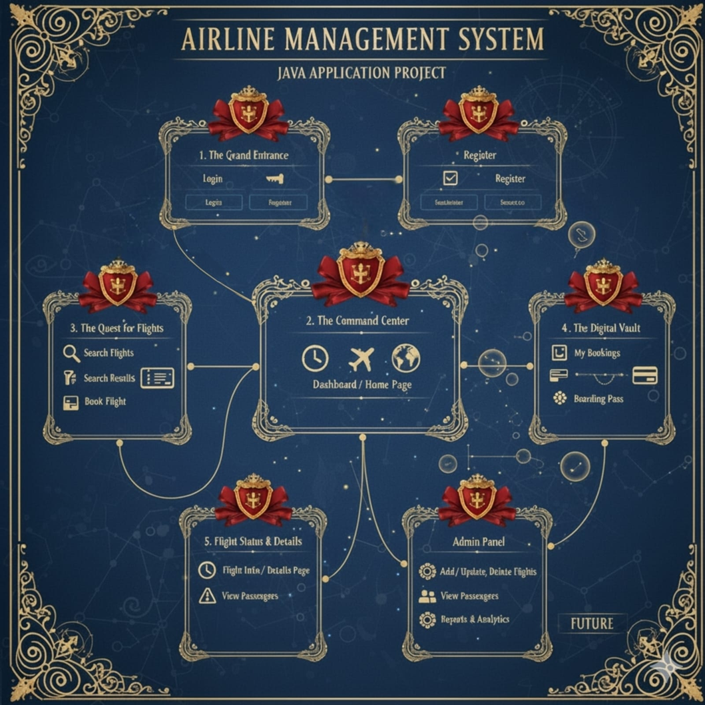

## Output Screen Shots

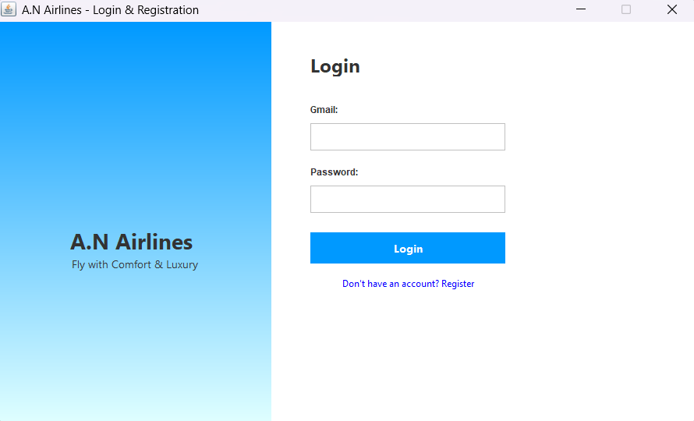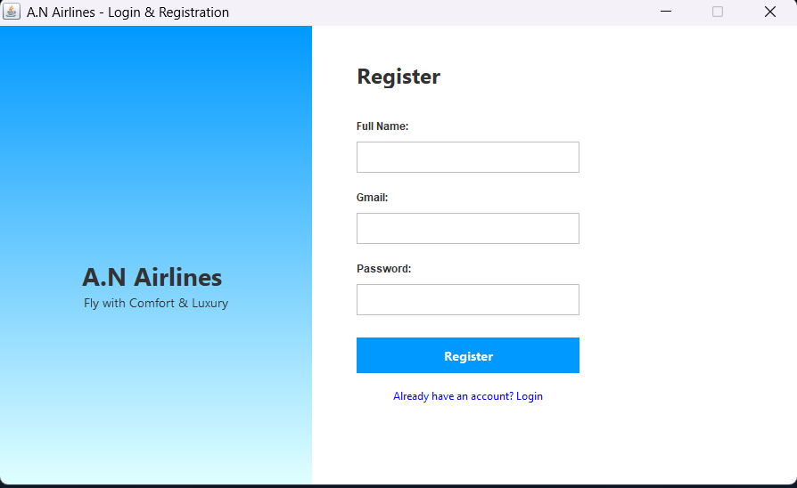

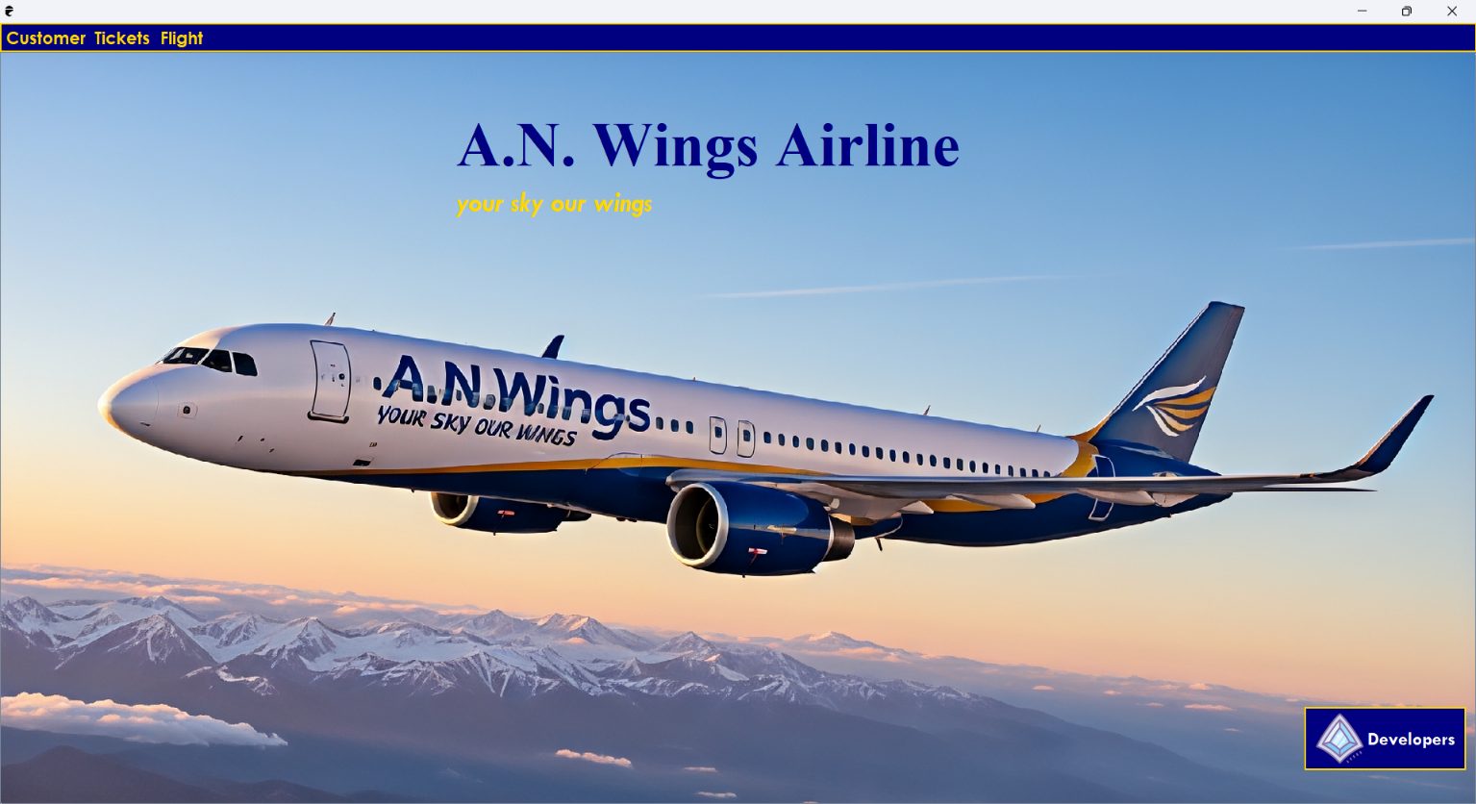

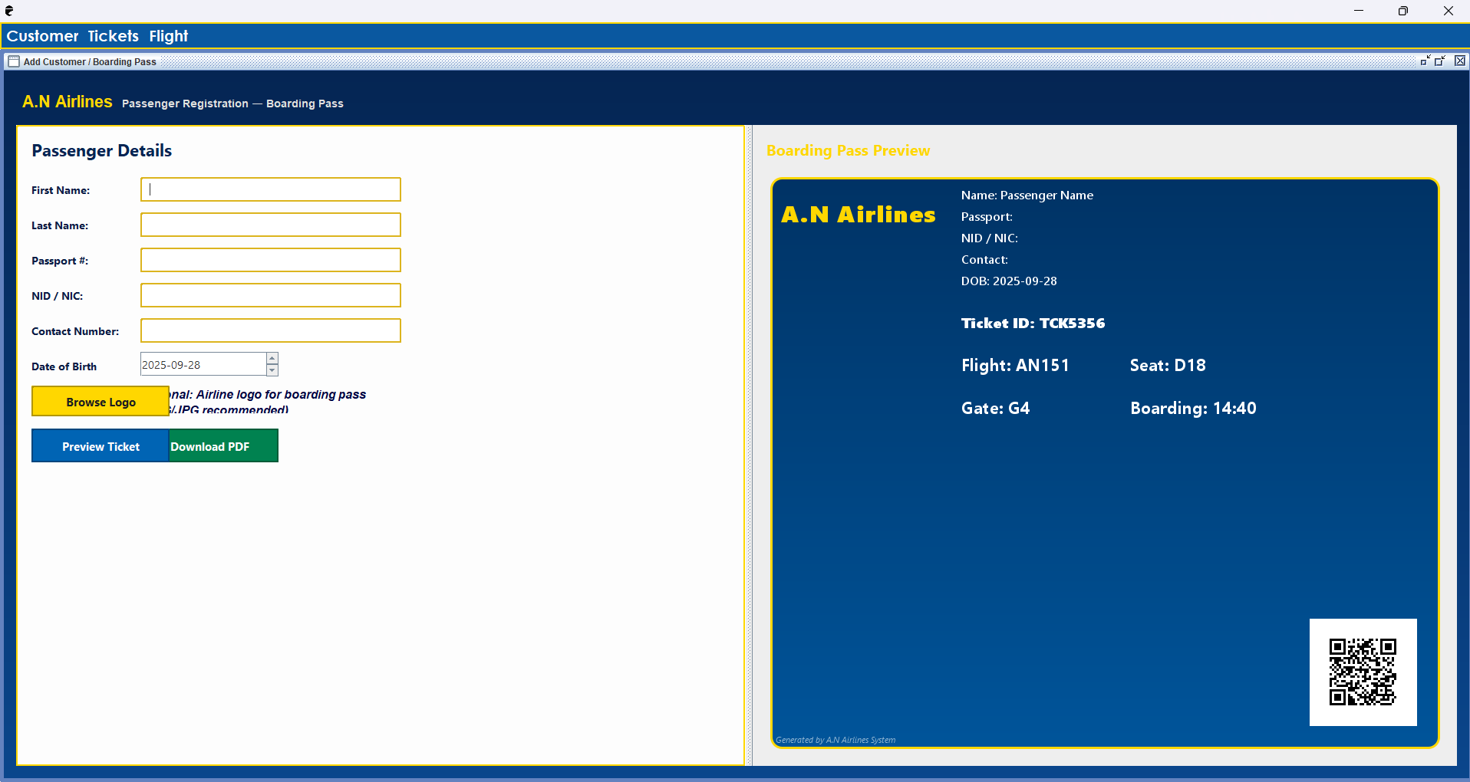

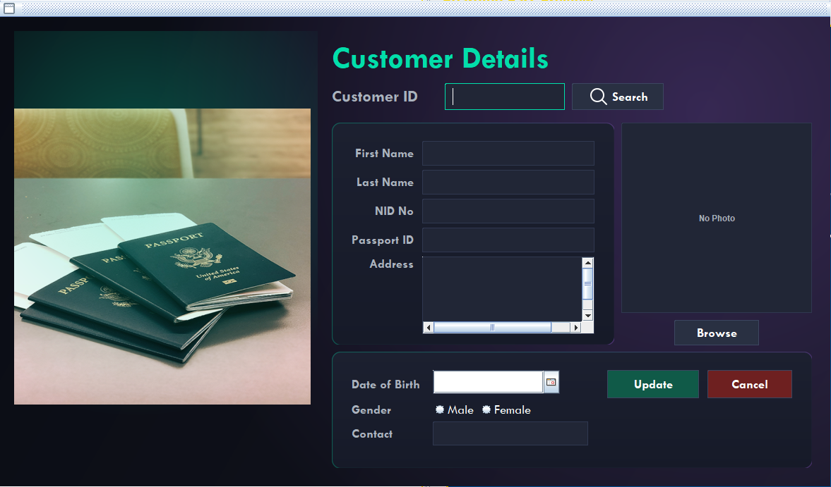

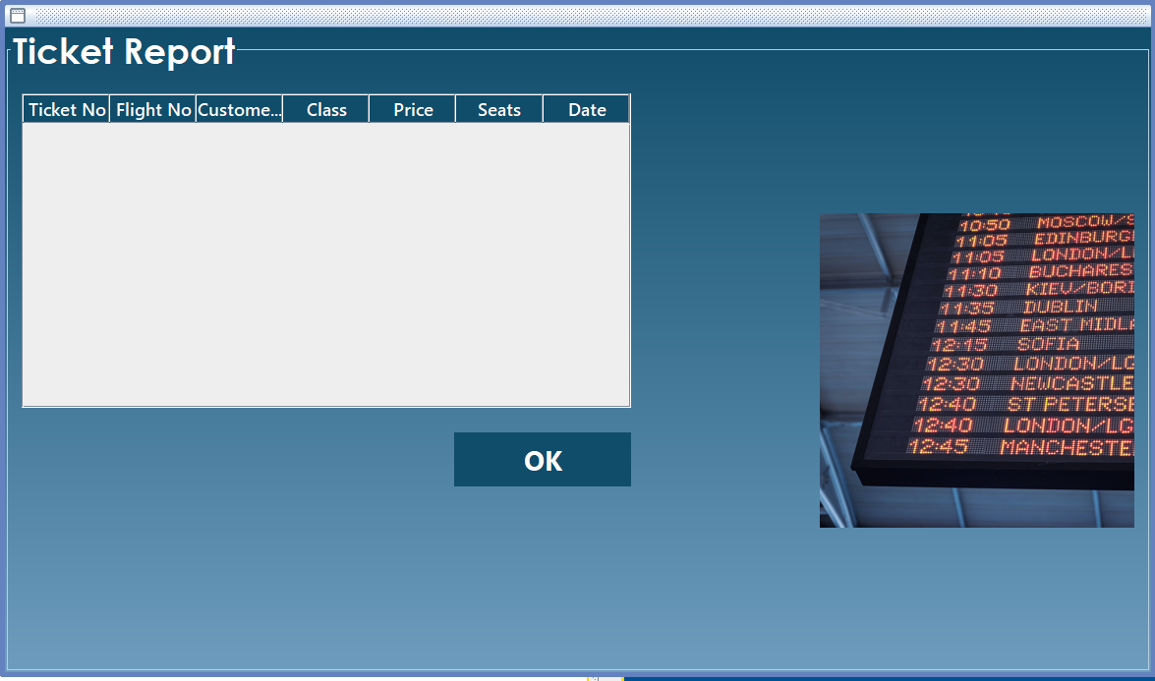

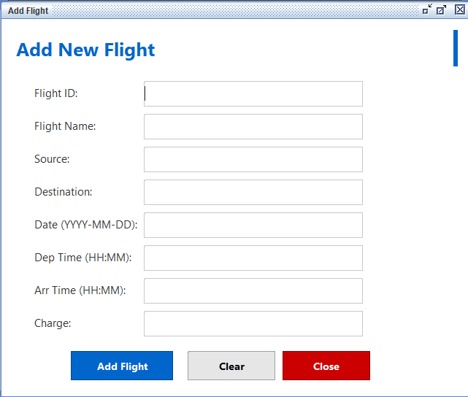

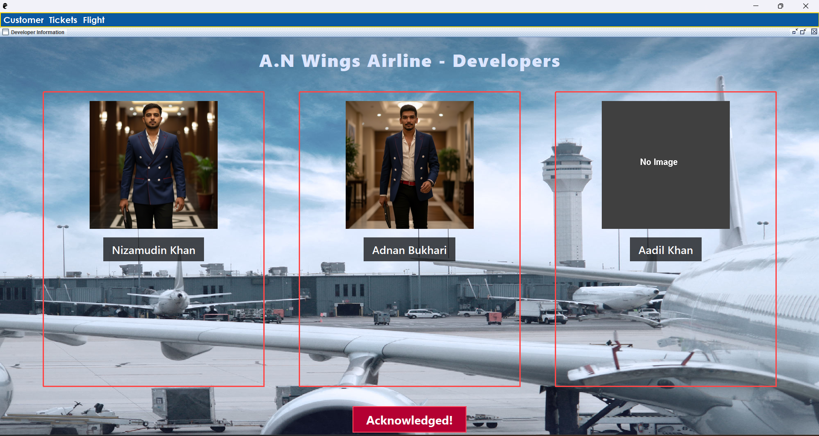

Developers

This Airline Management System project has been developed by a team of three members: Bukhari Adnan, Belim Nizamudin, and Aadil Khan. Each member has contributed with dedication and teamwork to ensure the successful completion of this project.

This Airline Management System project has been developed under the valuable guidance of Mr. Chirag Jadav.

**Coding tool NetBeans 12.6**

**The screenshots below display the source code of the Airline Management System project.**

Login & Register

(A.Login.java)

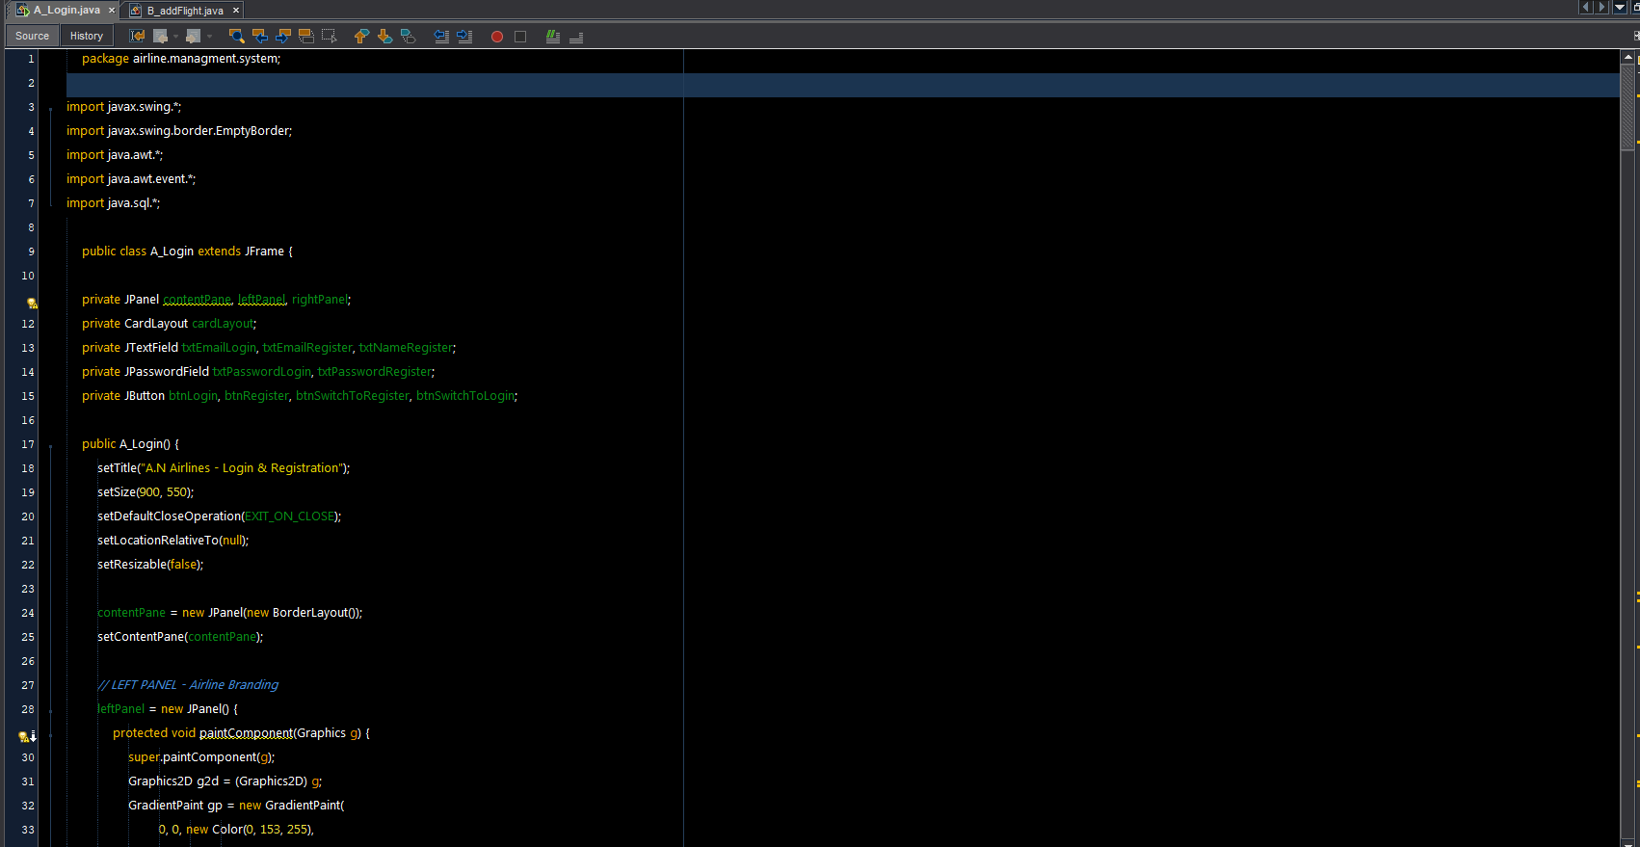

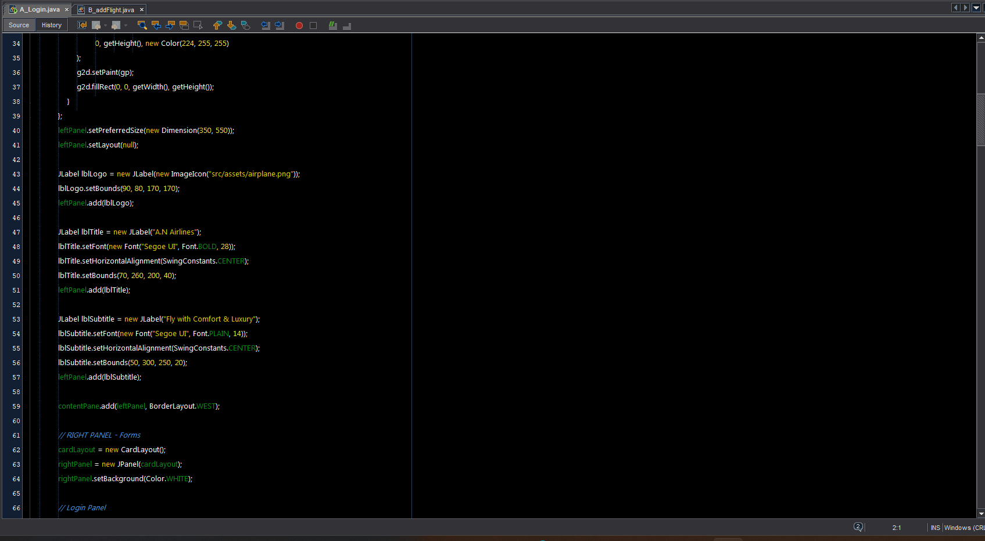

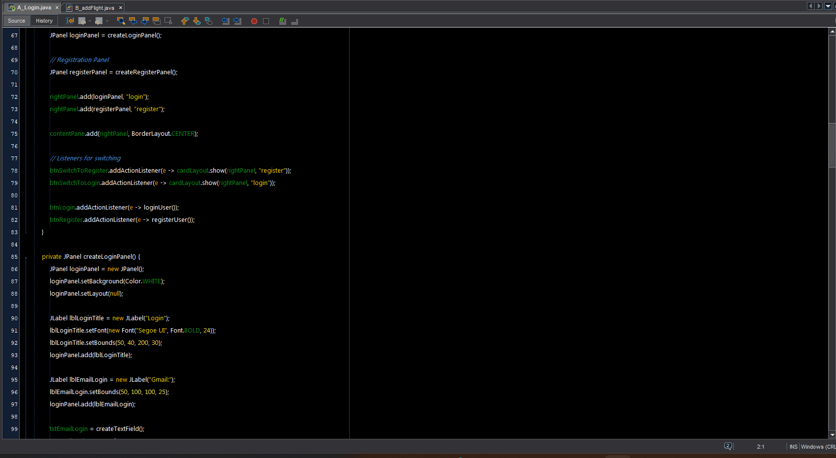

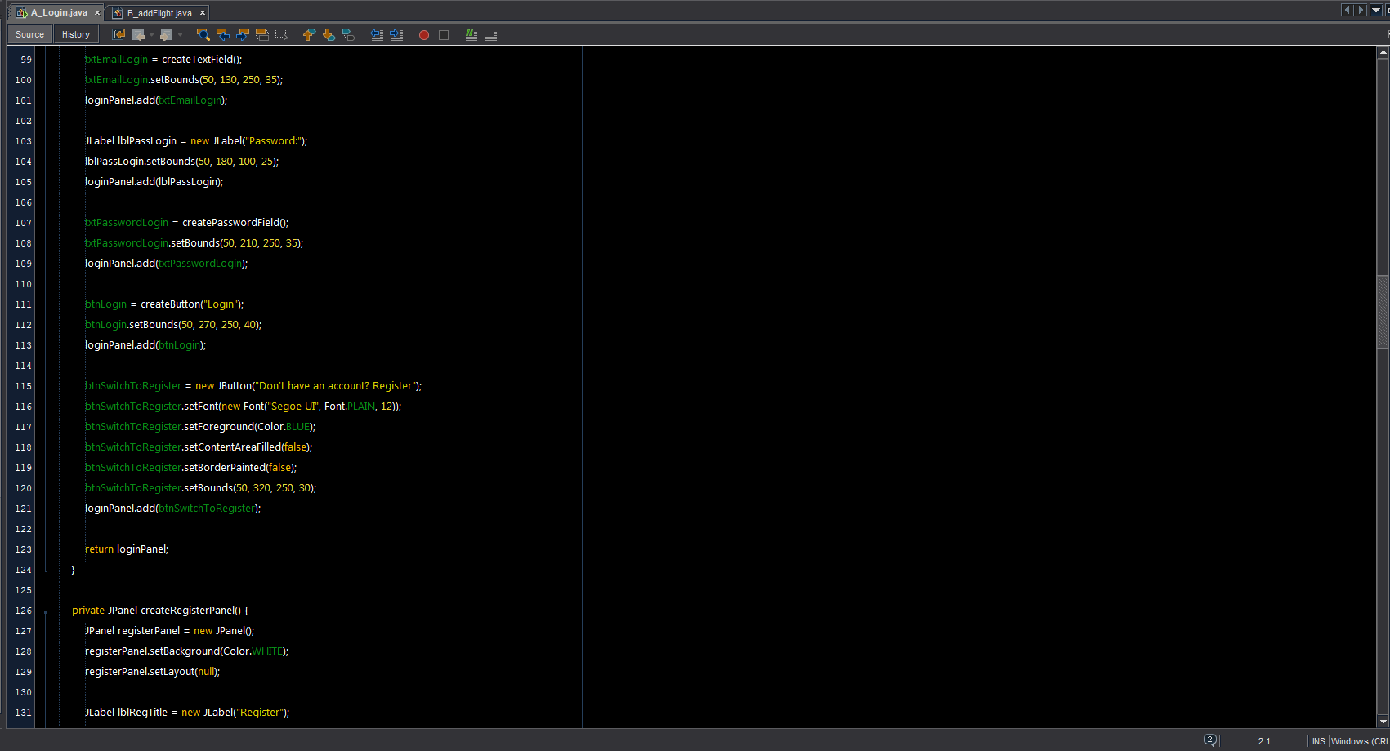

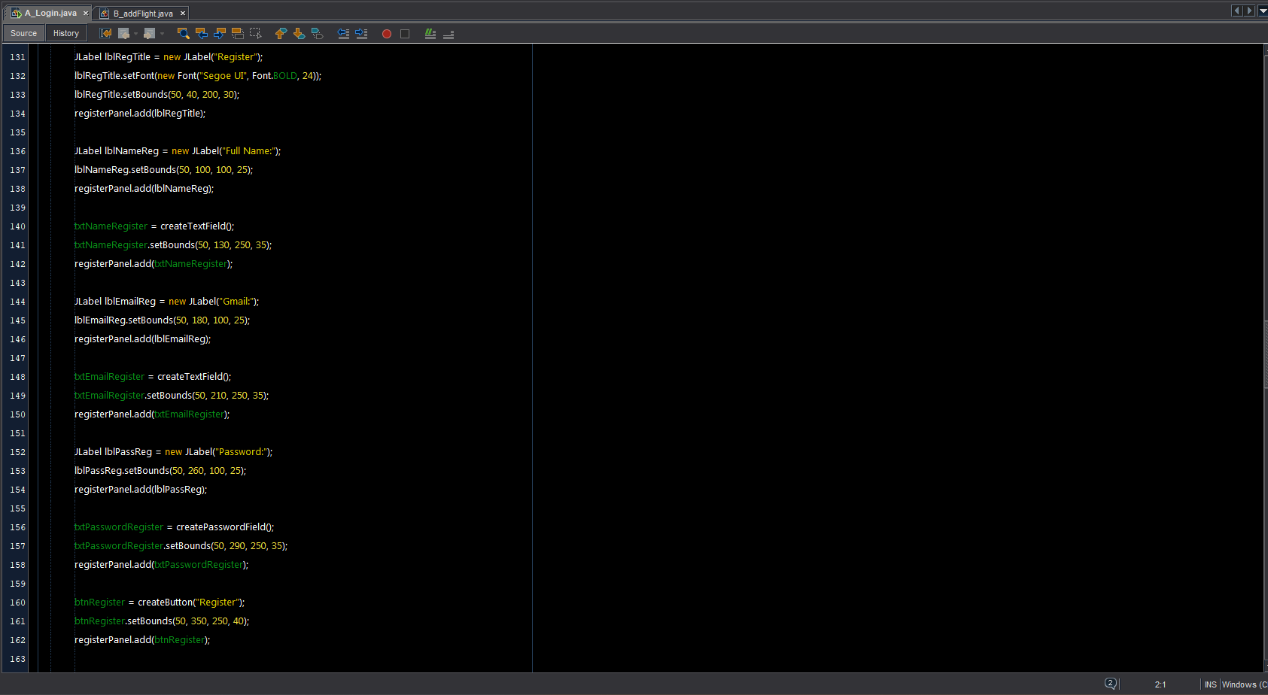

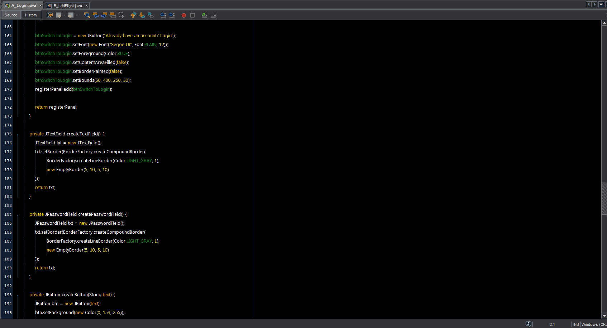

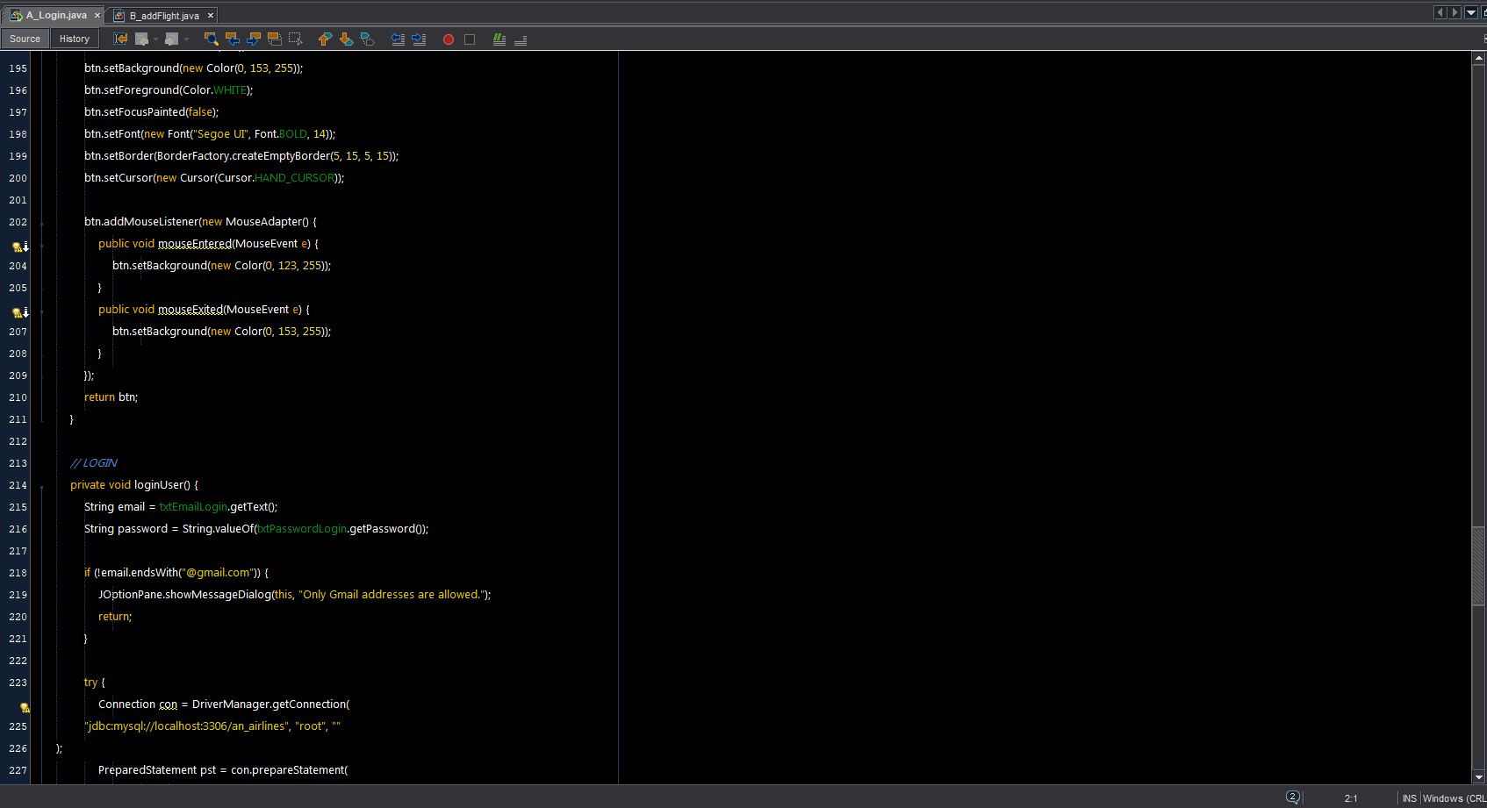

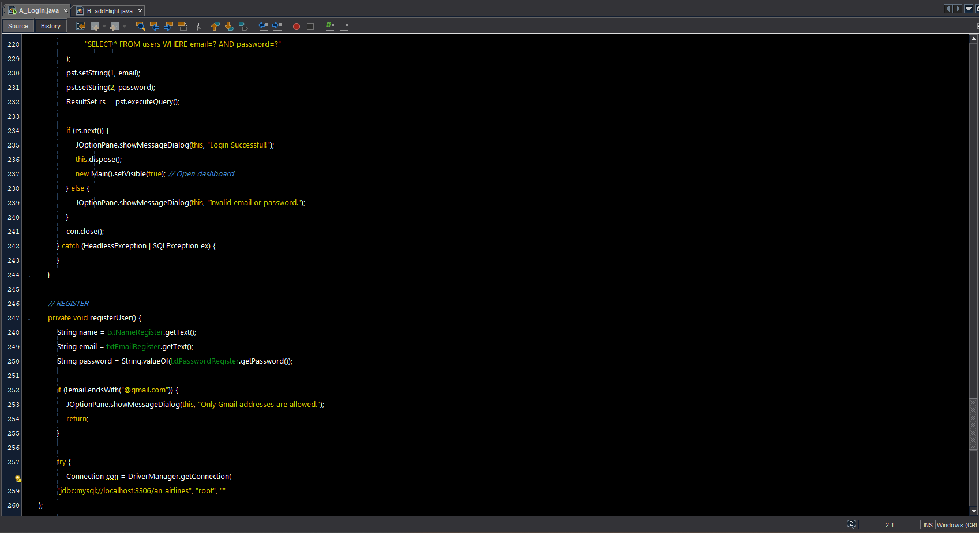

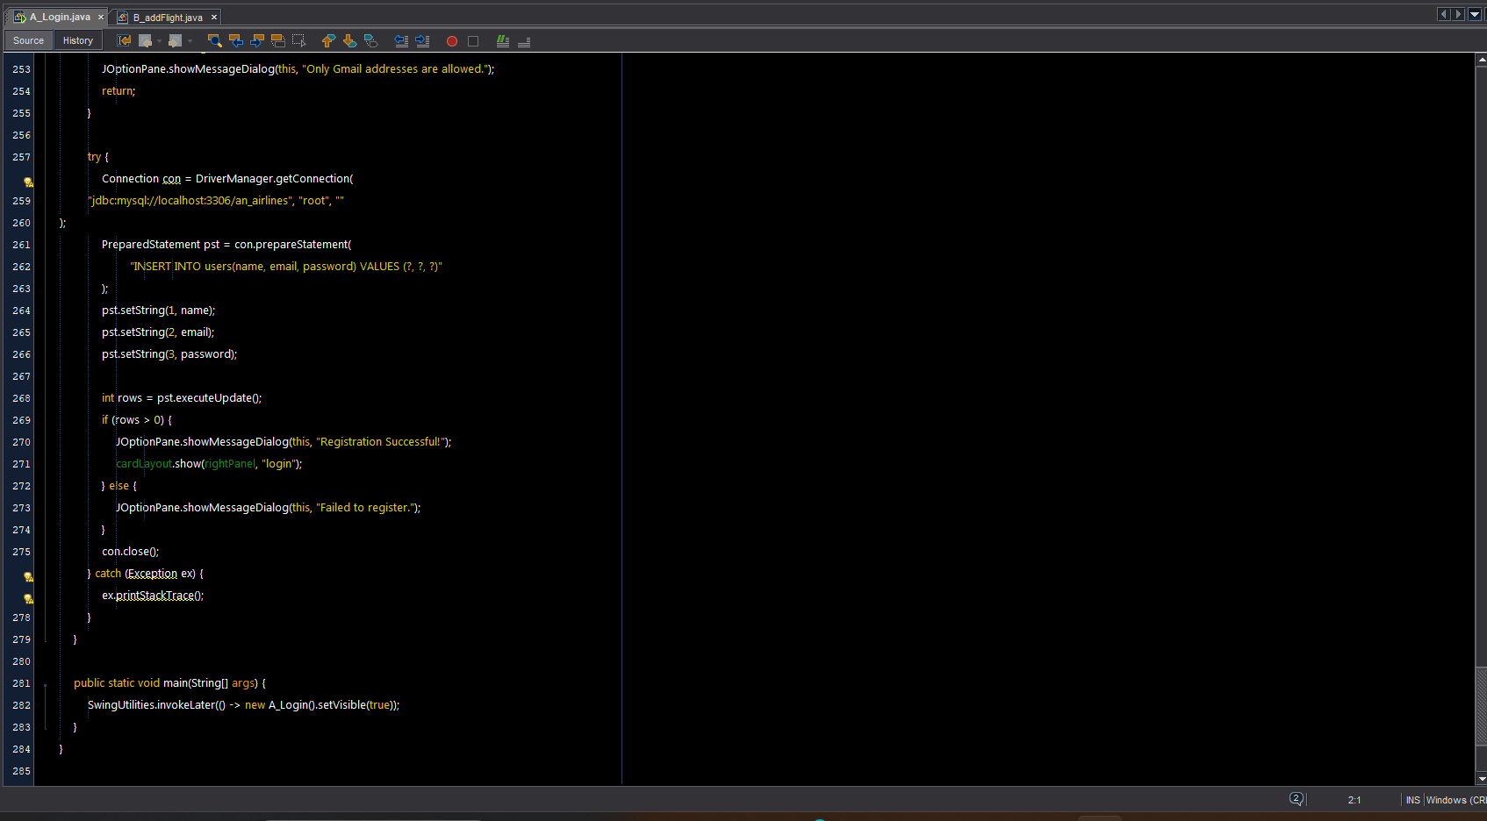

B.AddFilght.java

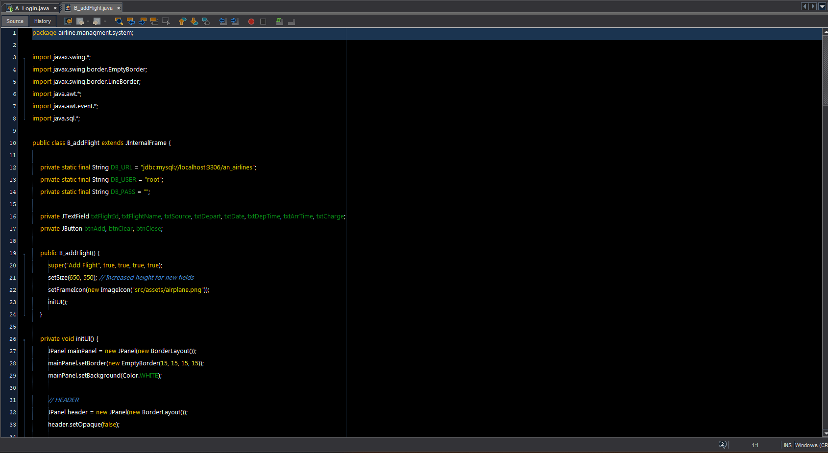

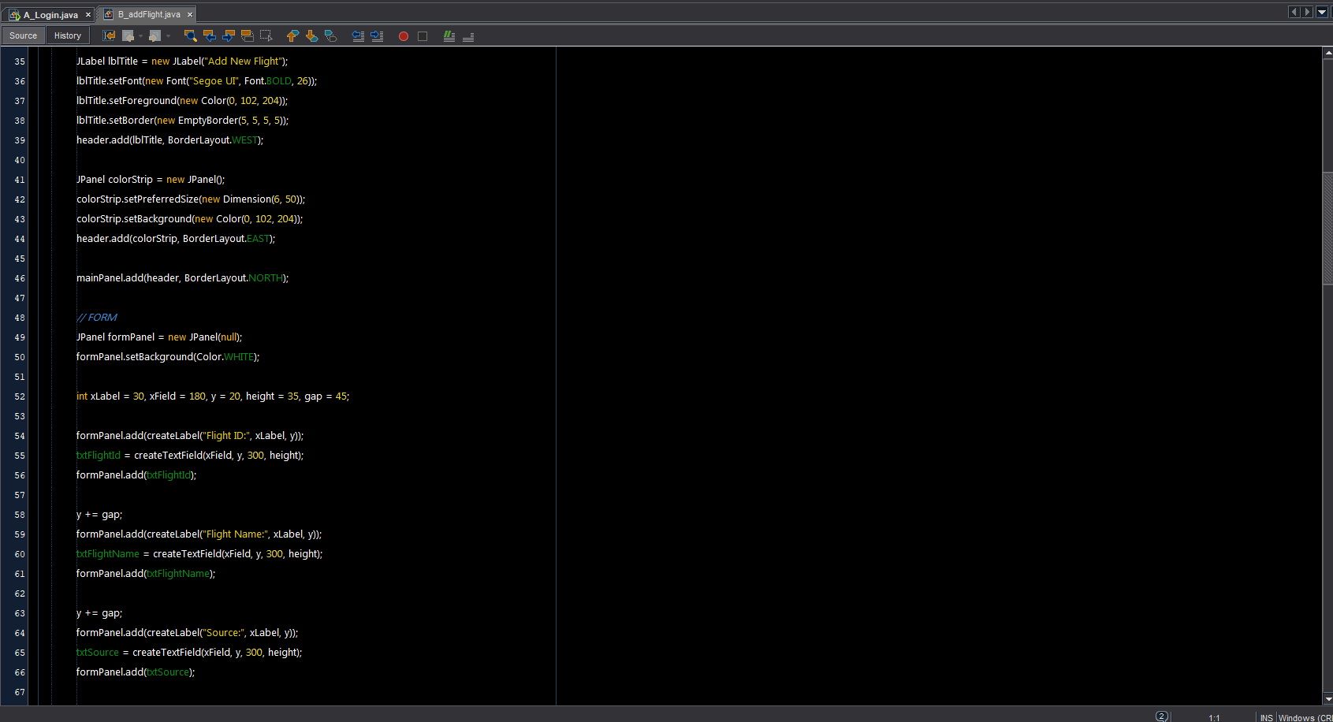

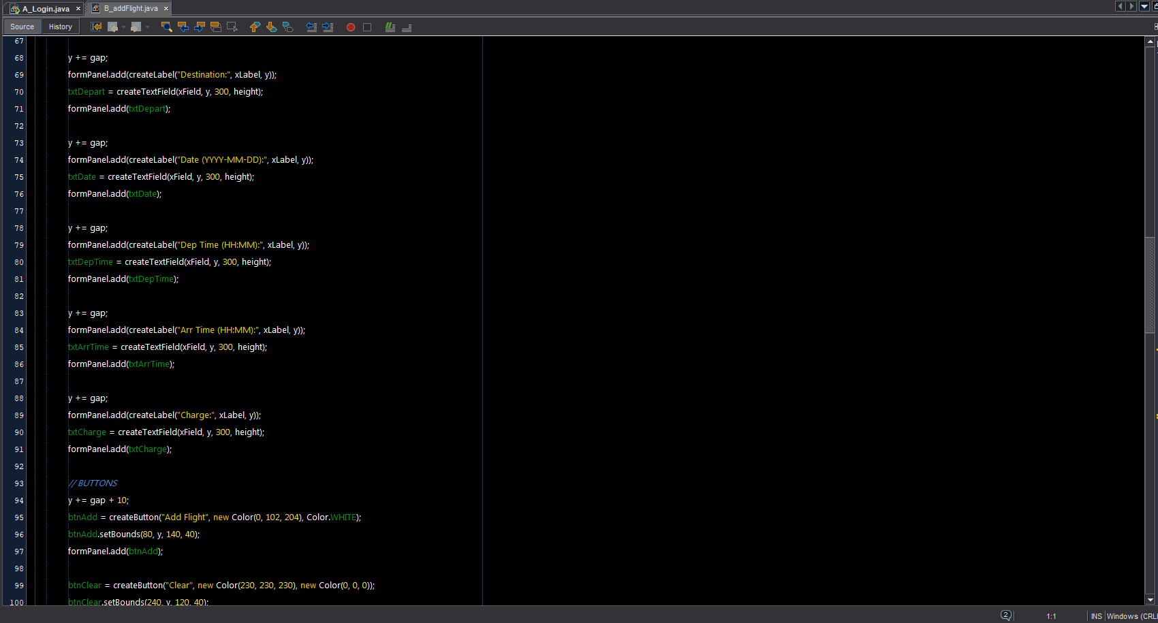





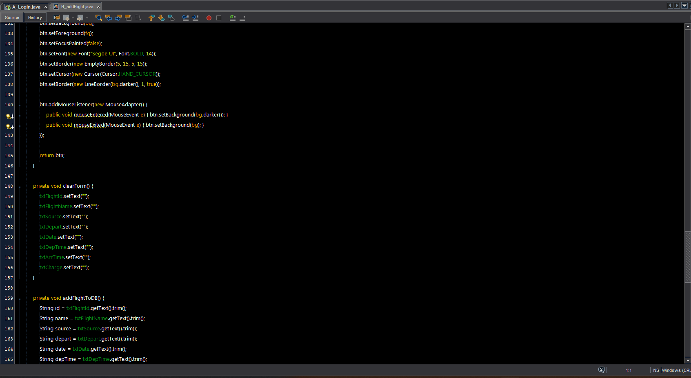

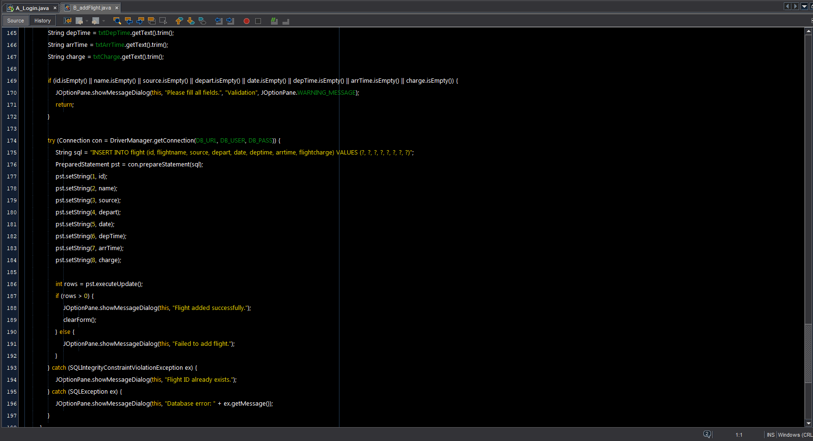

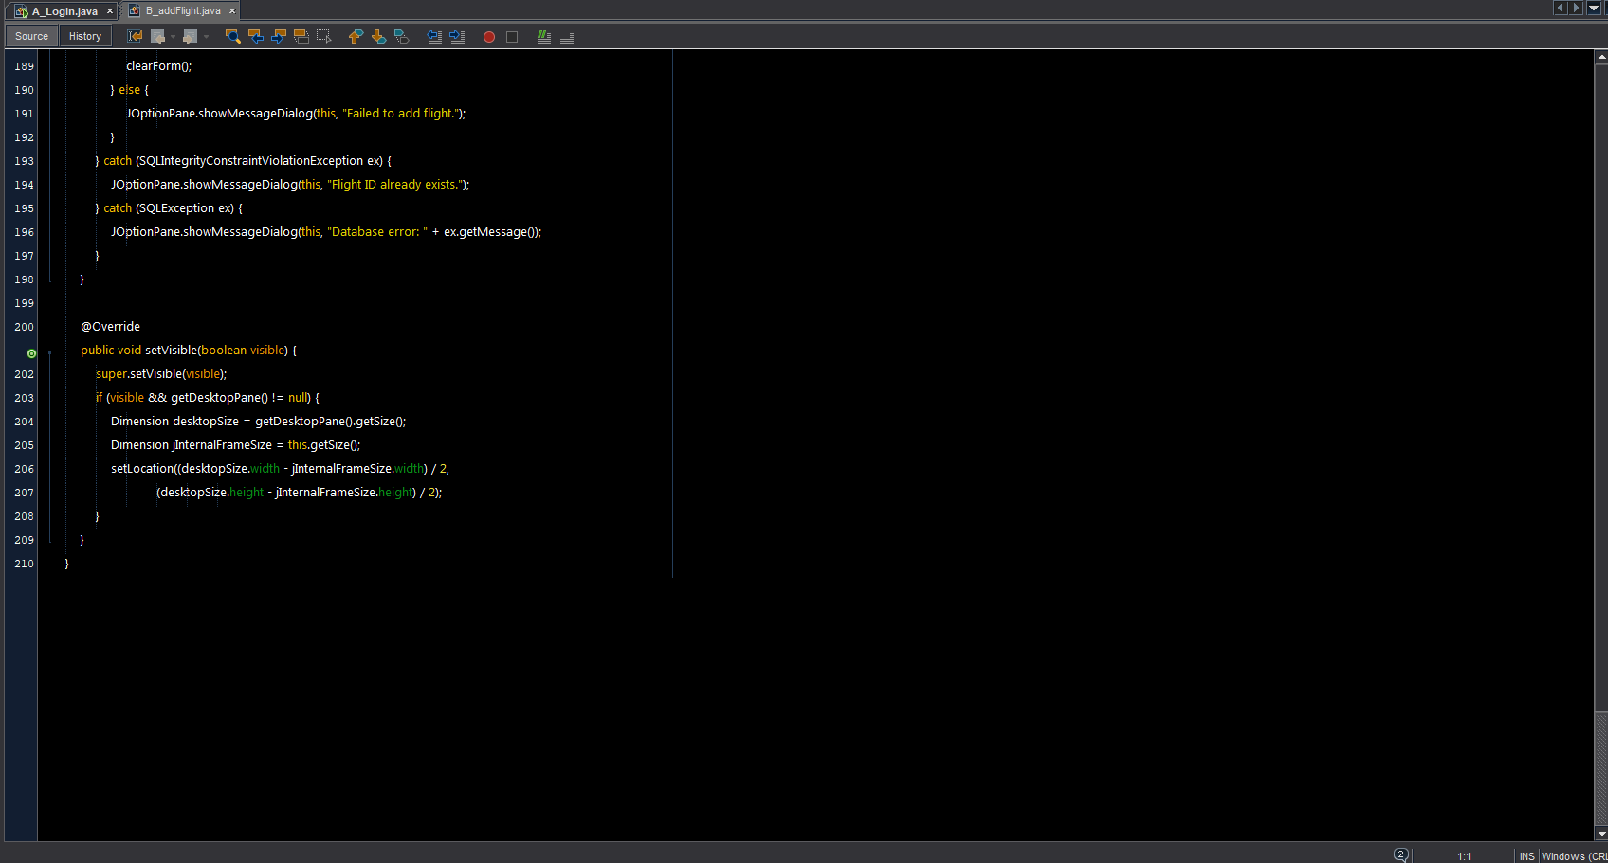

# C_BookTicket .java

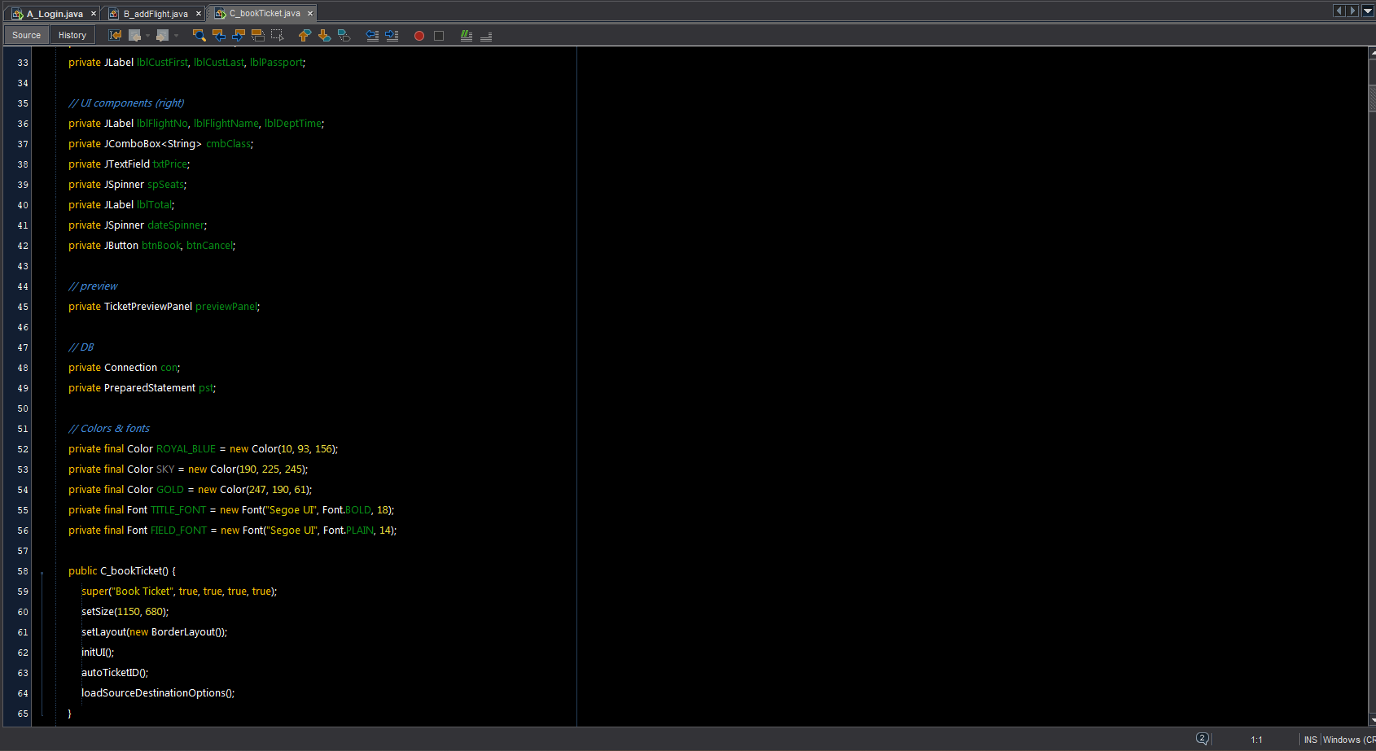

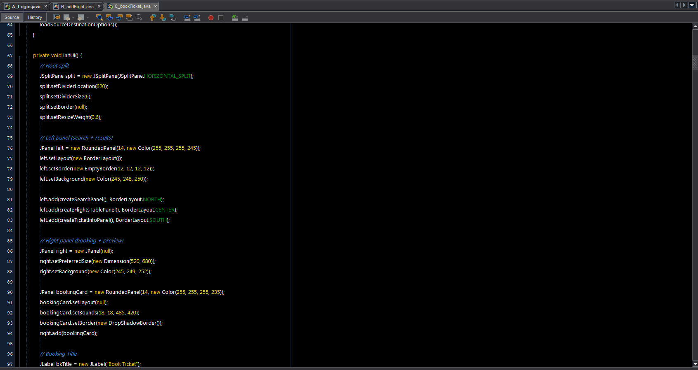

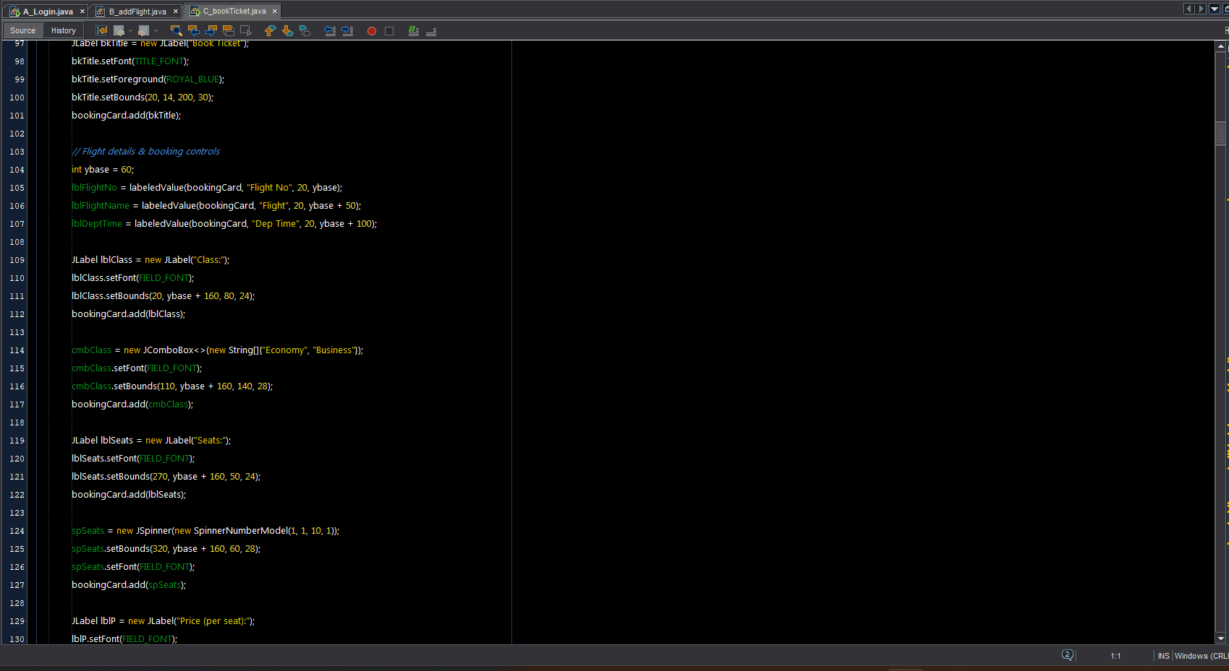

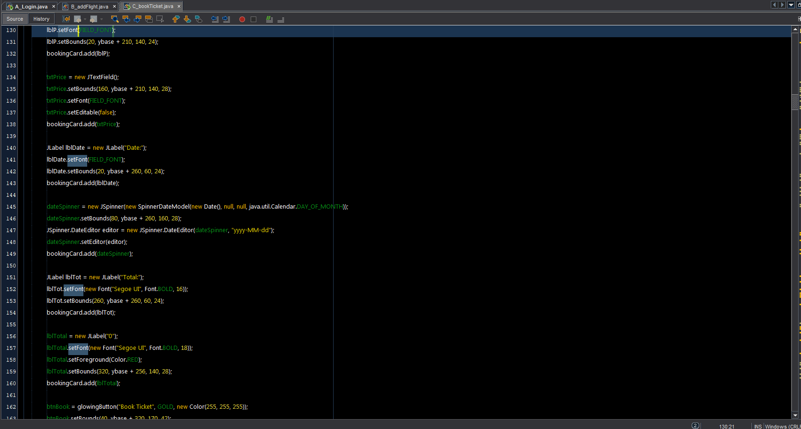

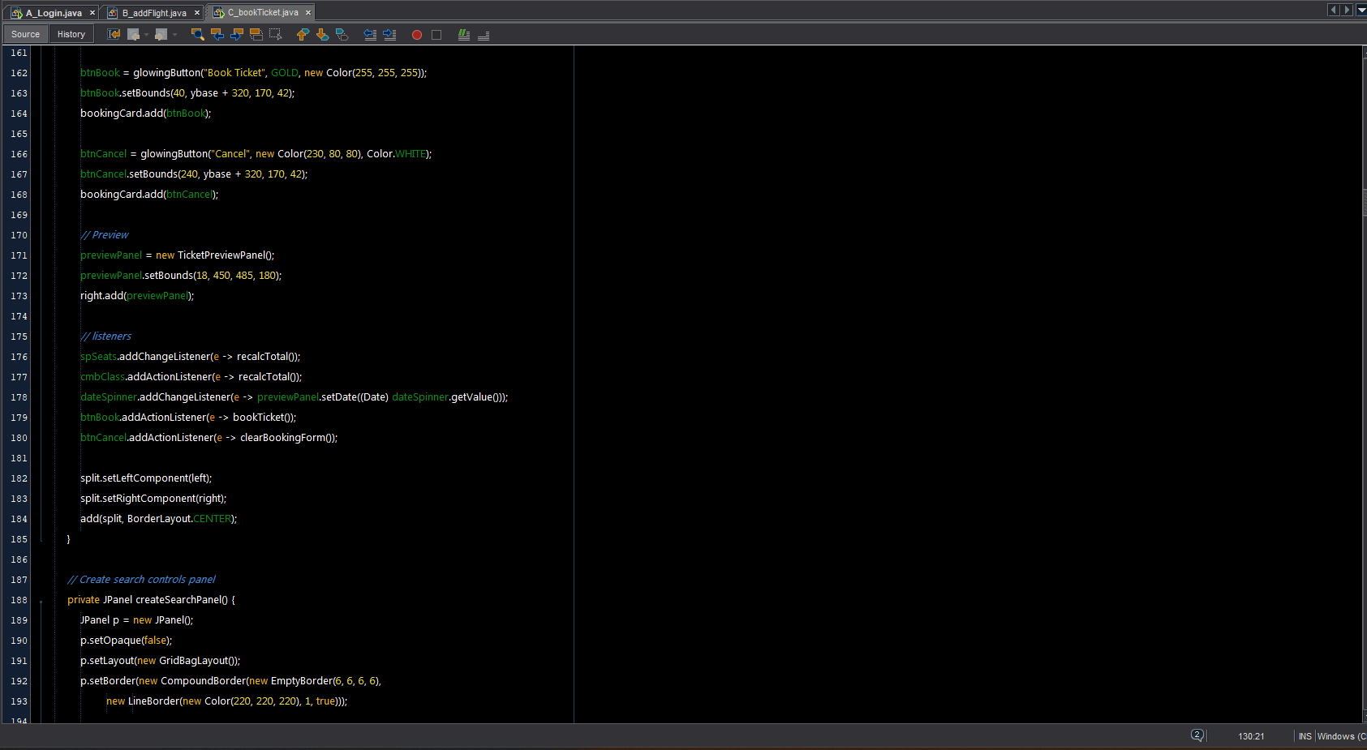

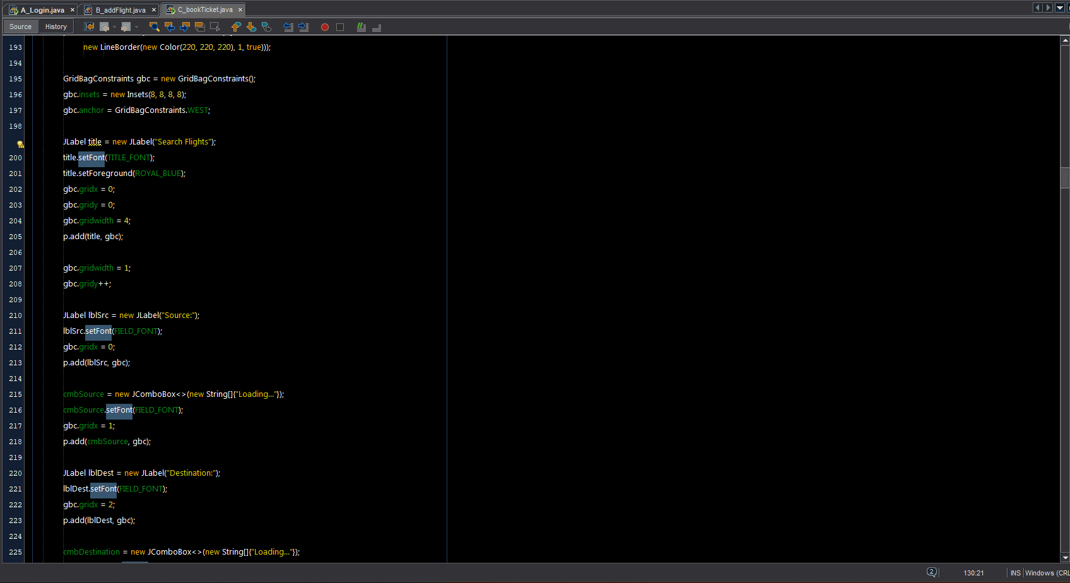

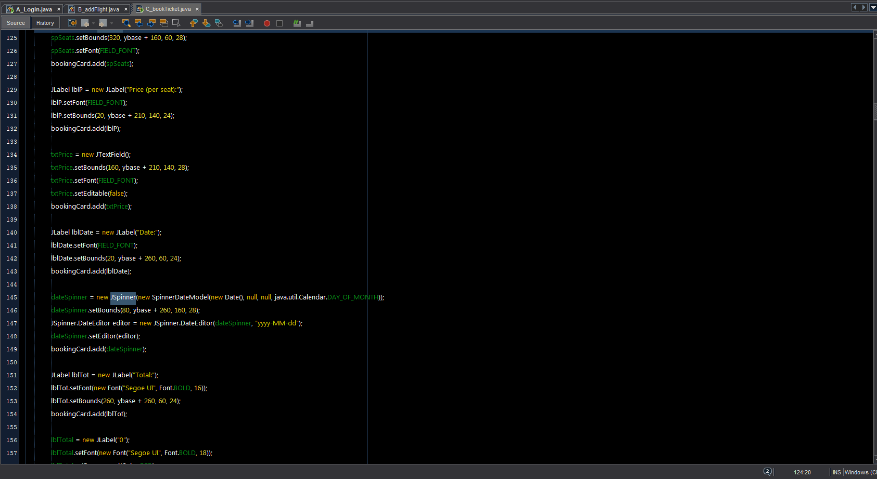

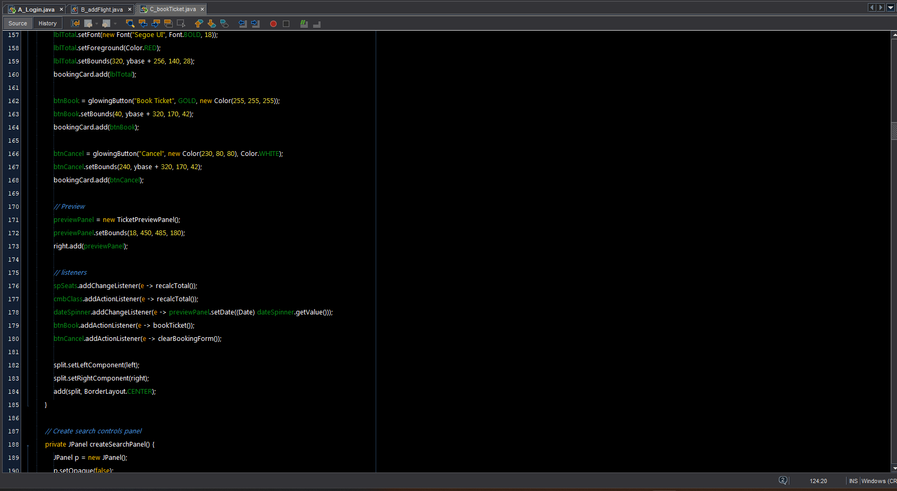



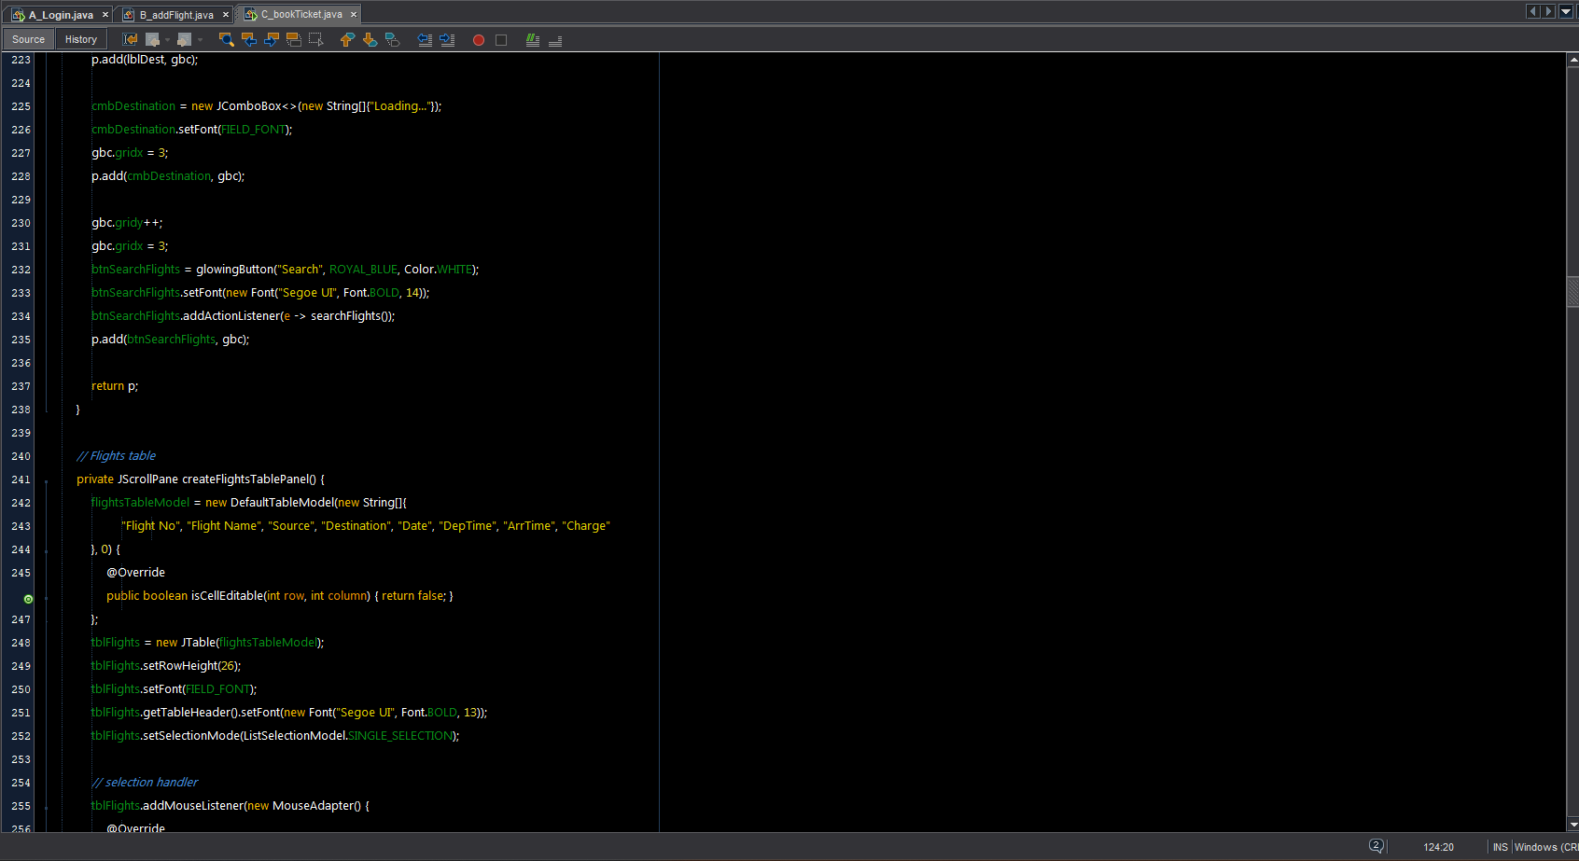

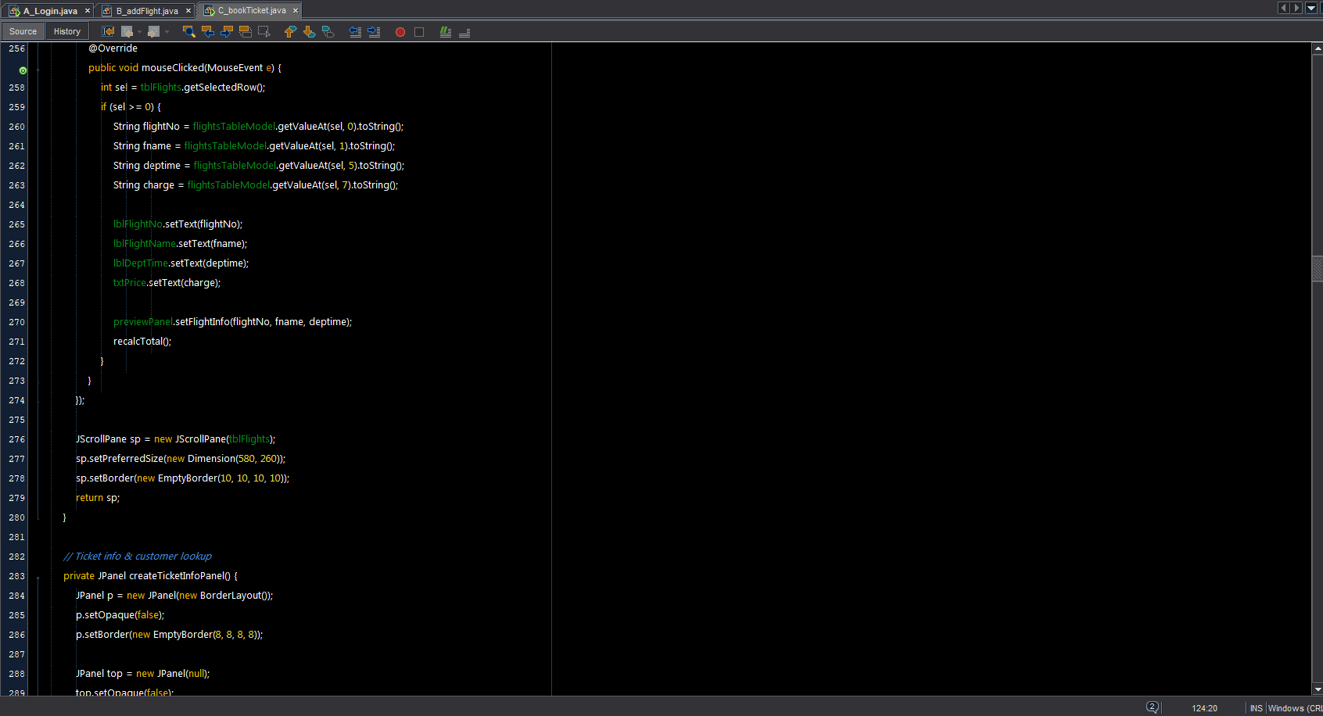

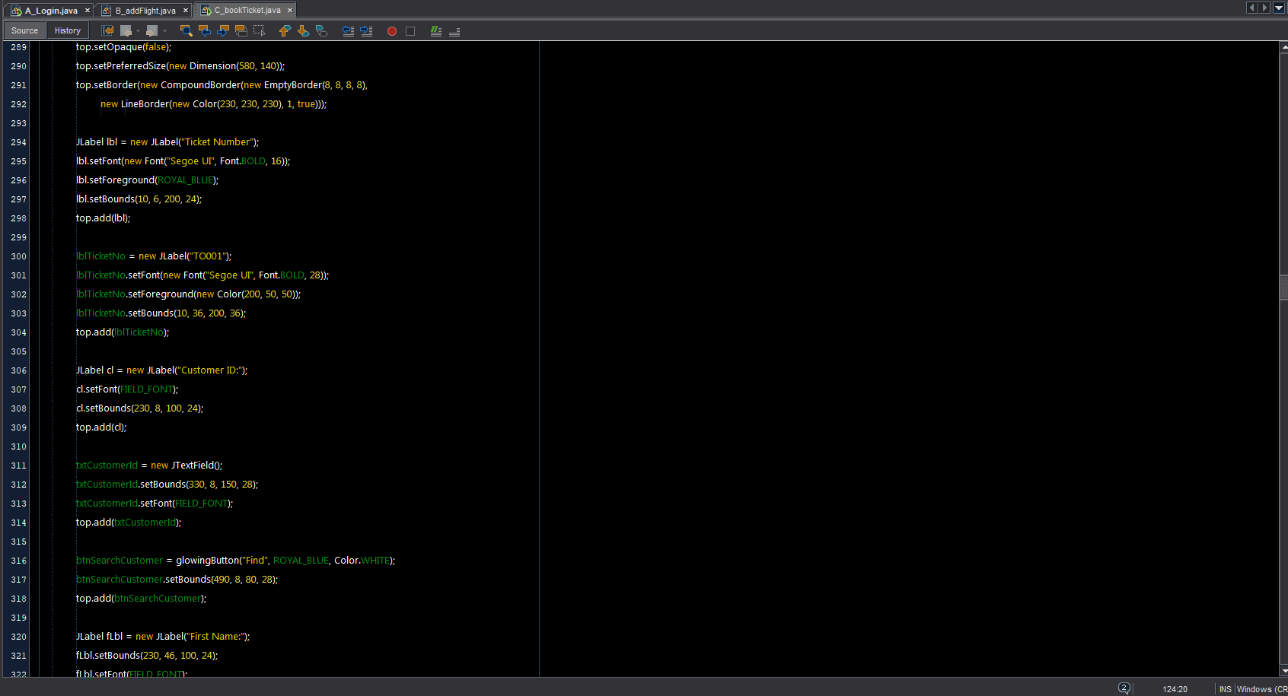





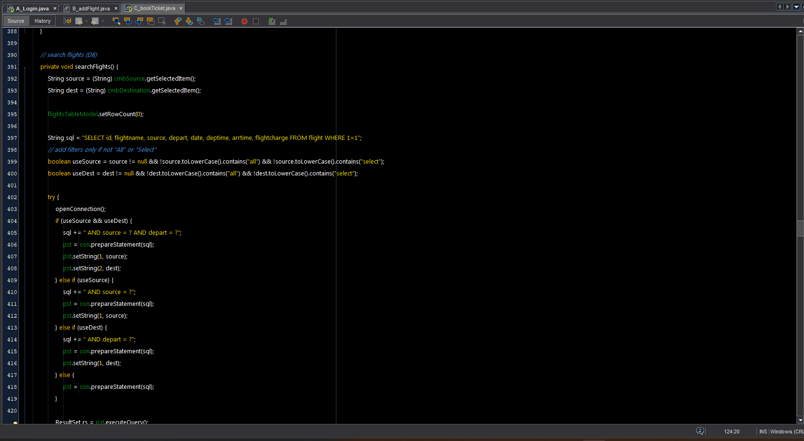

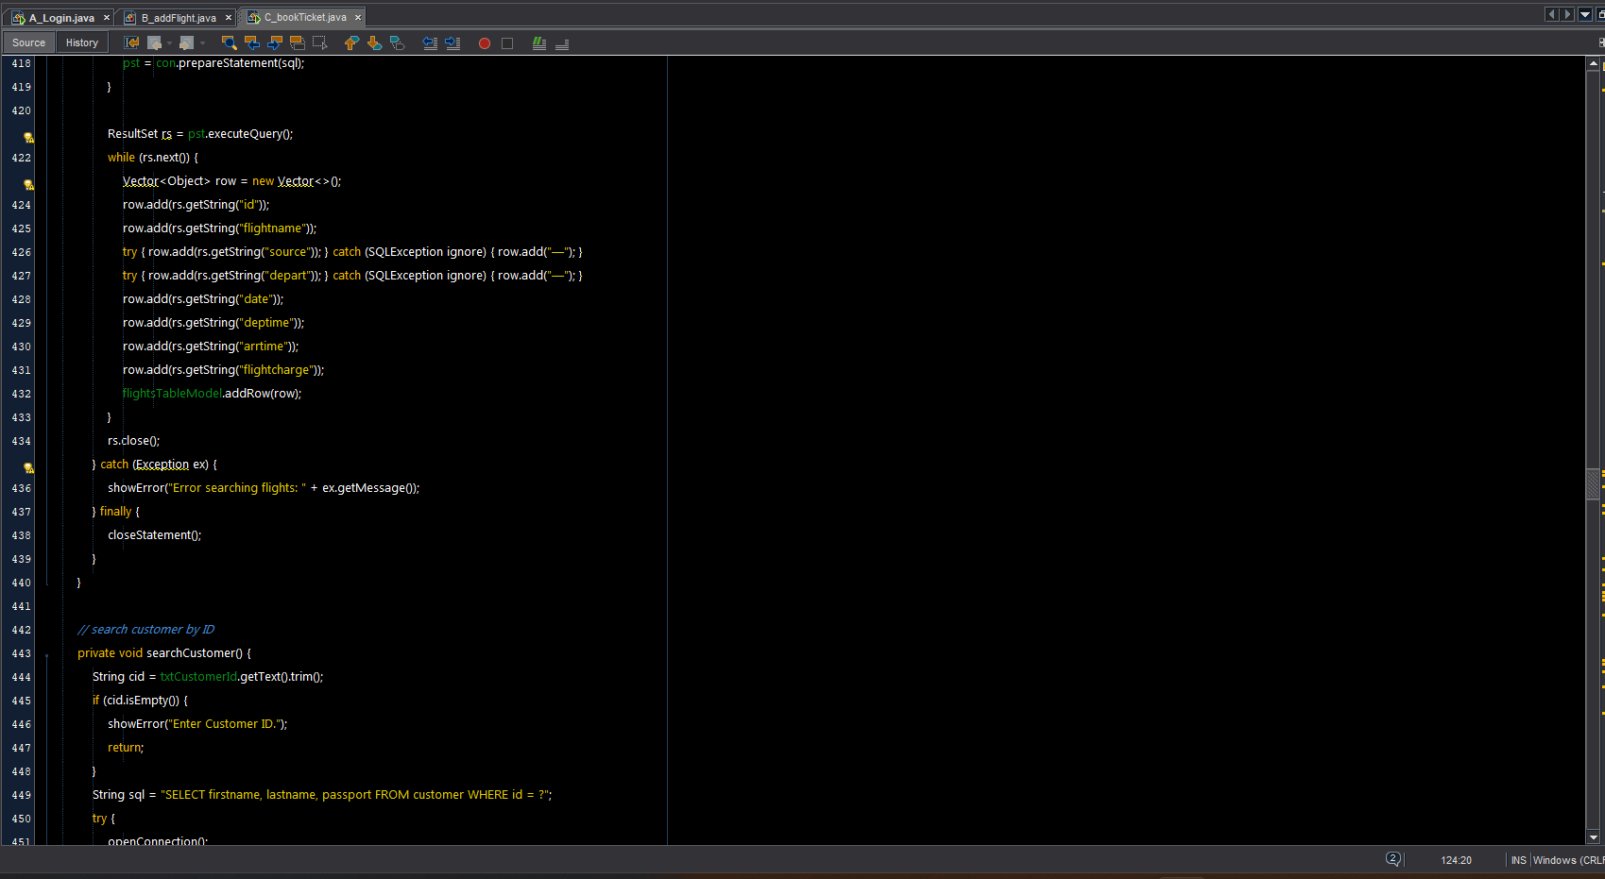

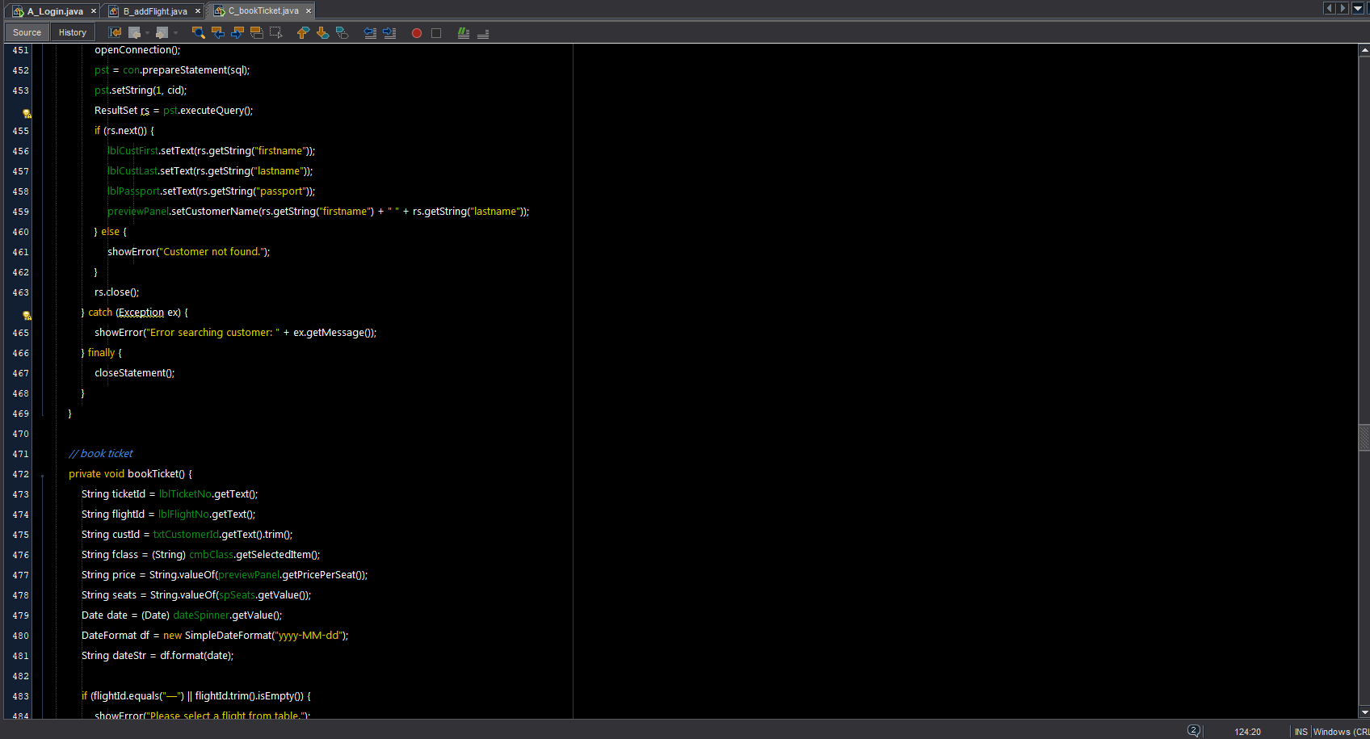

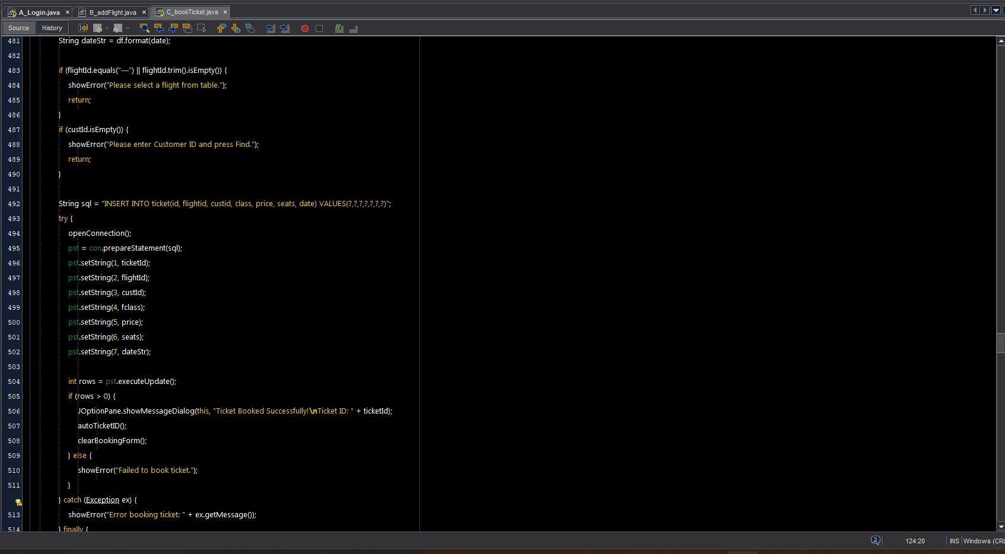

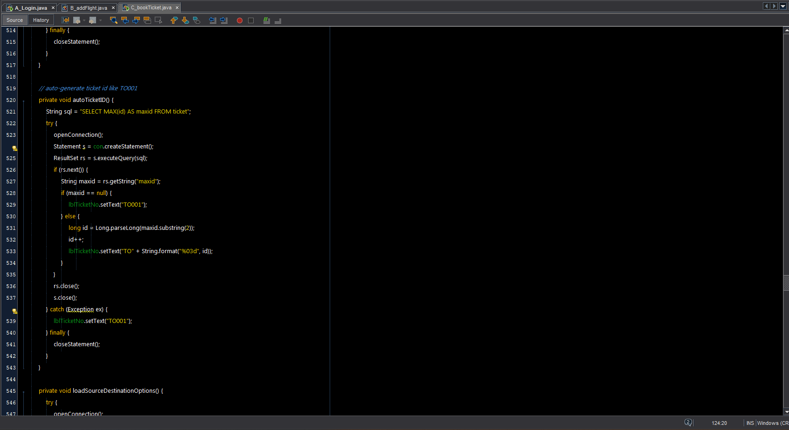

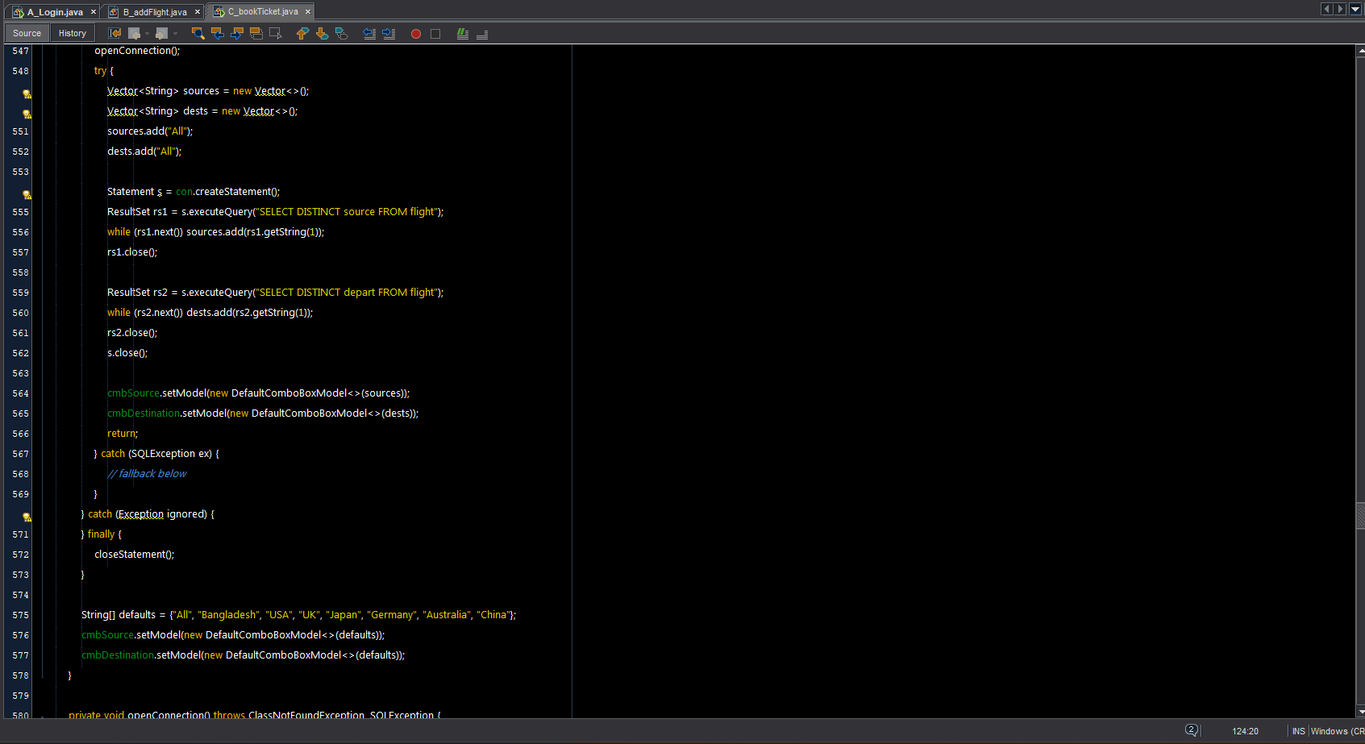

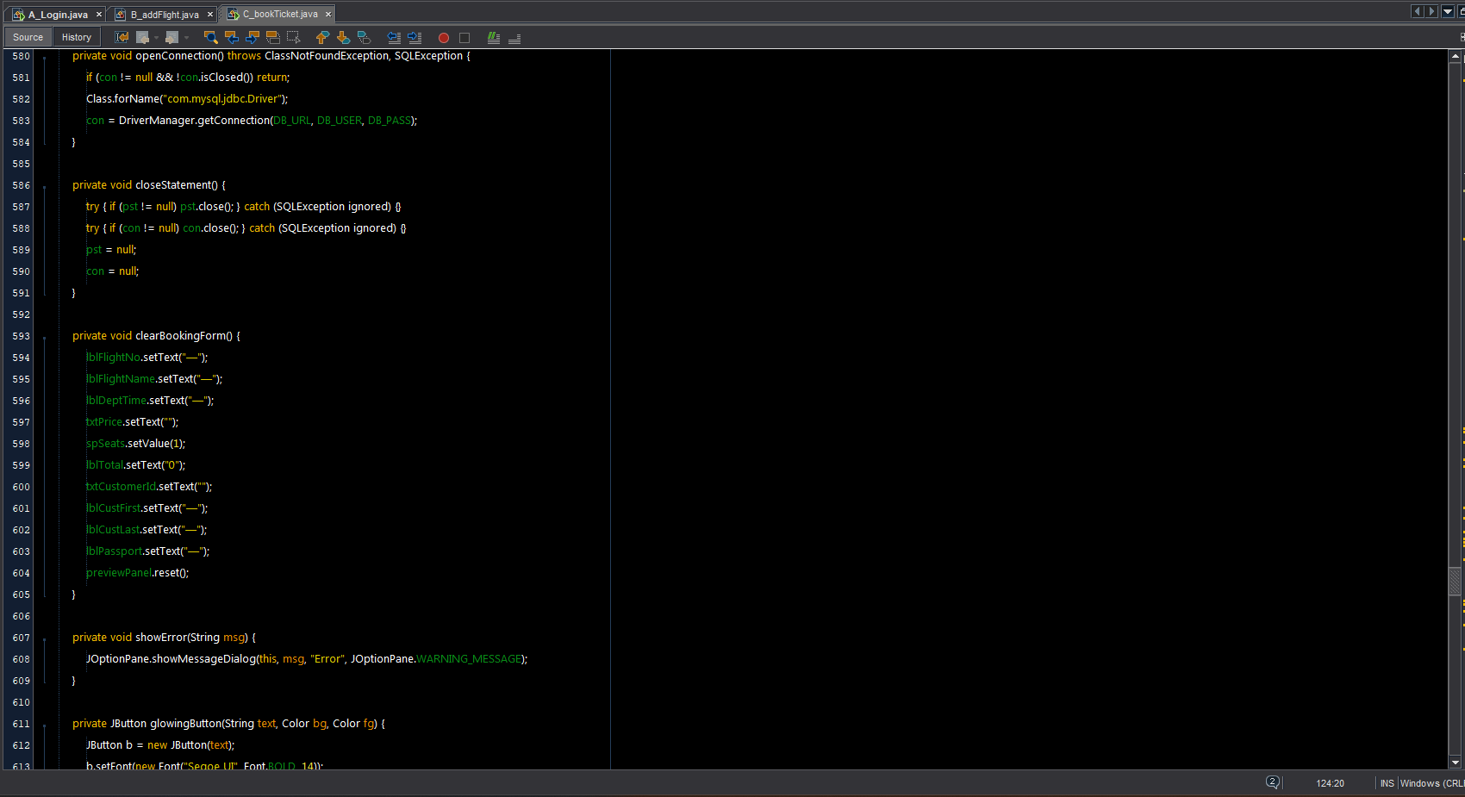

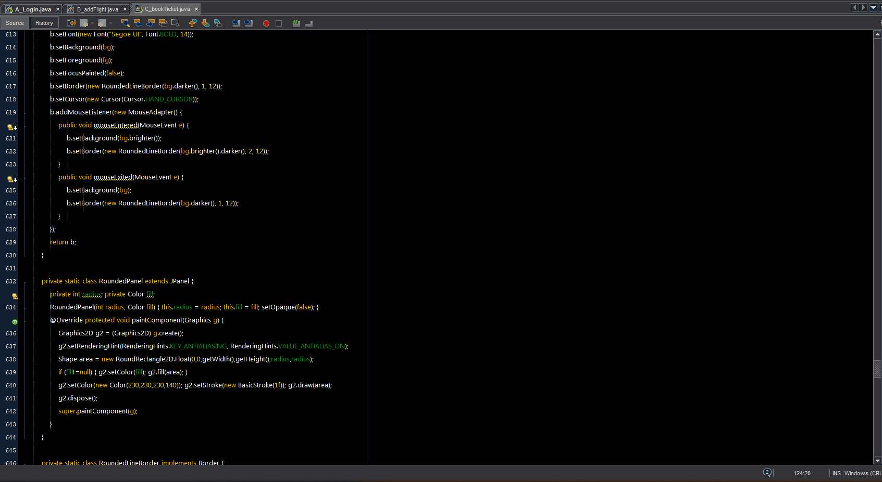

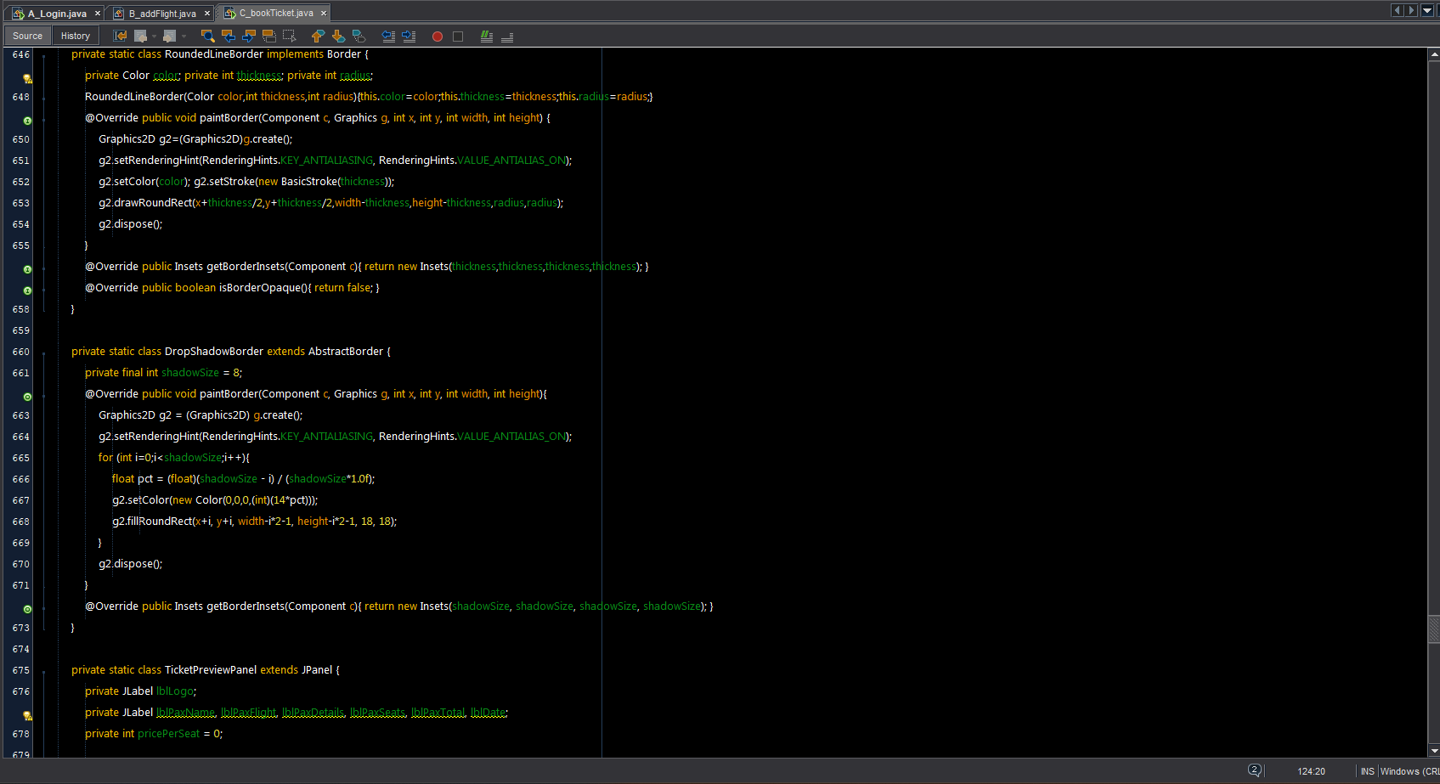

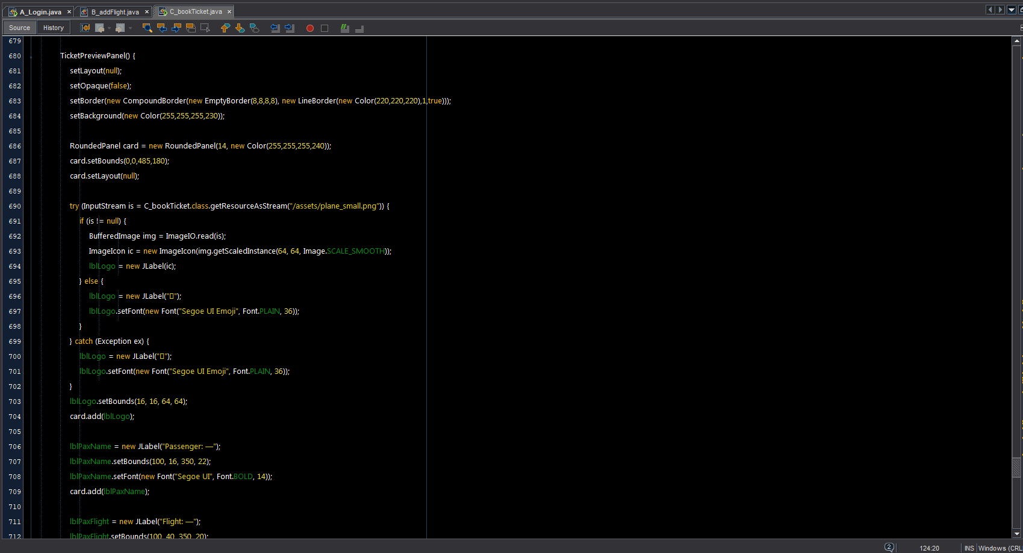

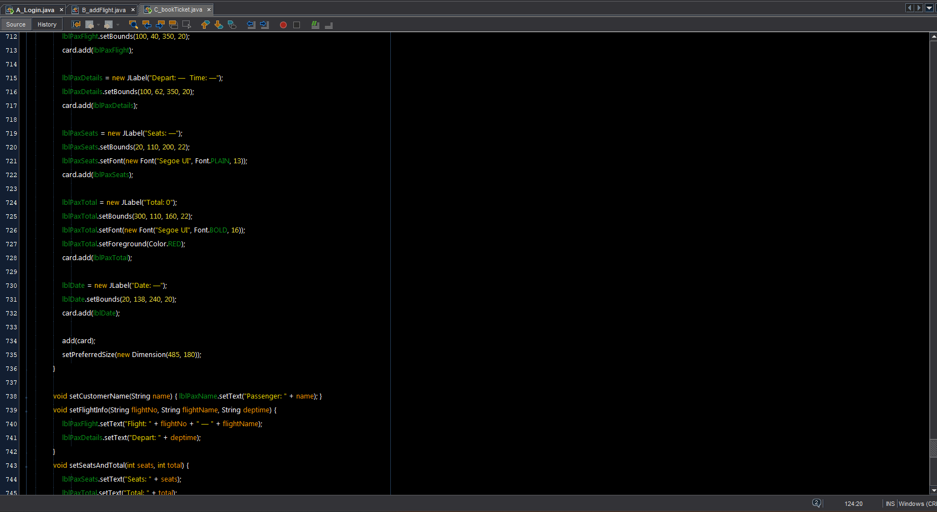

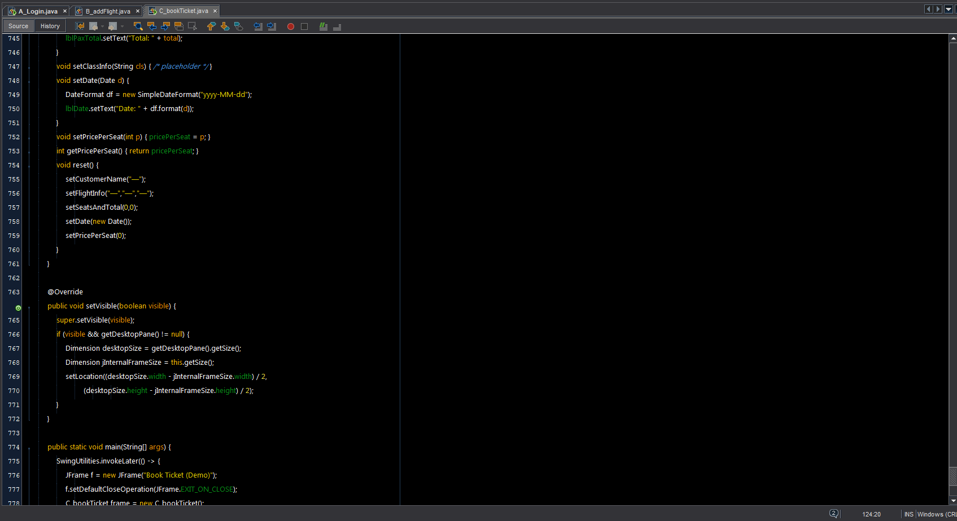

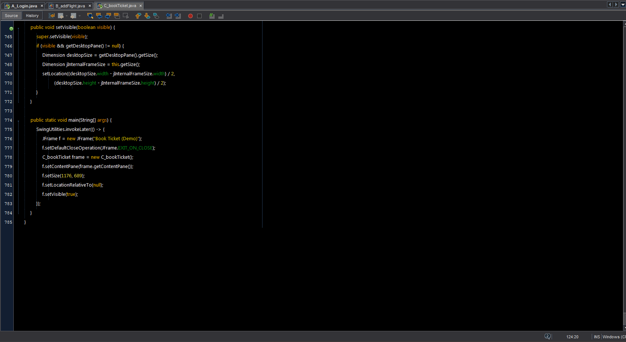

D_AddCustomer.java

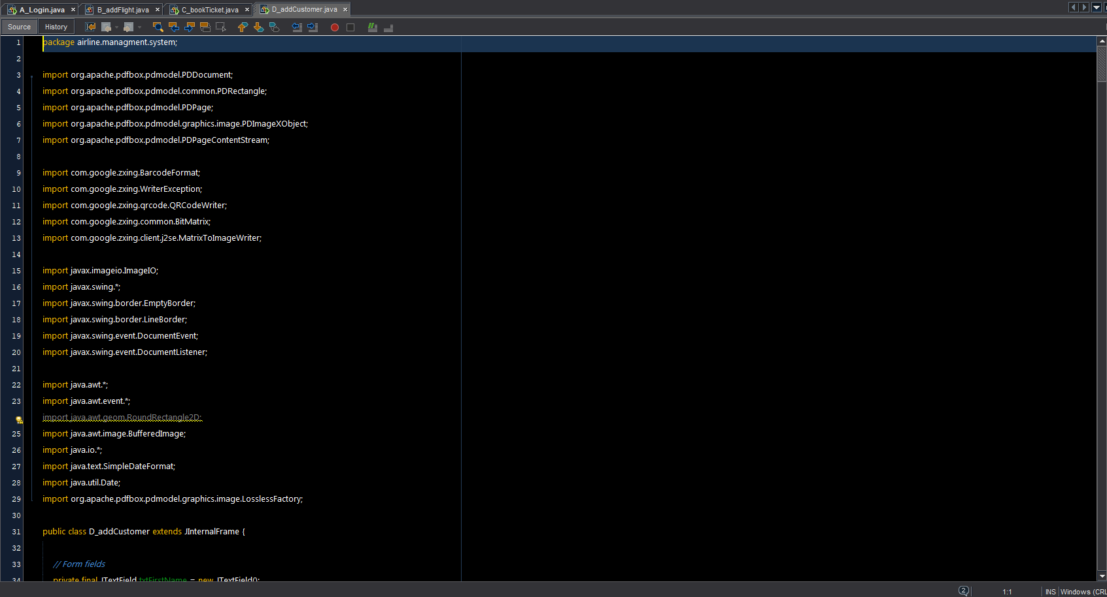

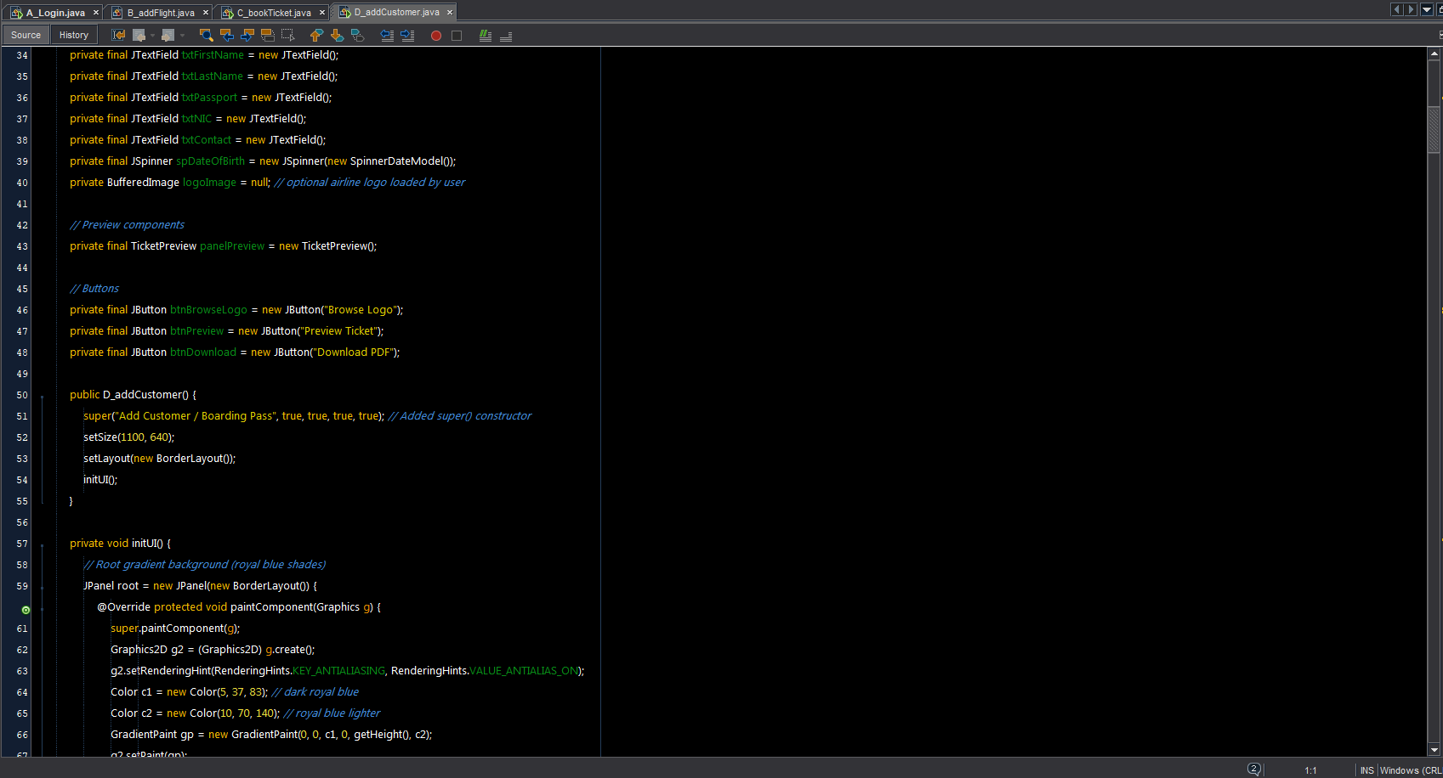

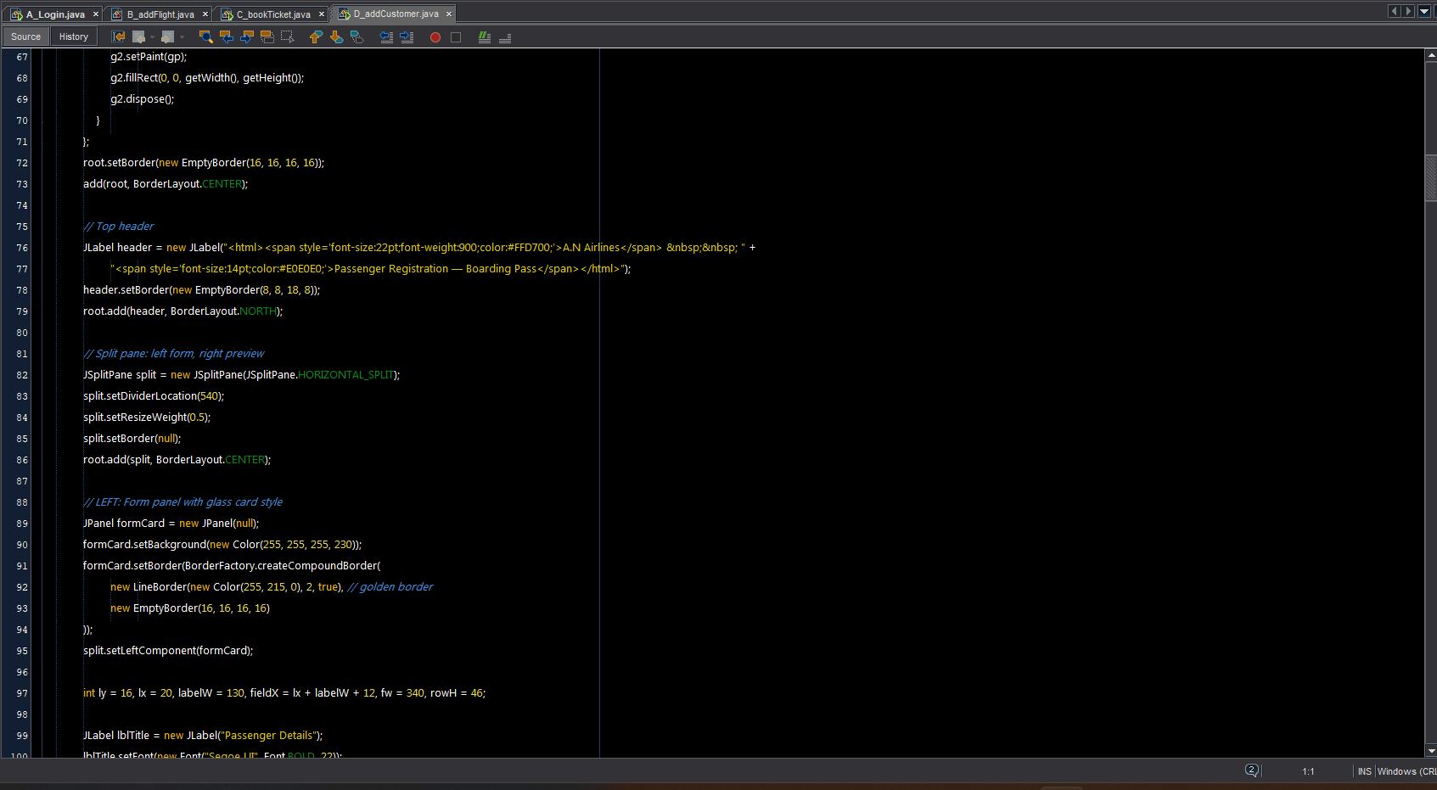

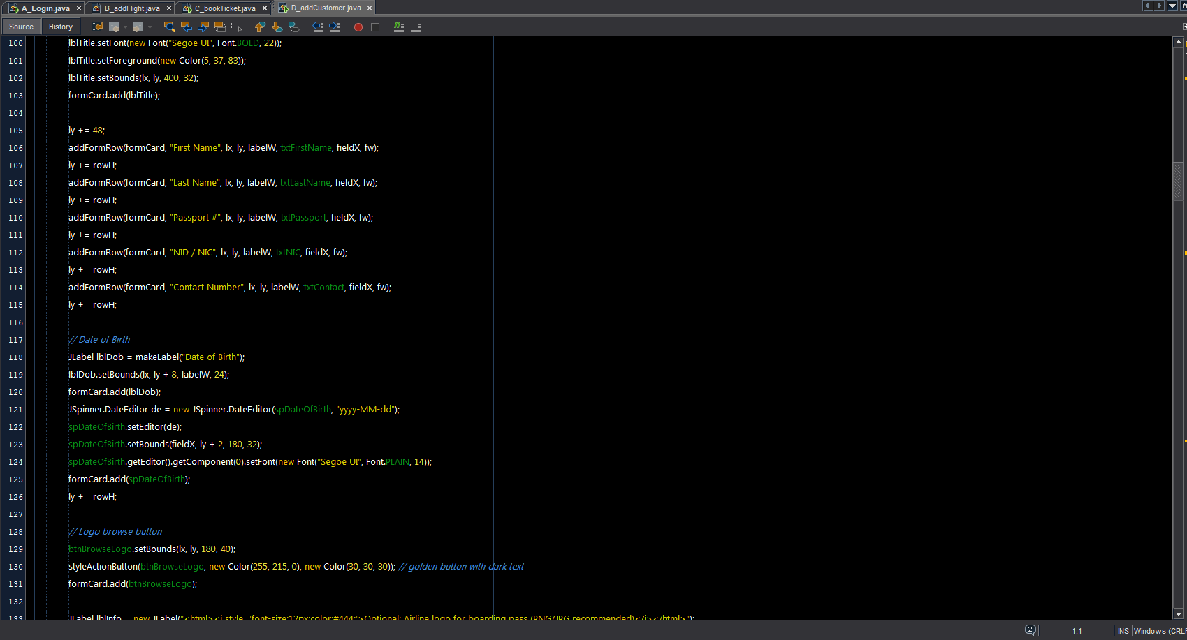

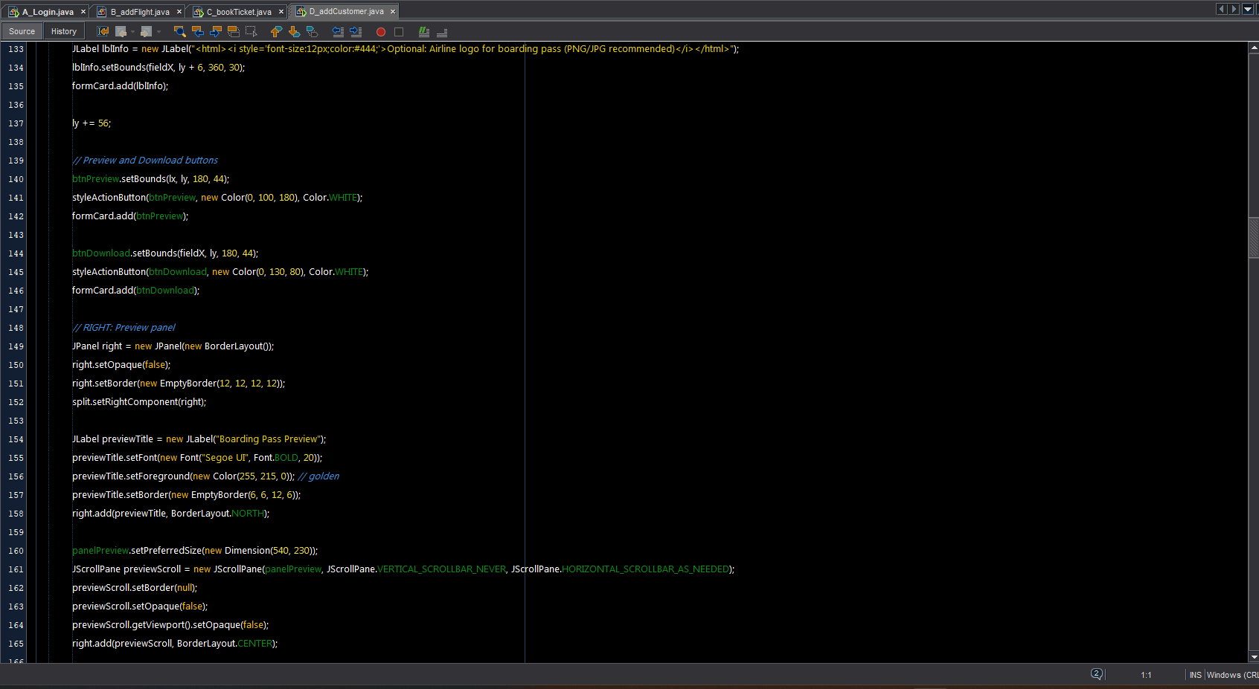

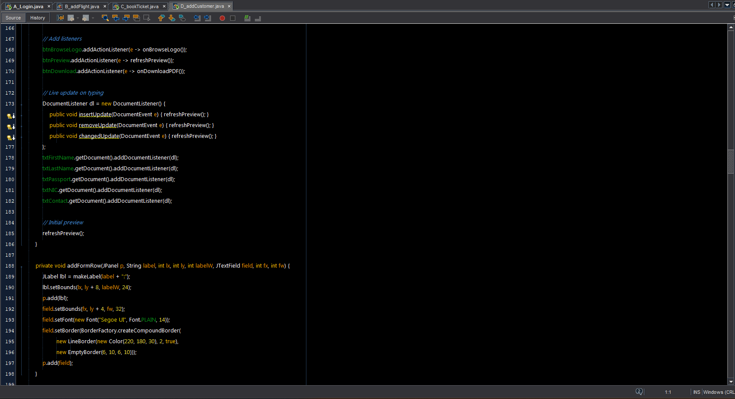

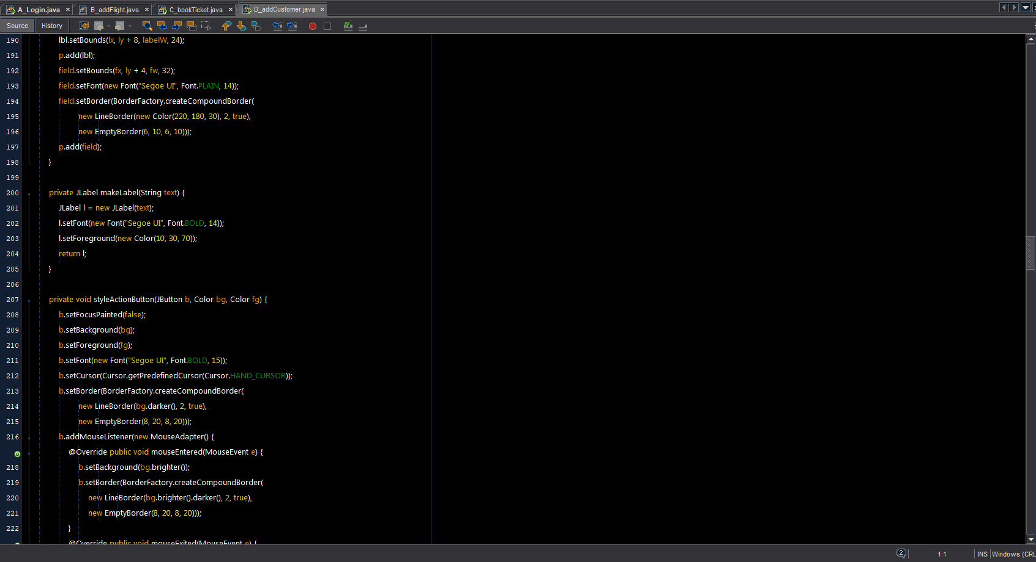

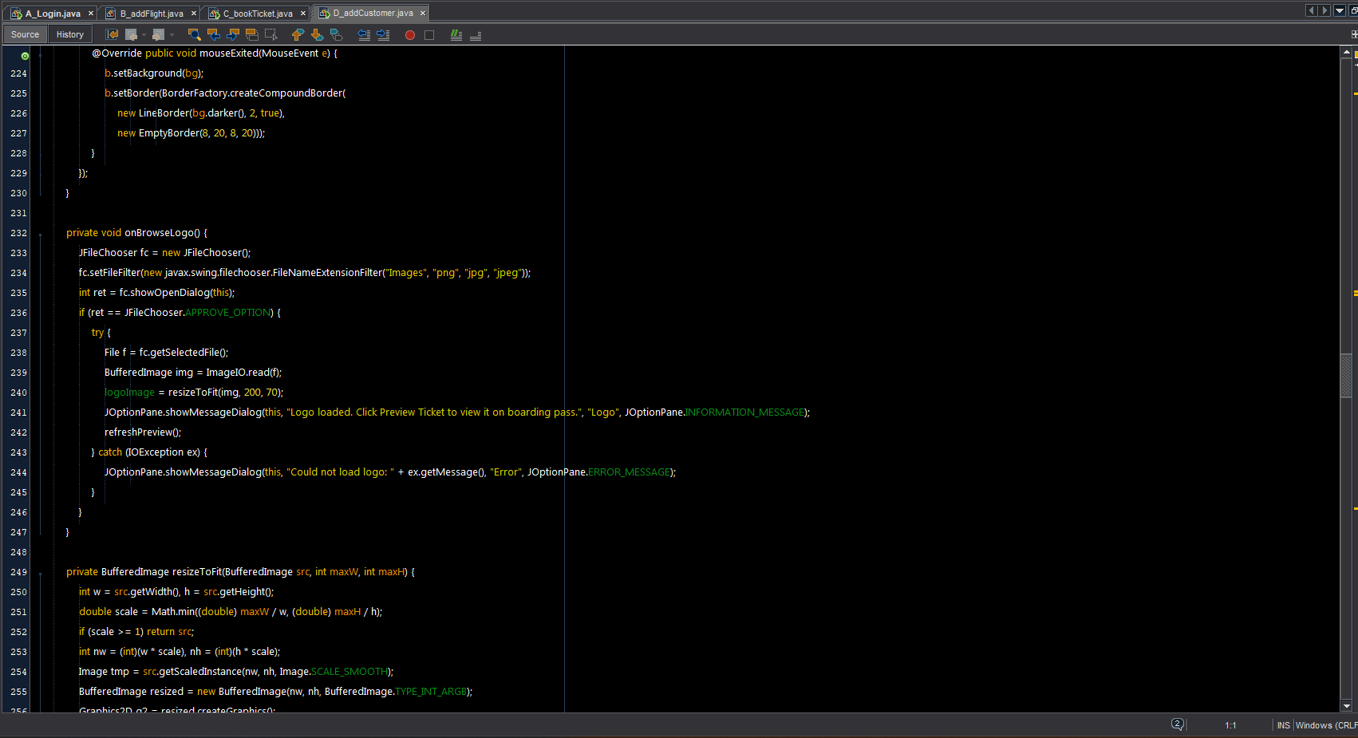

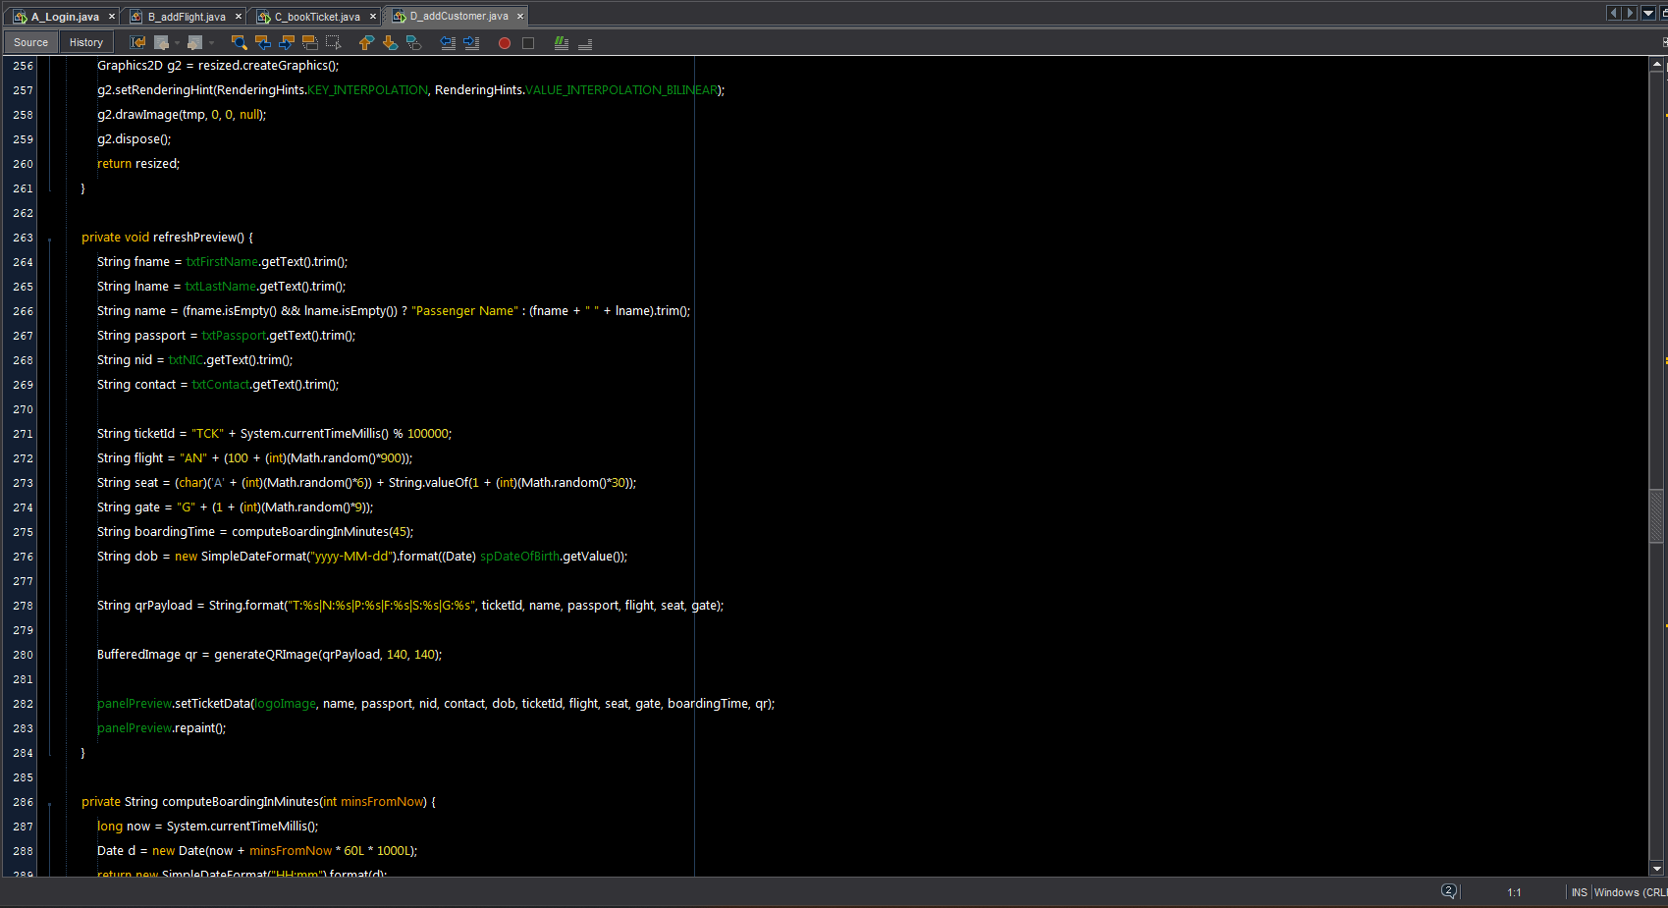

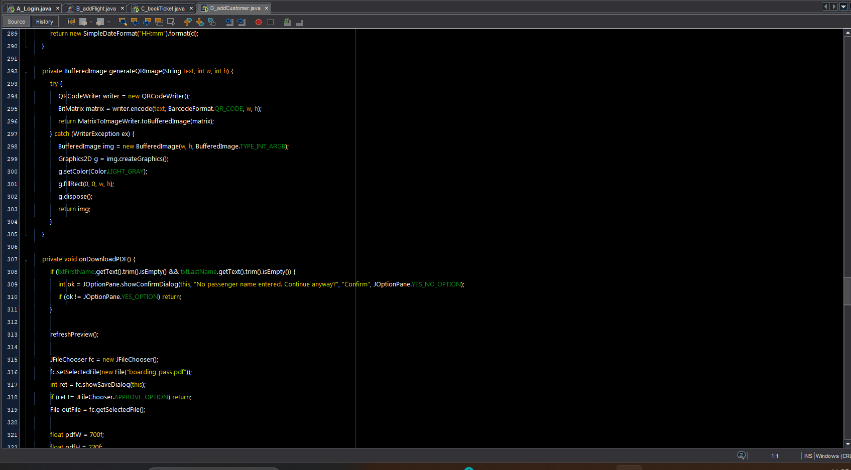

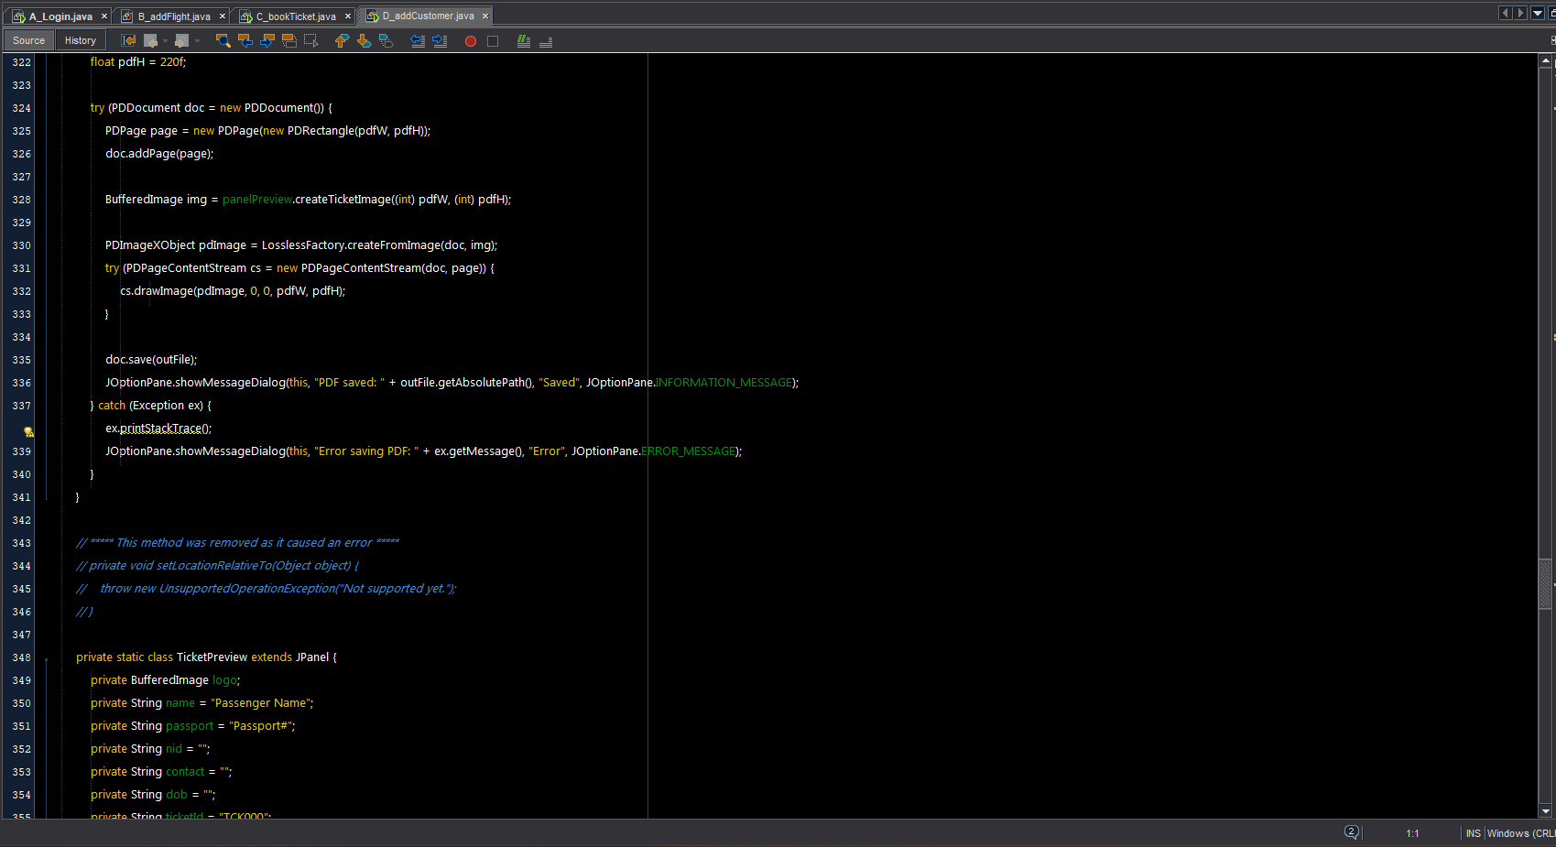

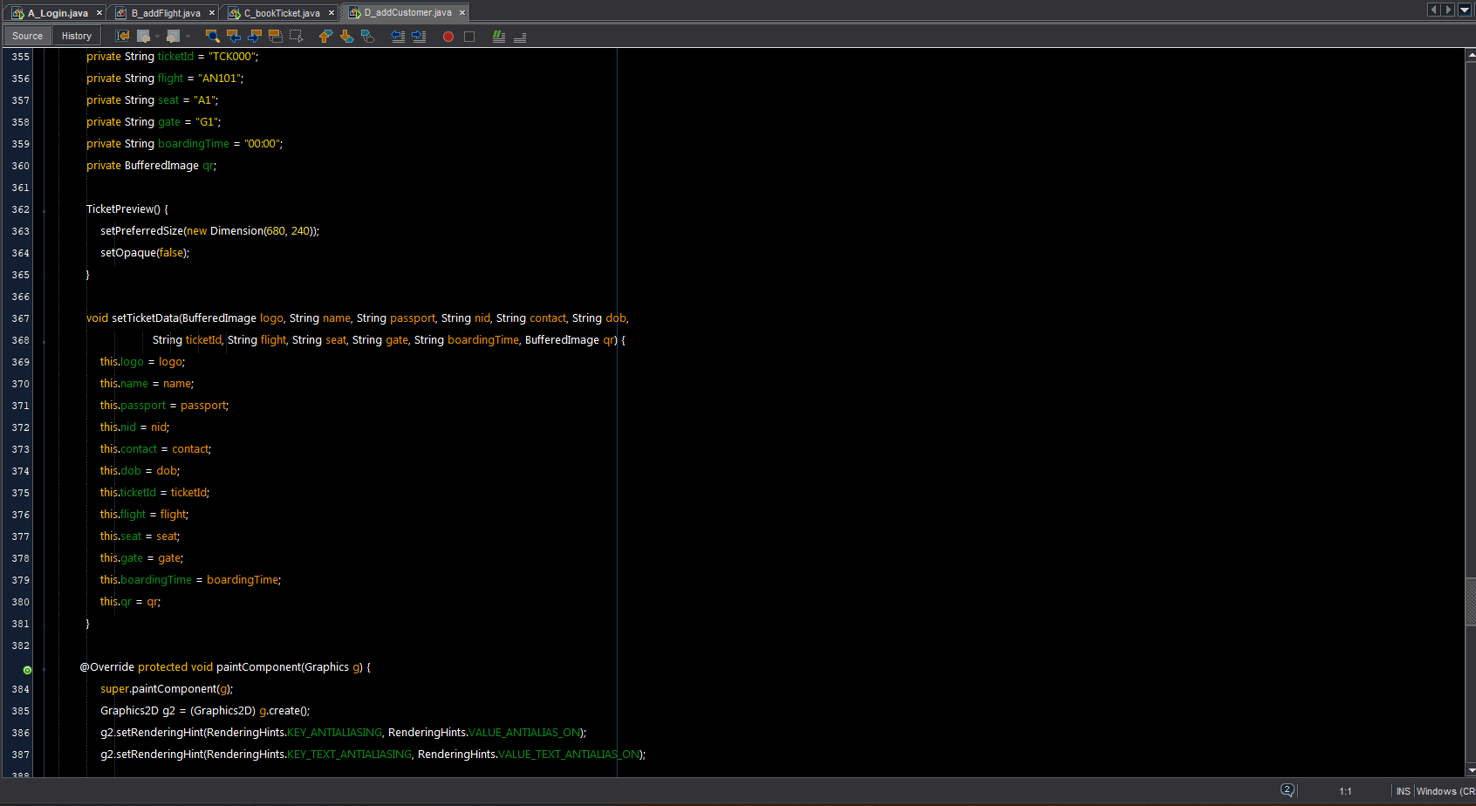

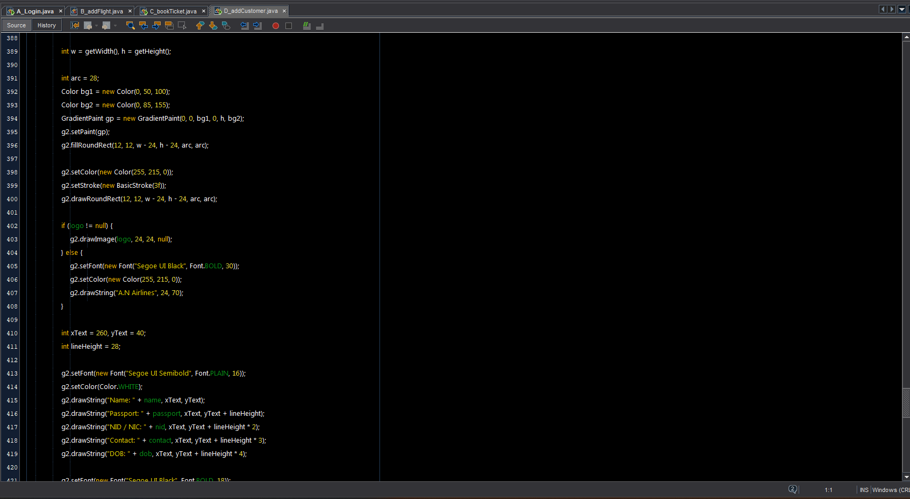

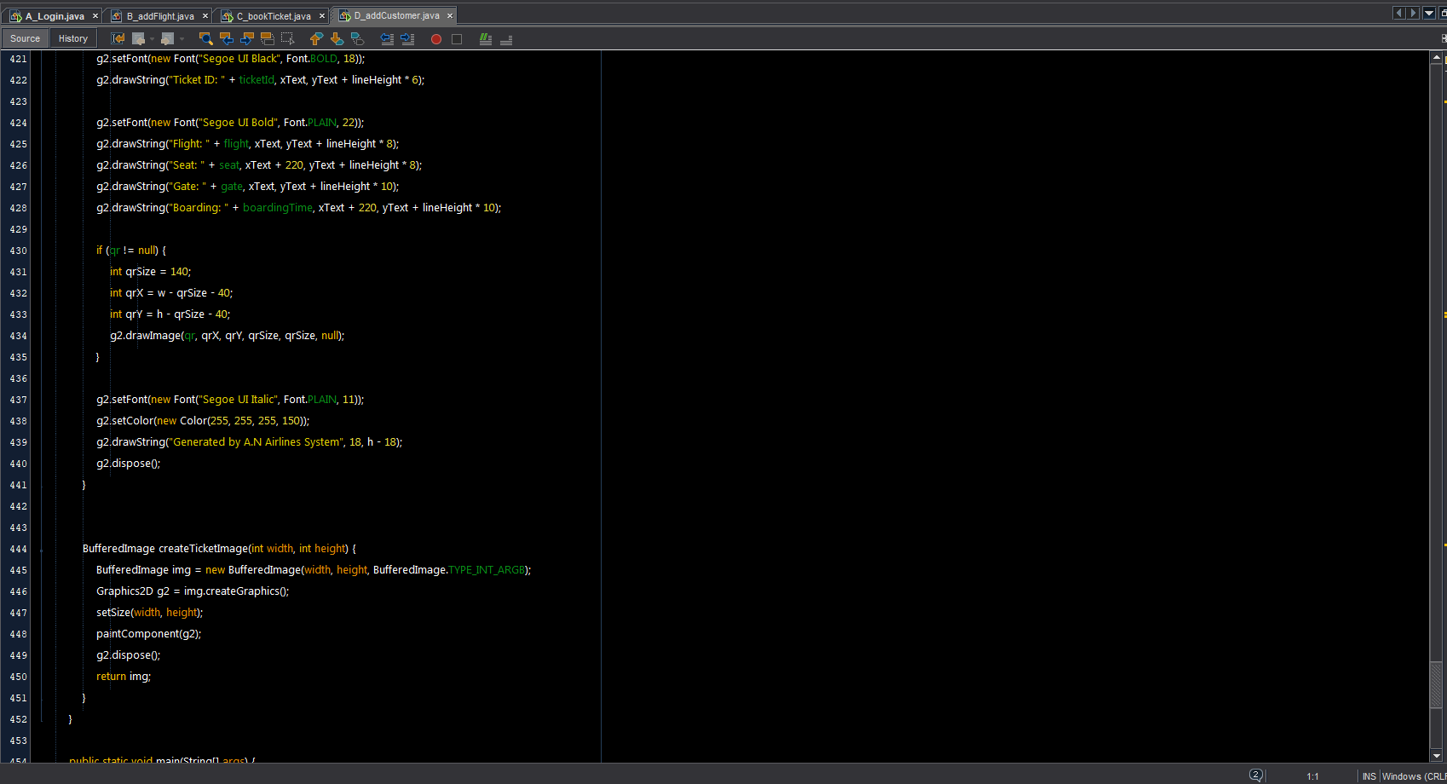

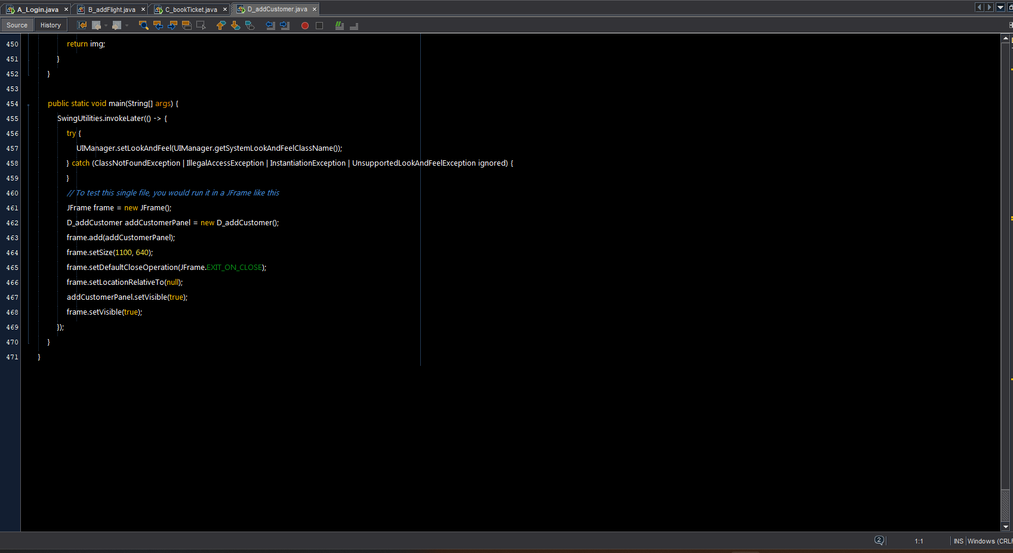

Devlopers.java

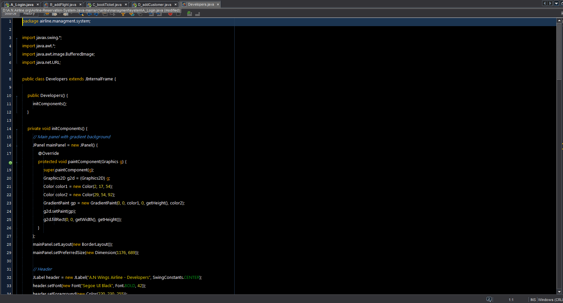

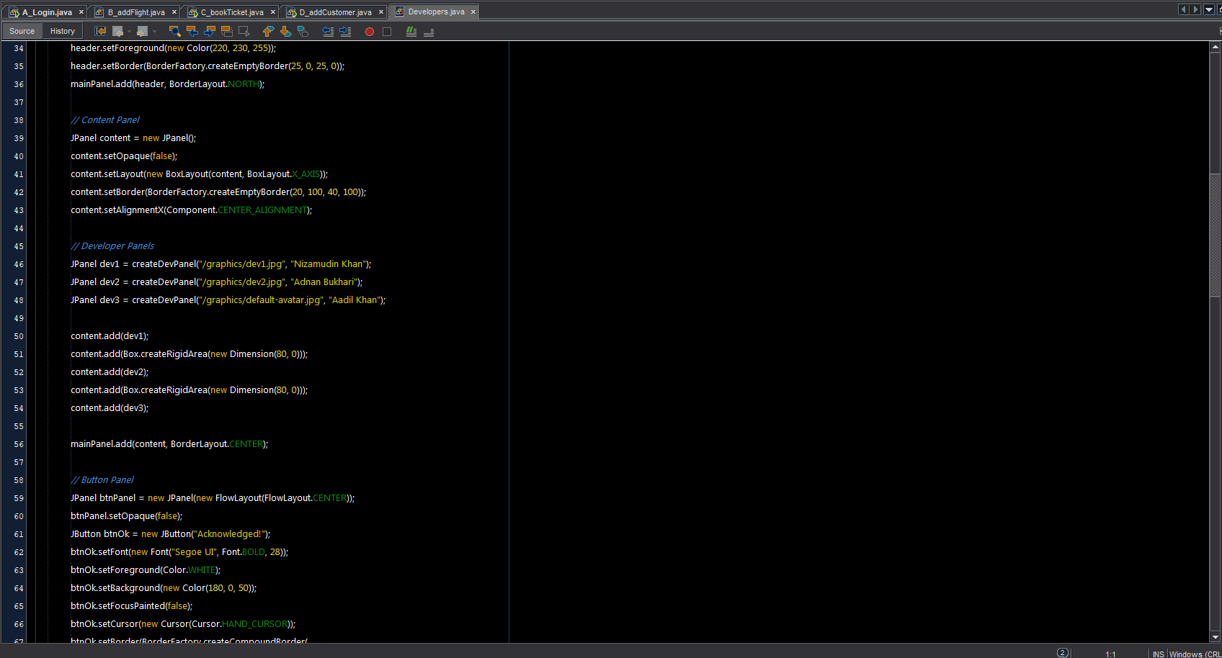

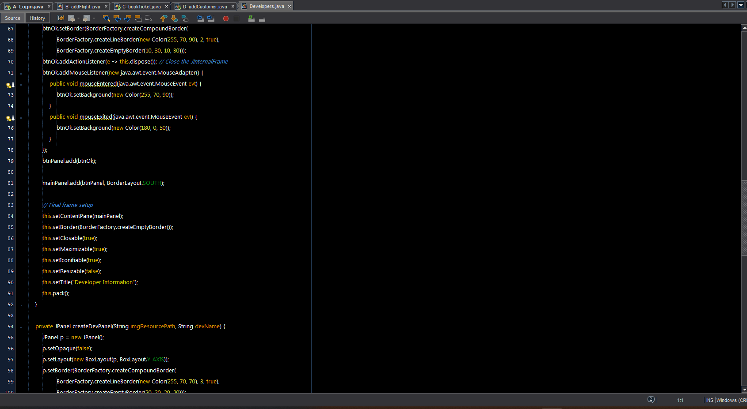

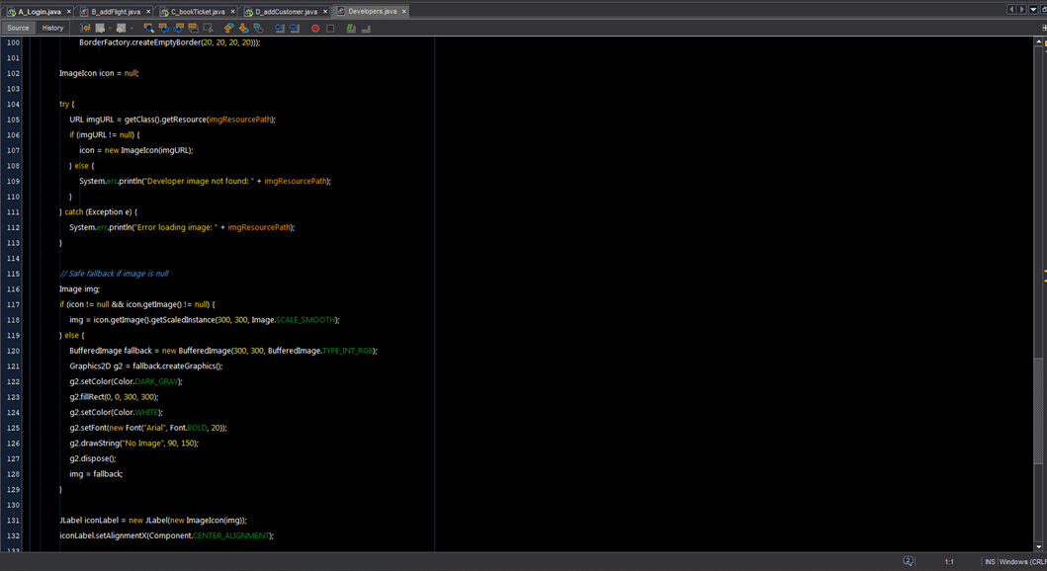

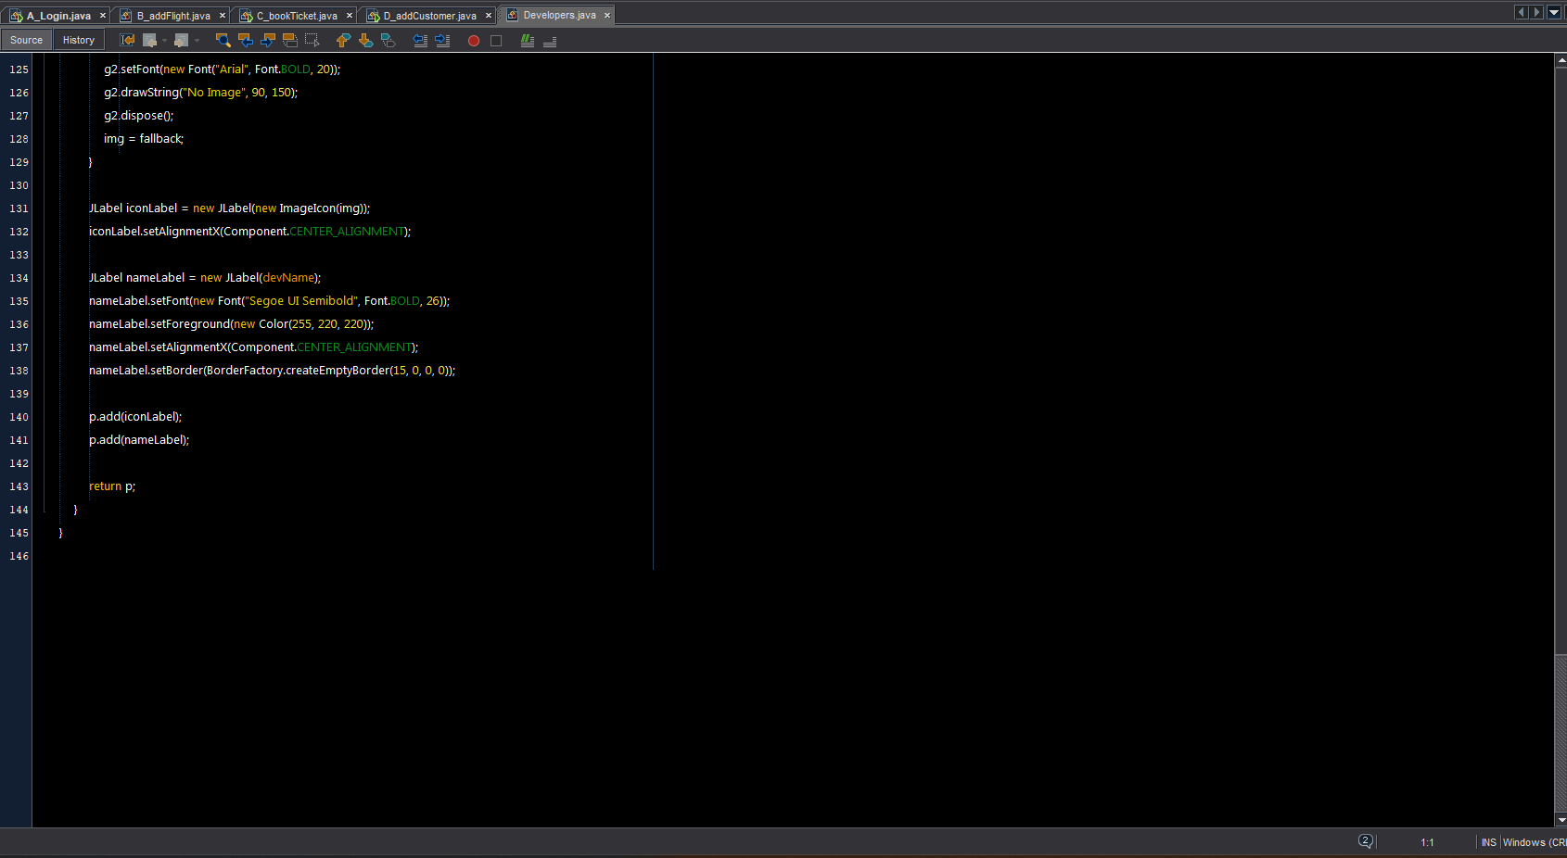

E_ticketReport.java

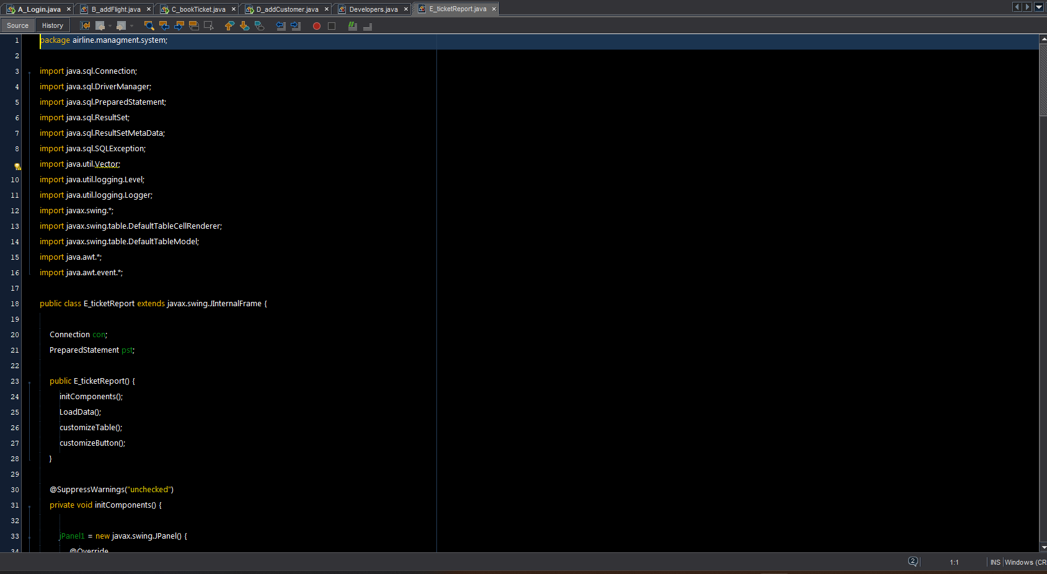

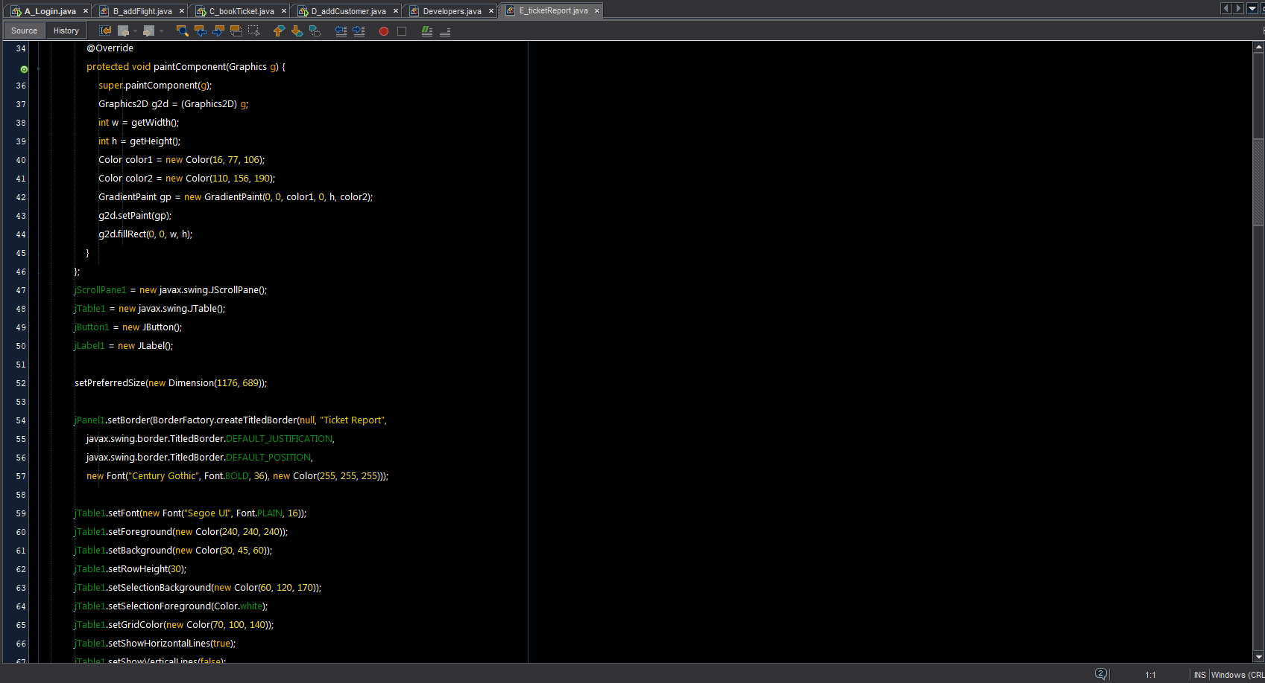

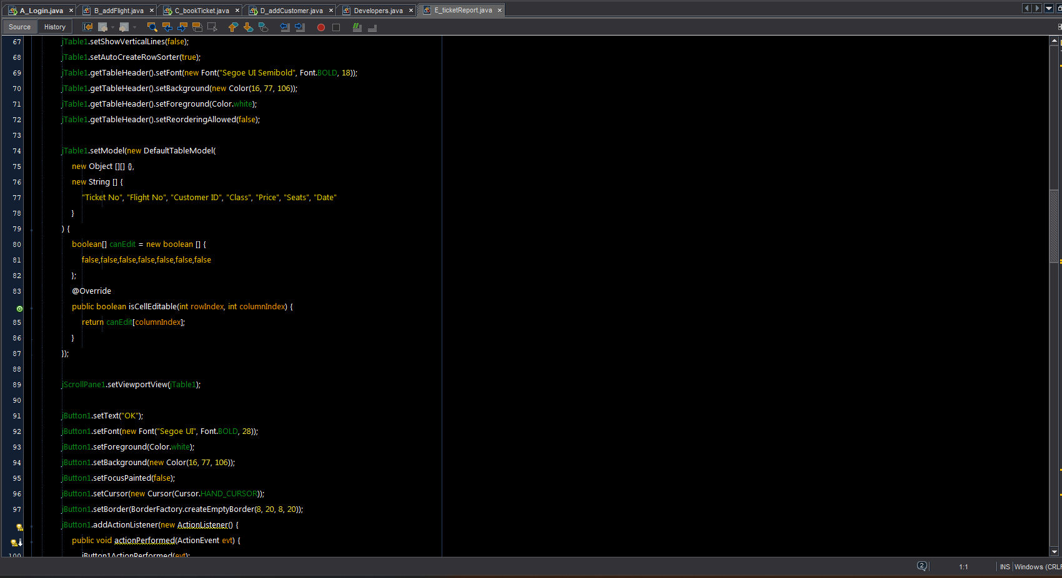

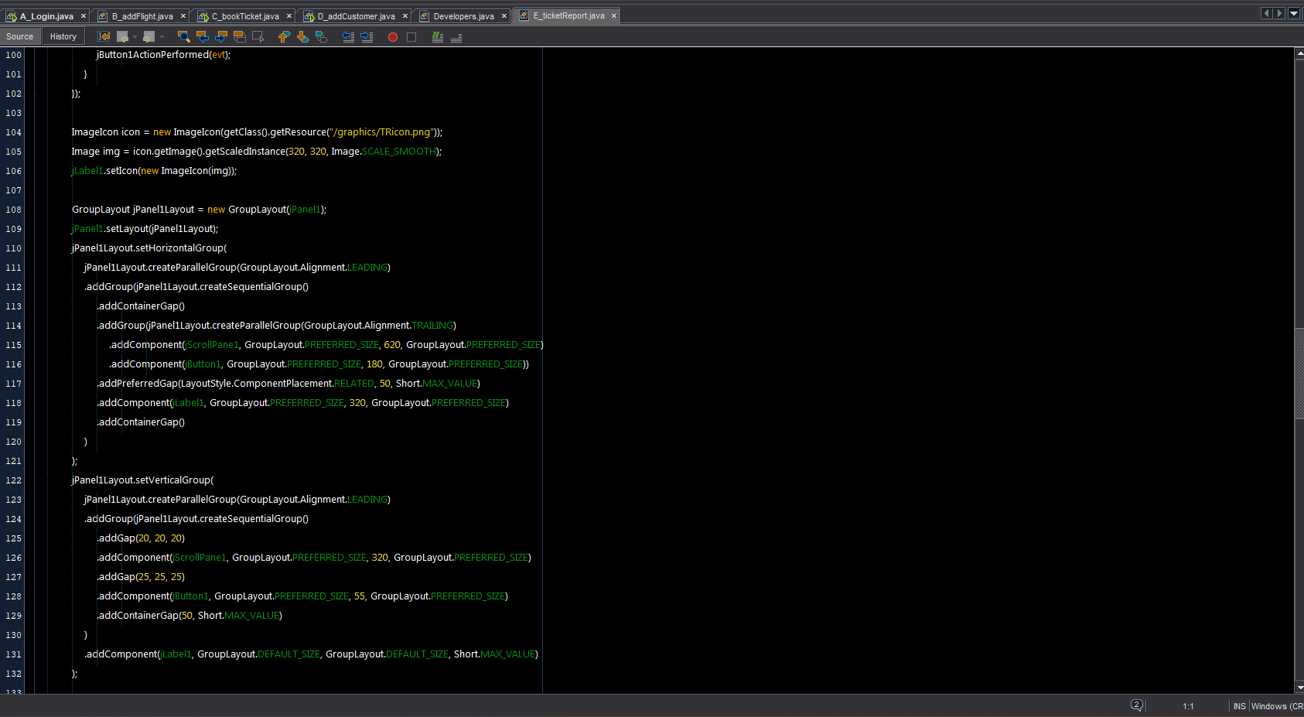

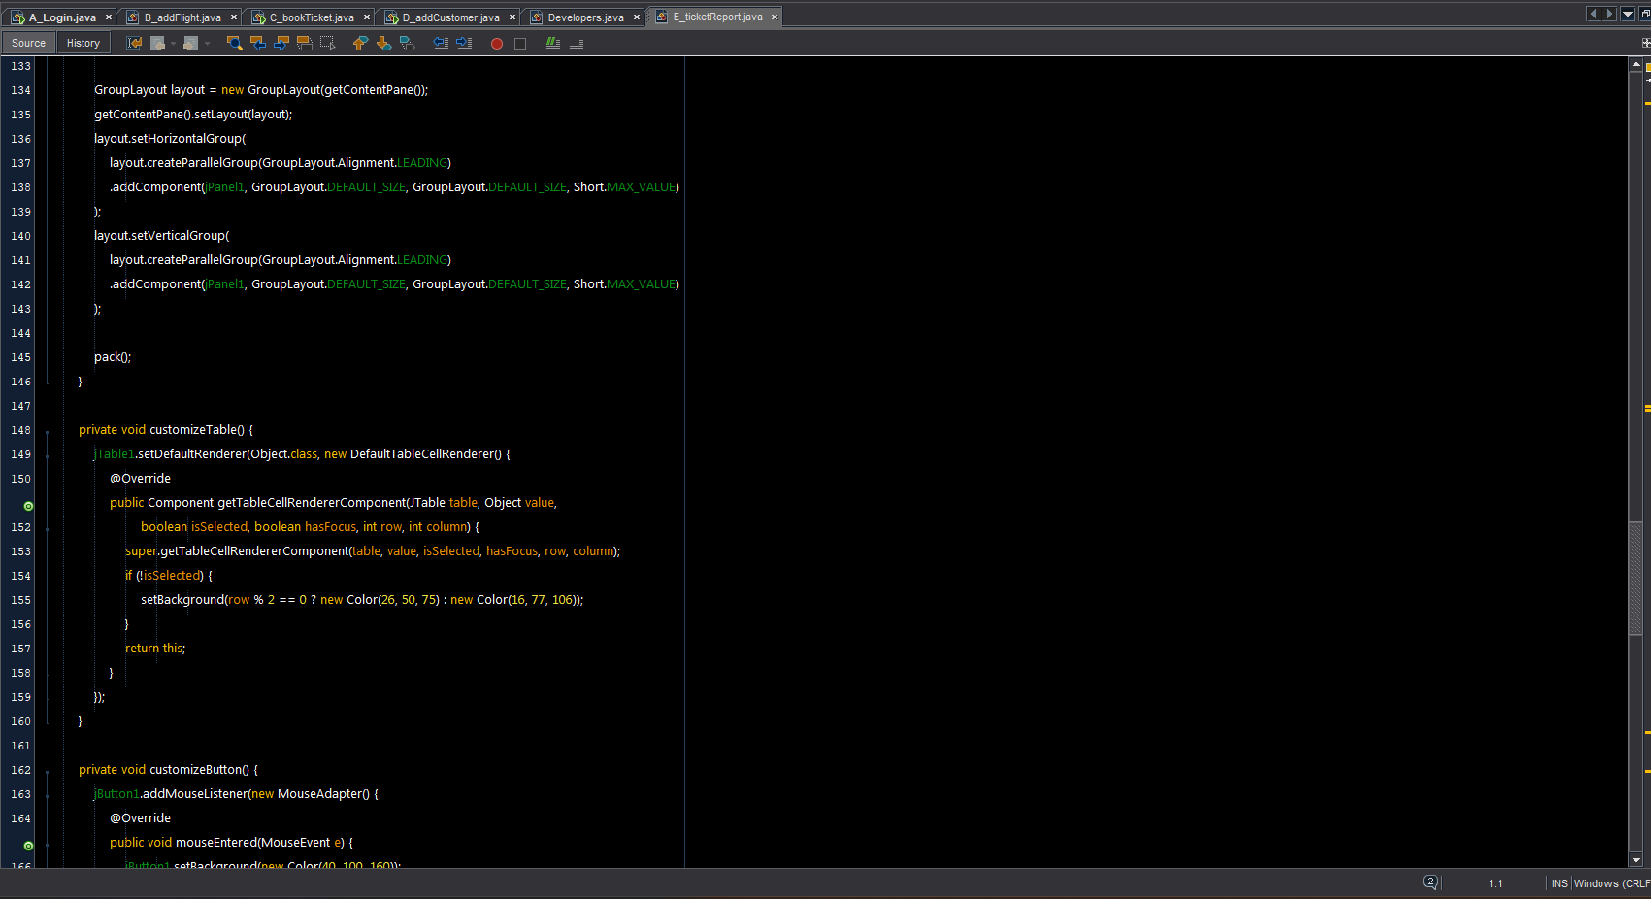

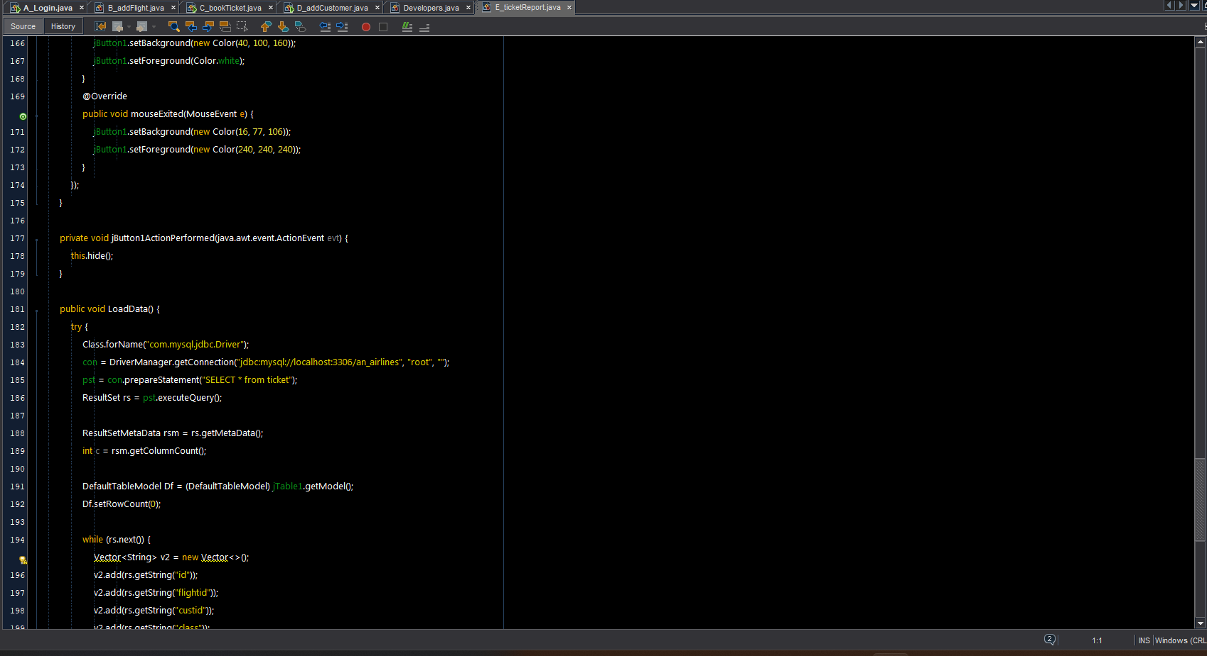

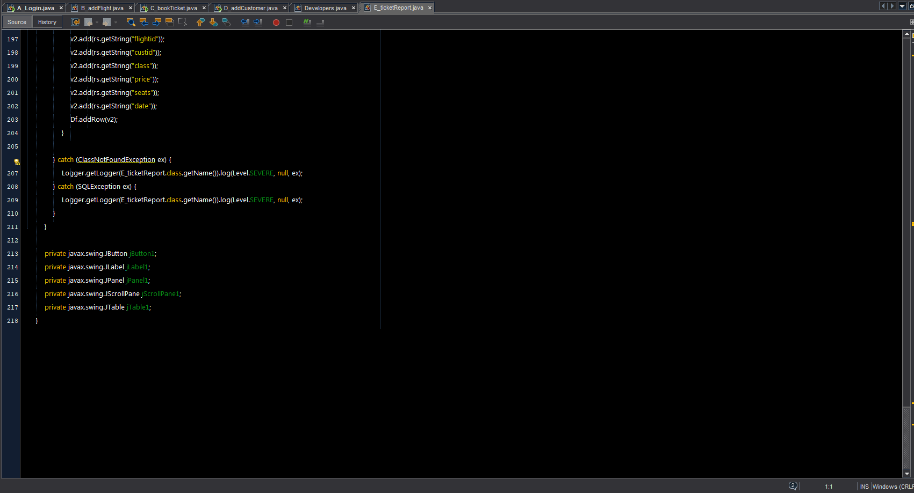

Main.java

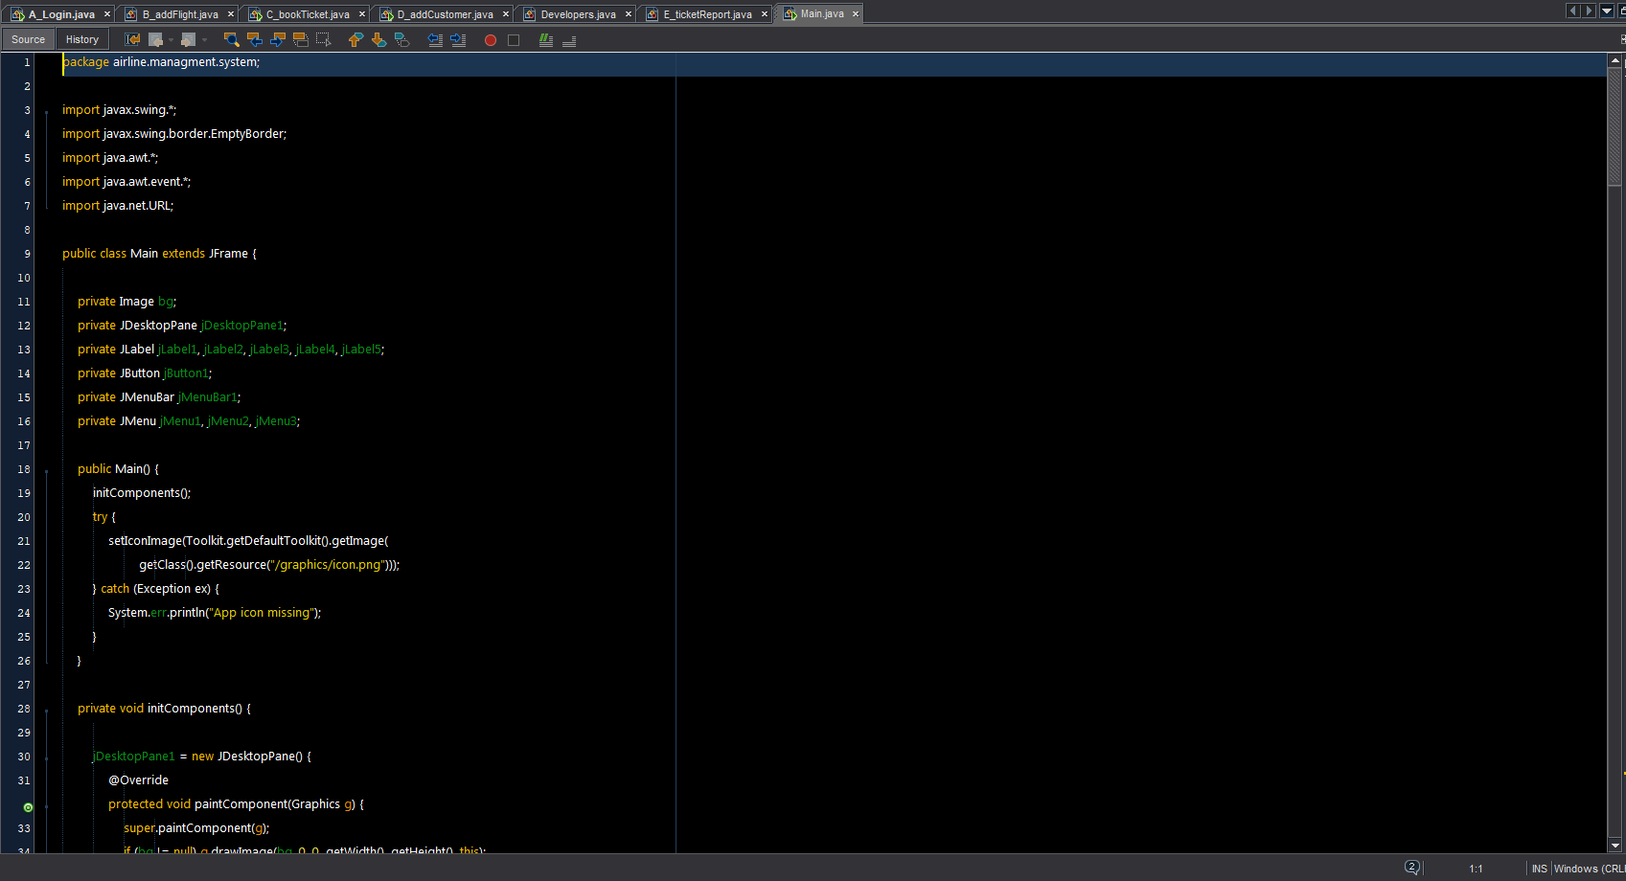

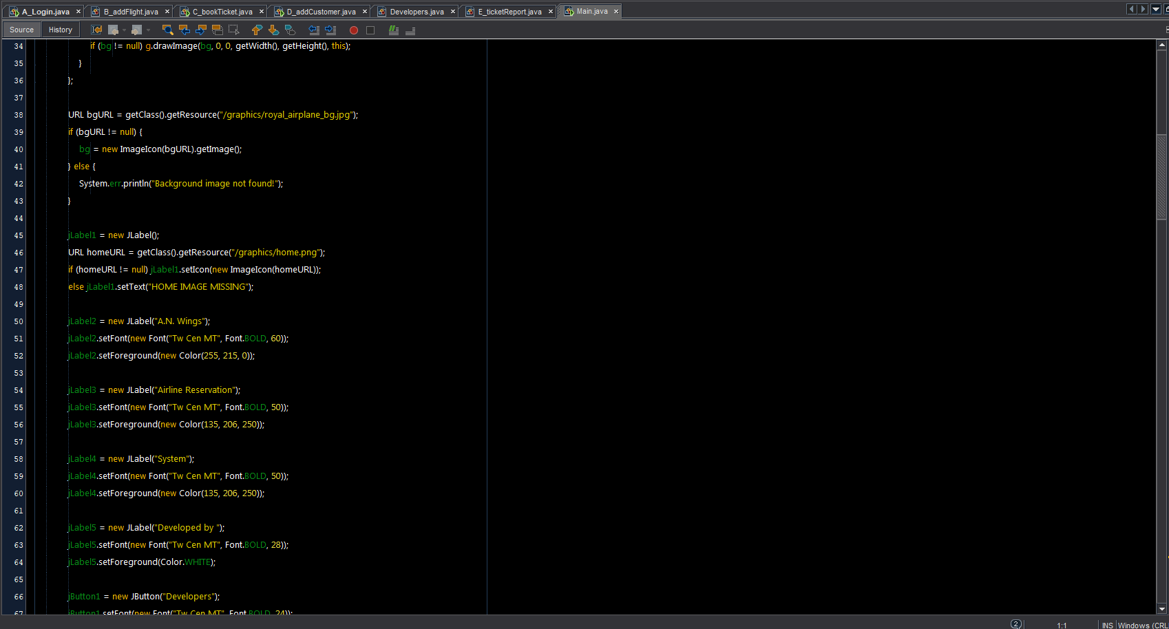

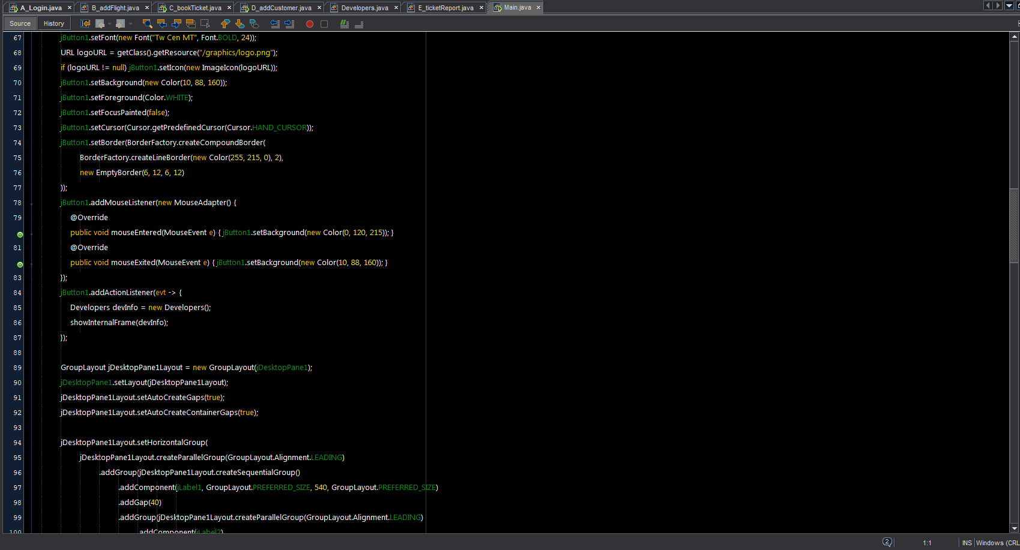

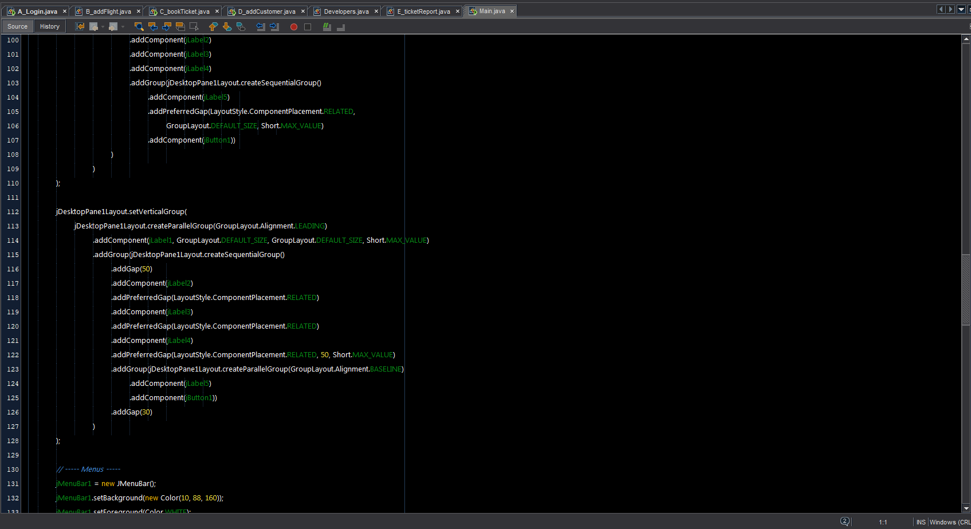

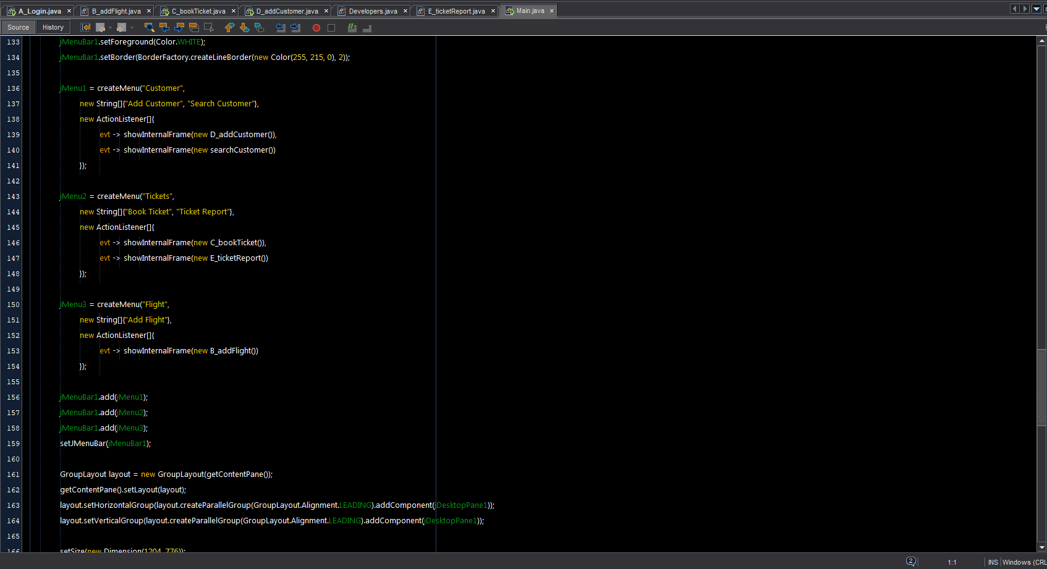

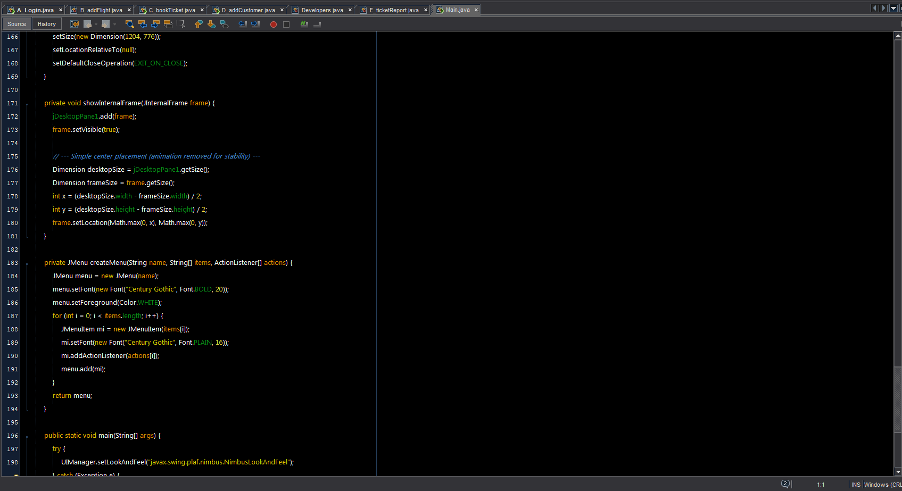

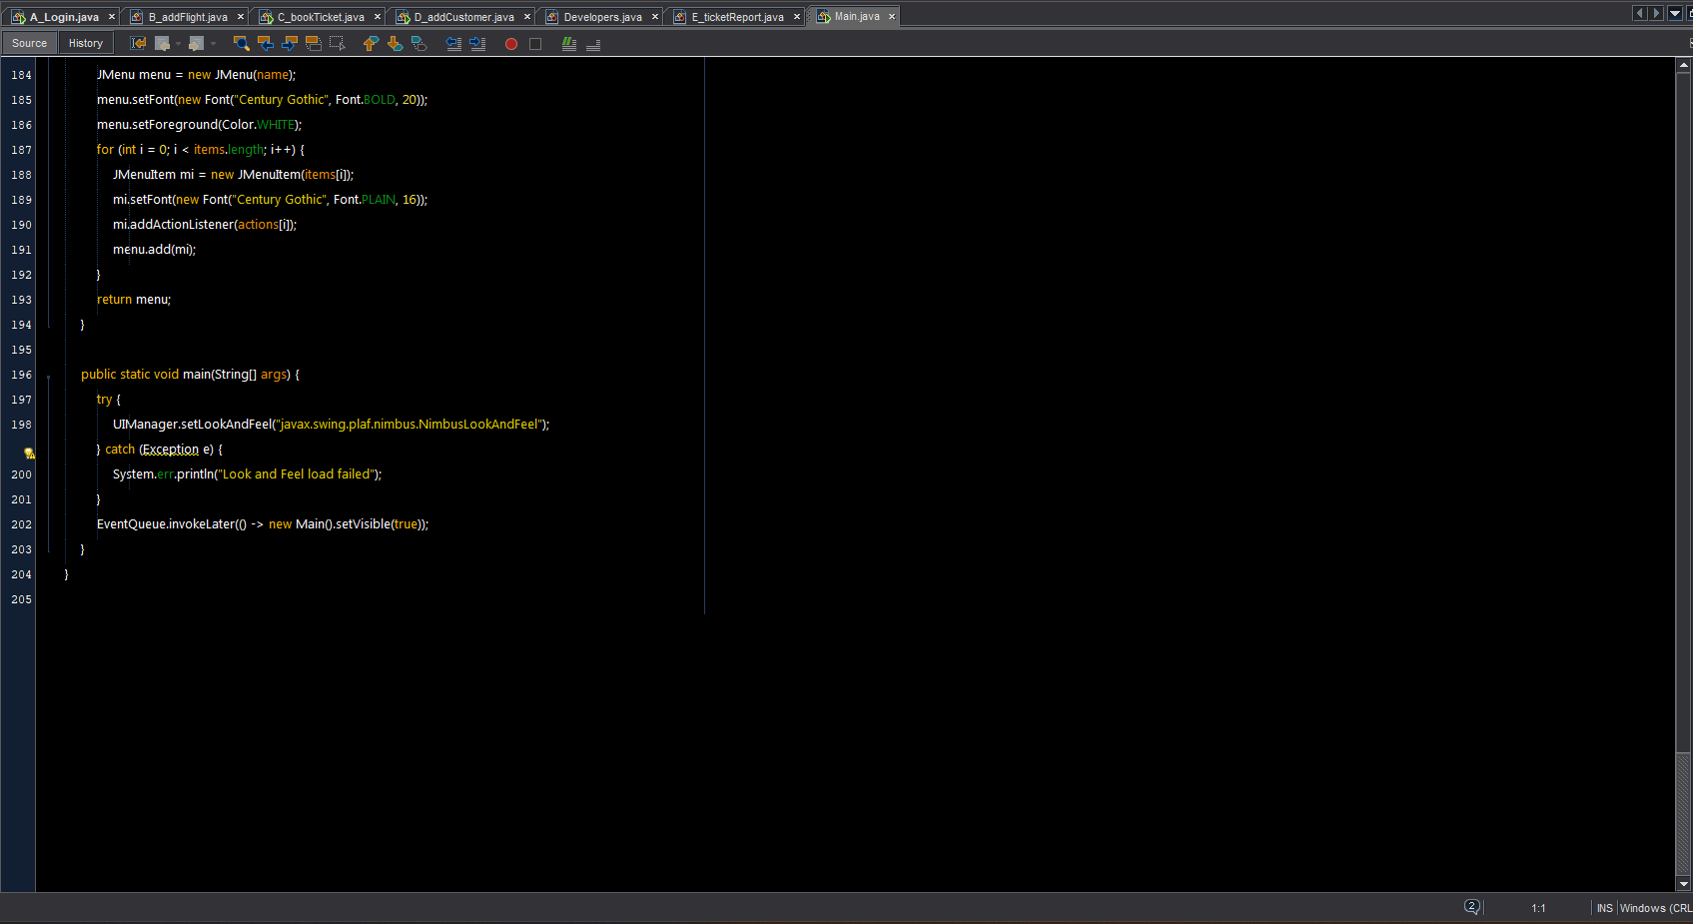

SearchCustomer.java

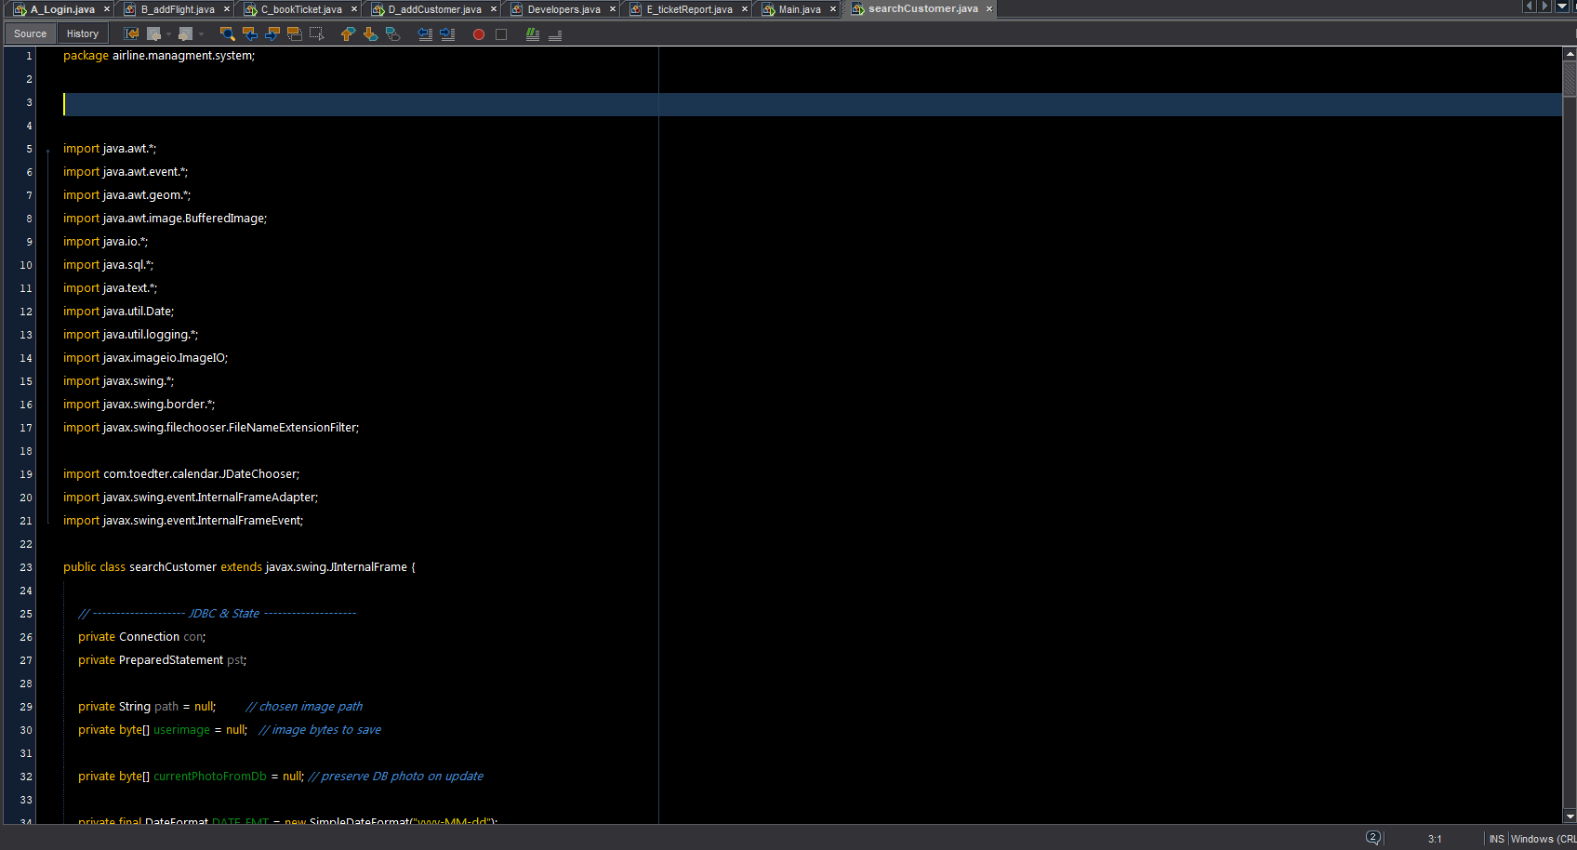

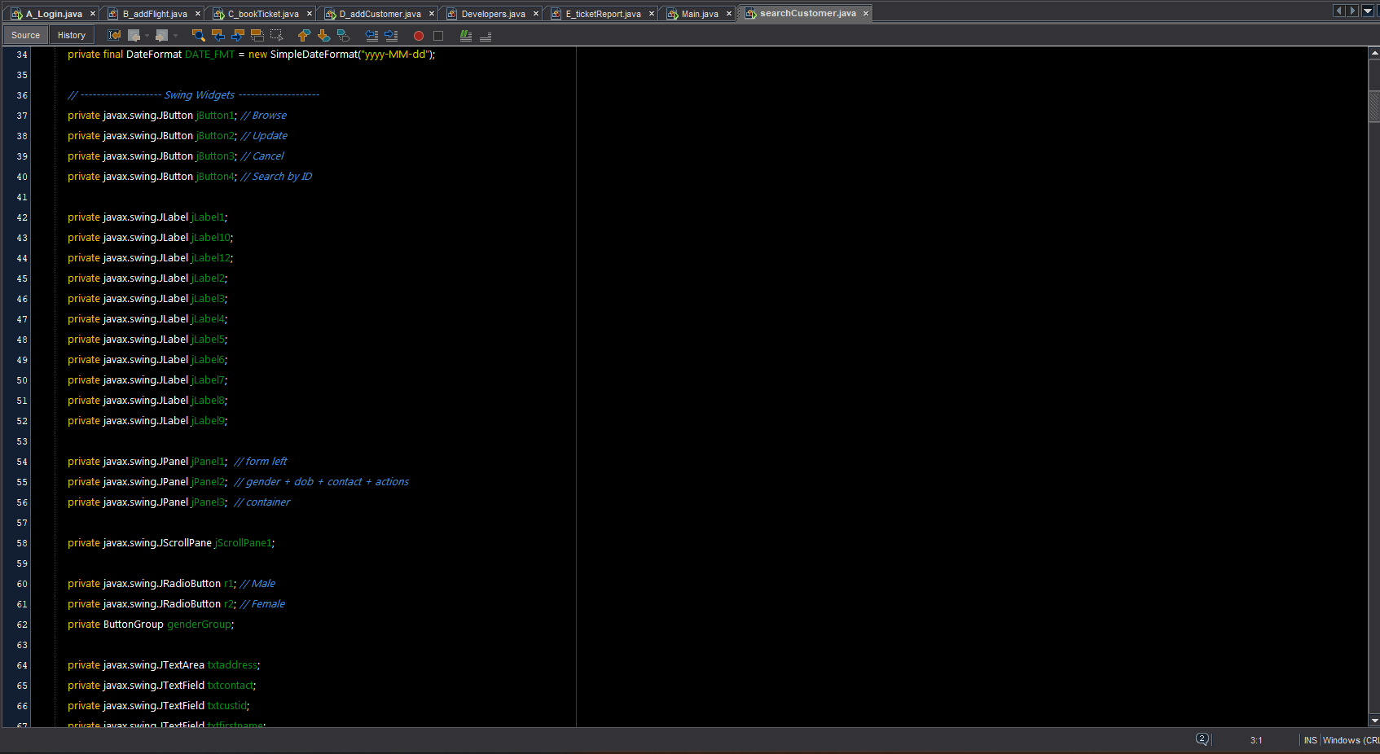

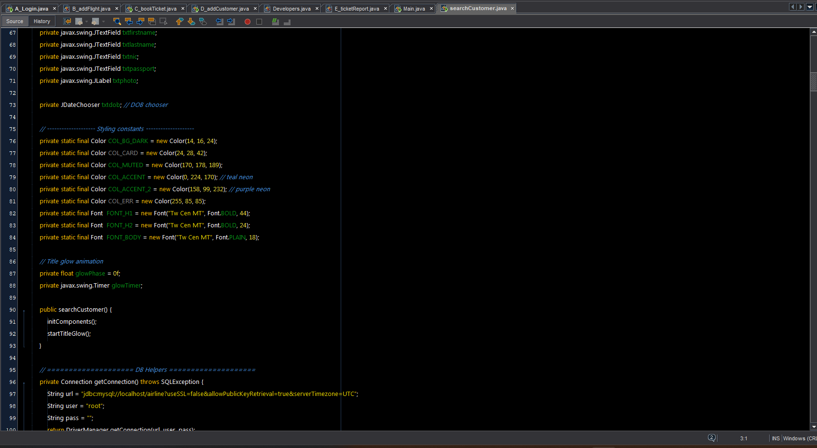

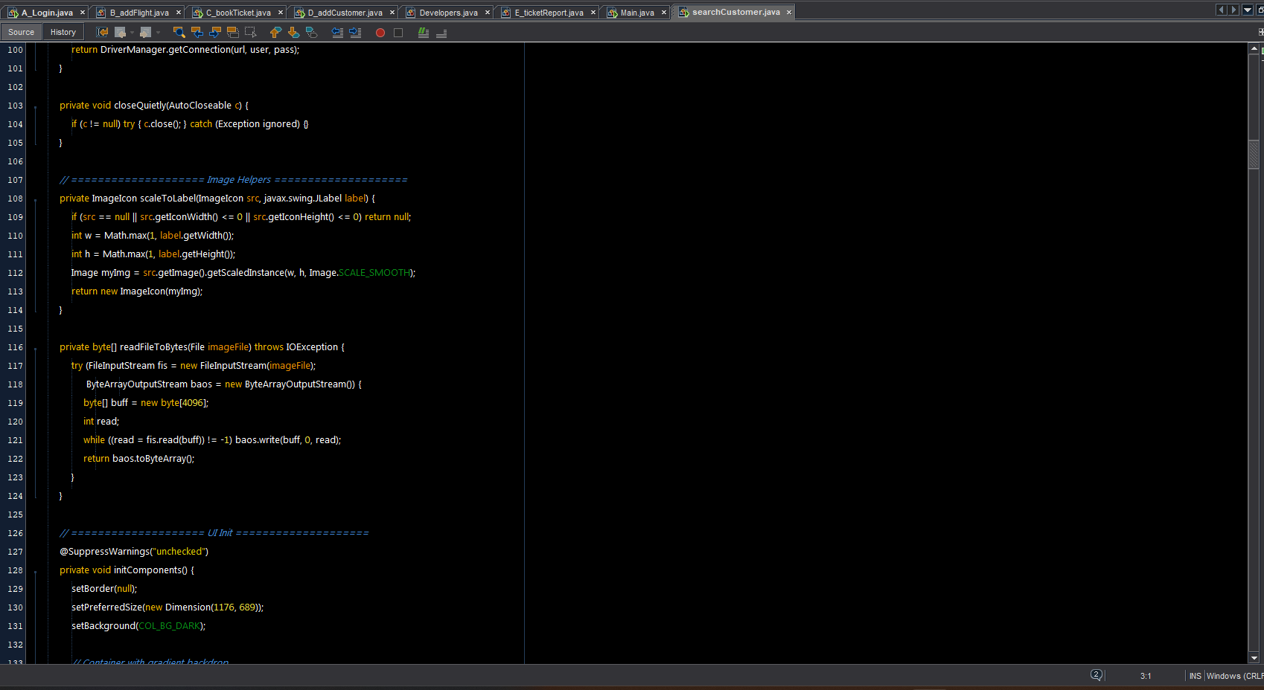

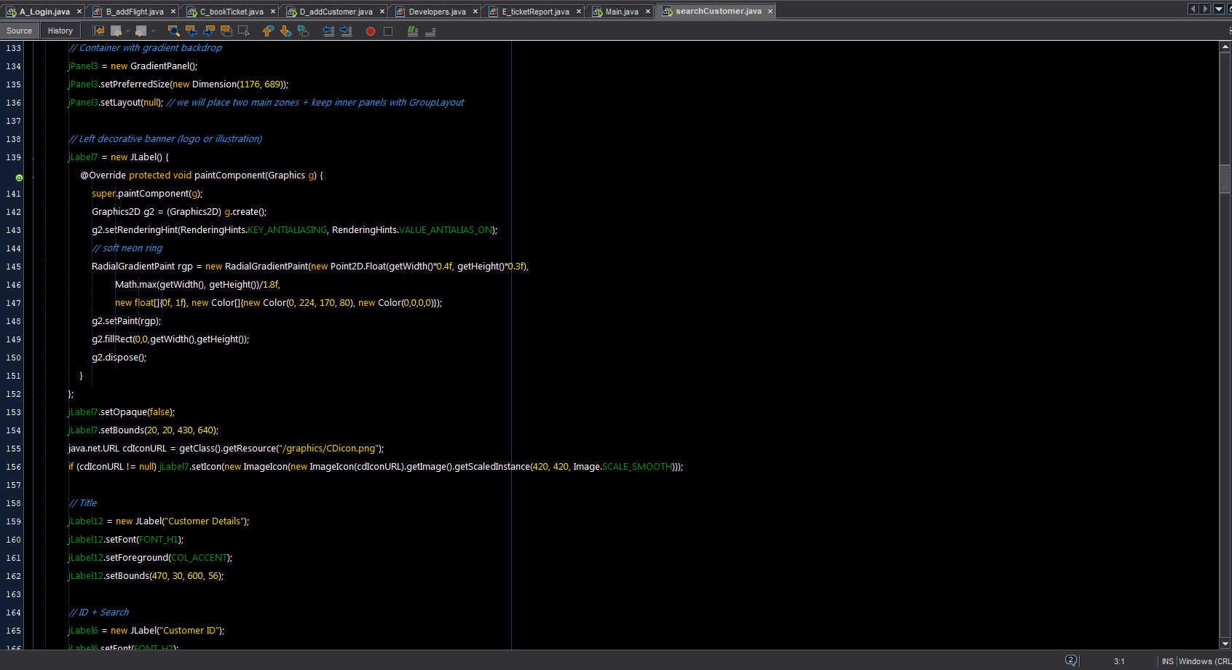

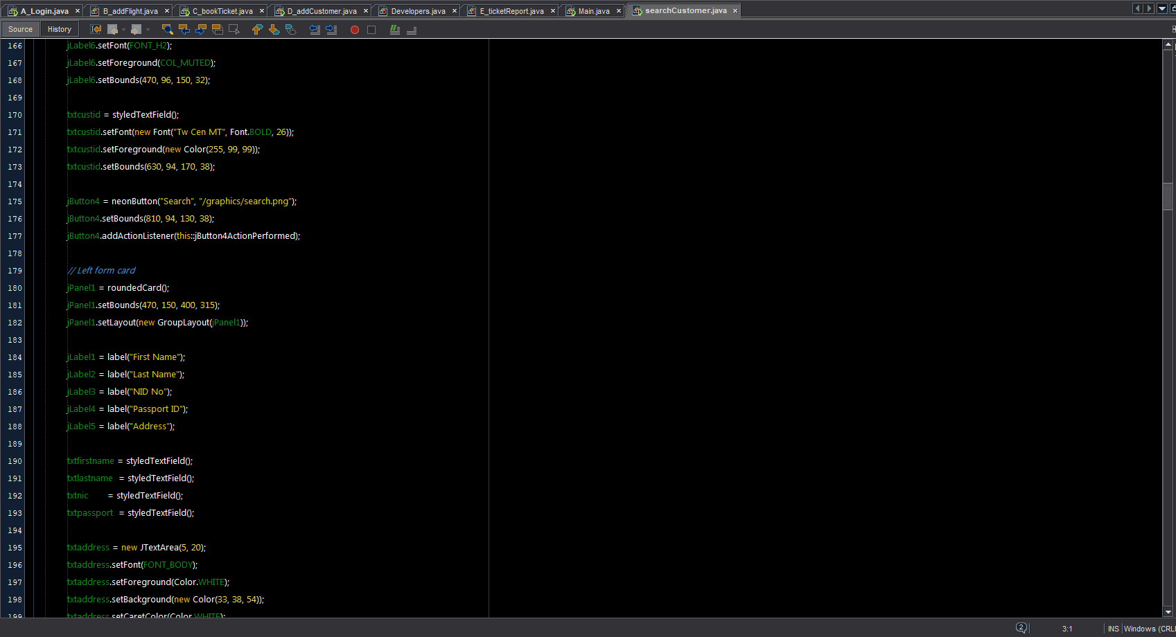

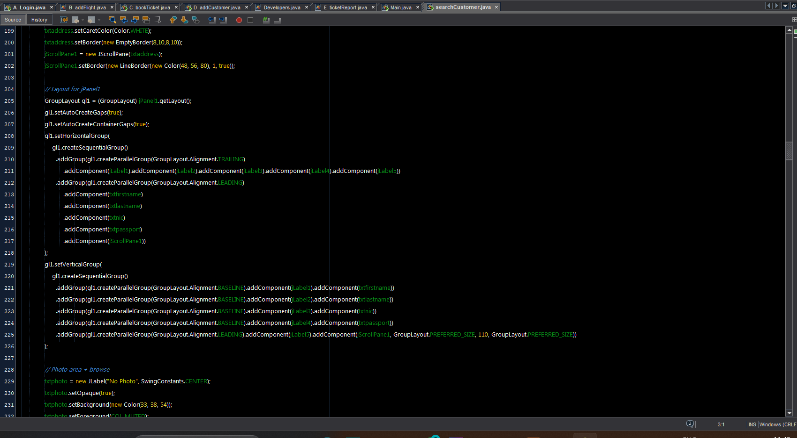

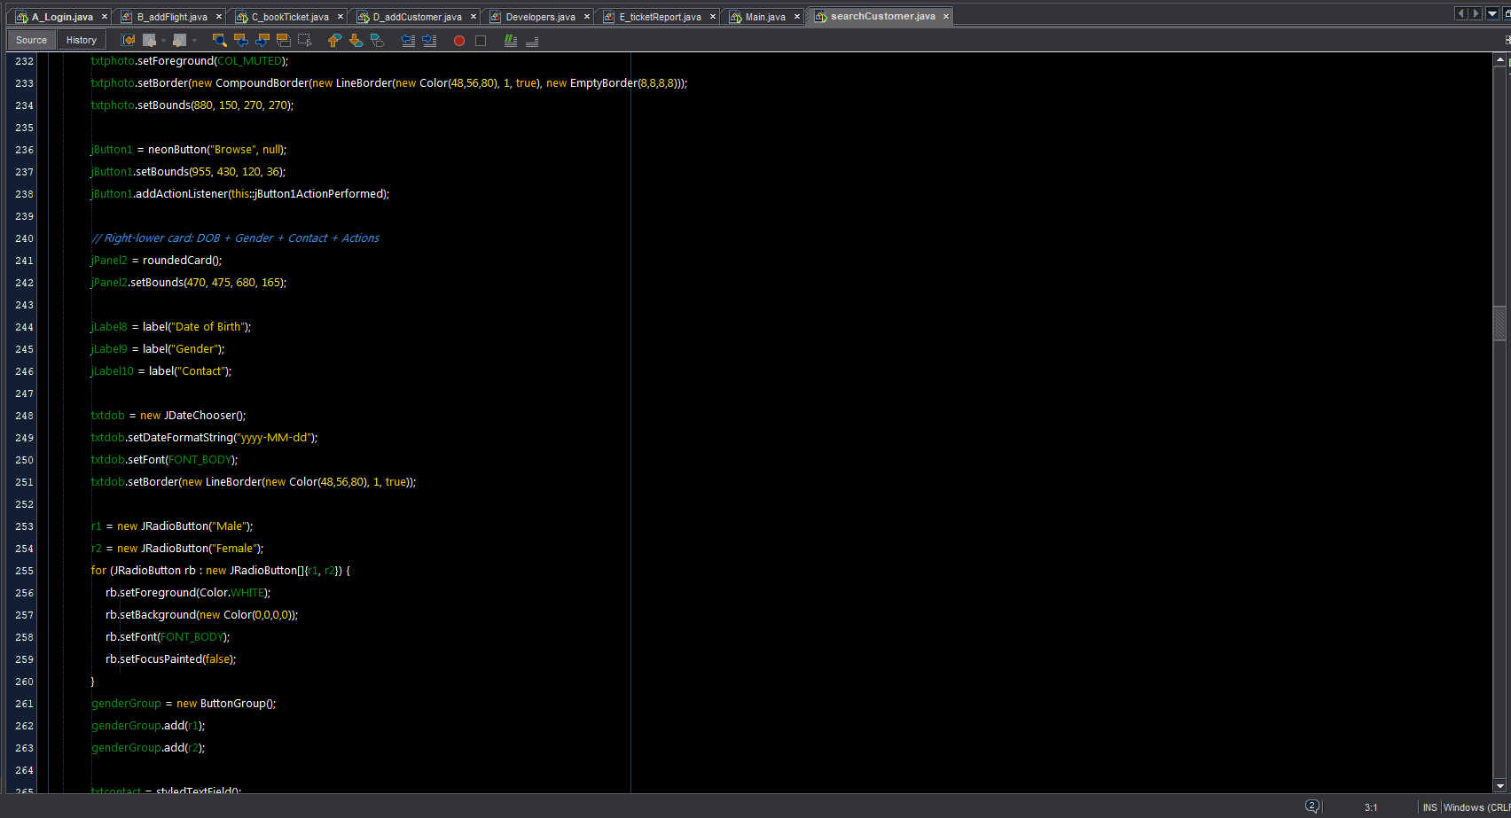

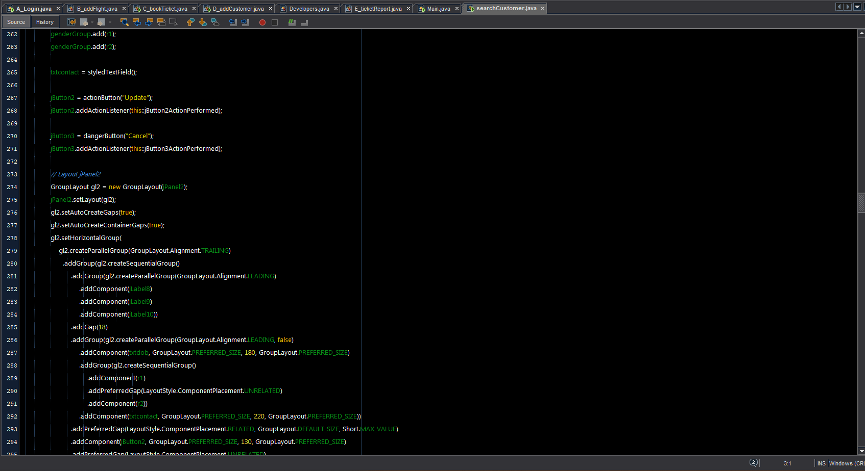

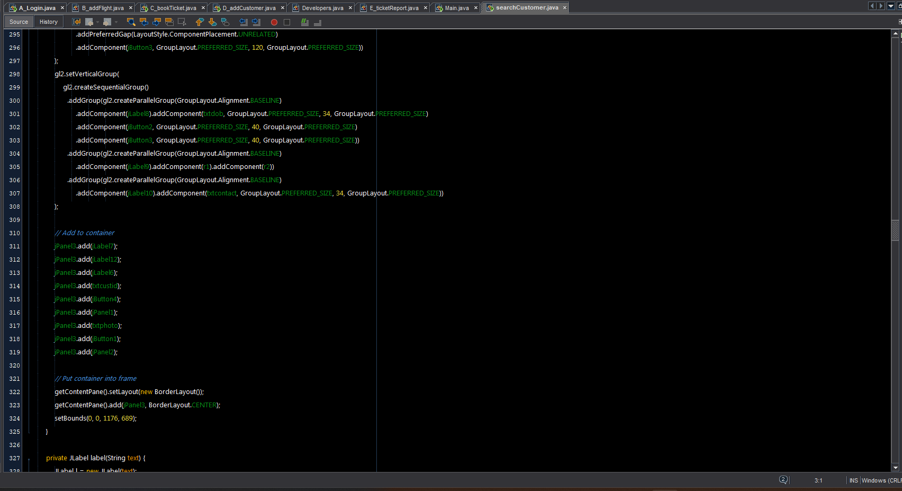

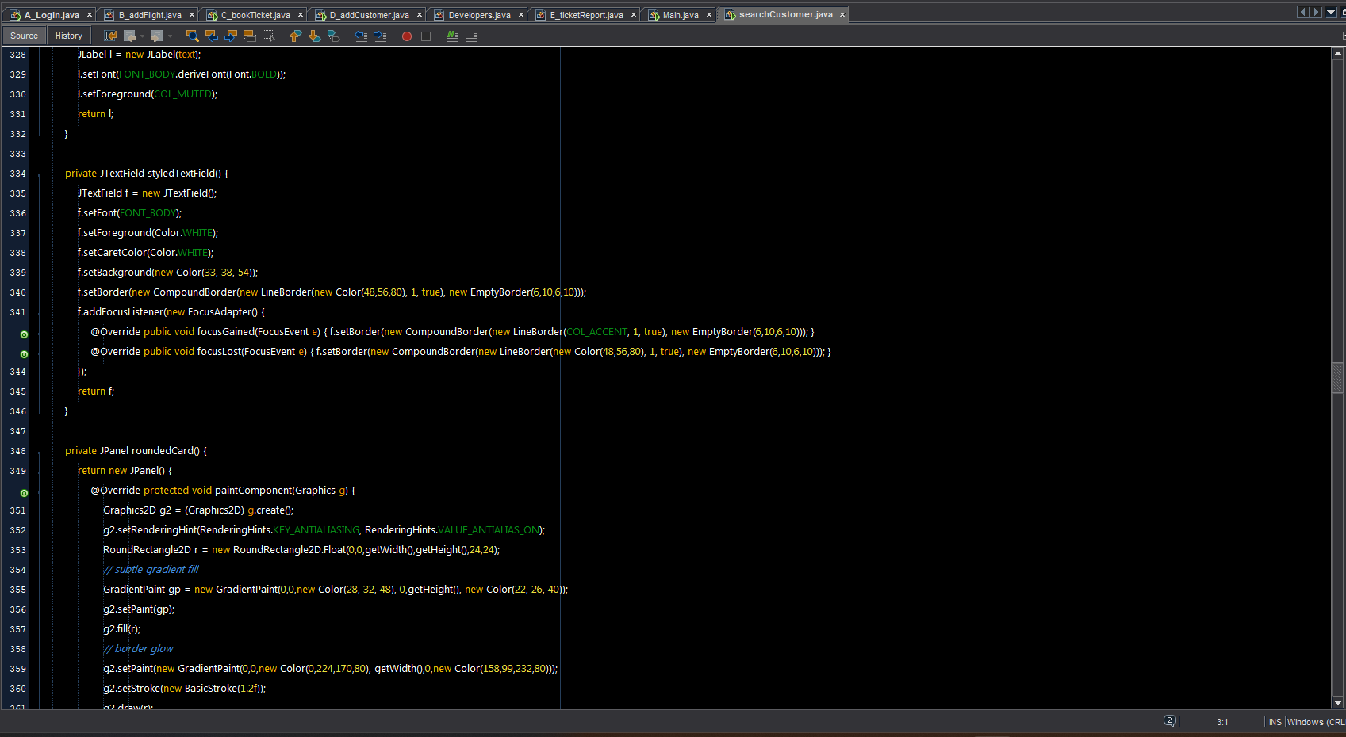

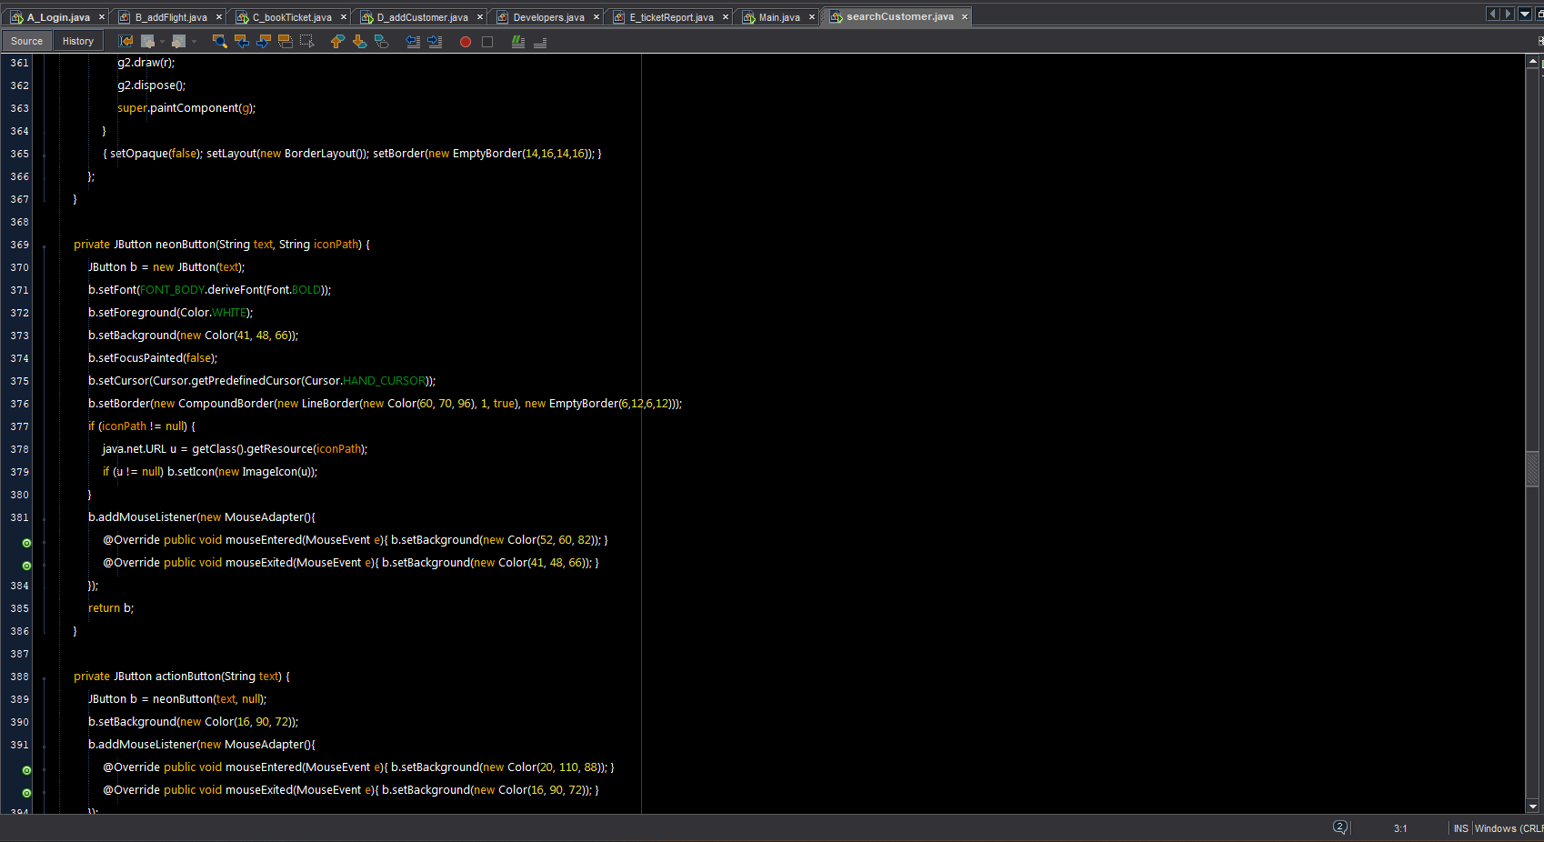

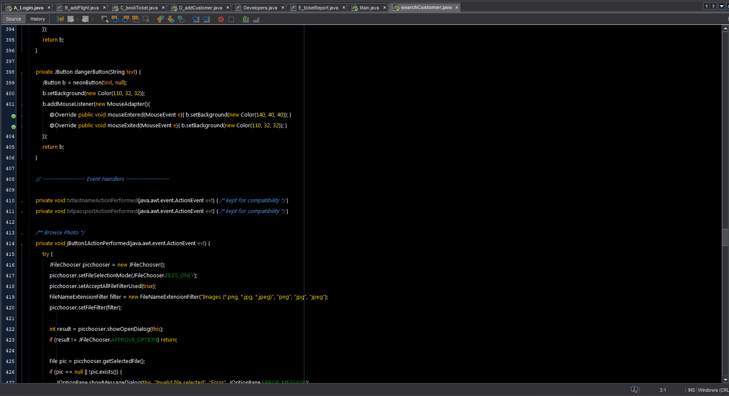

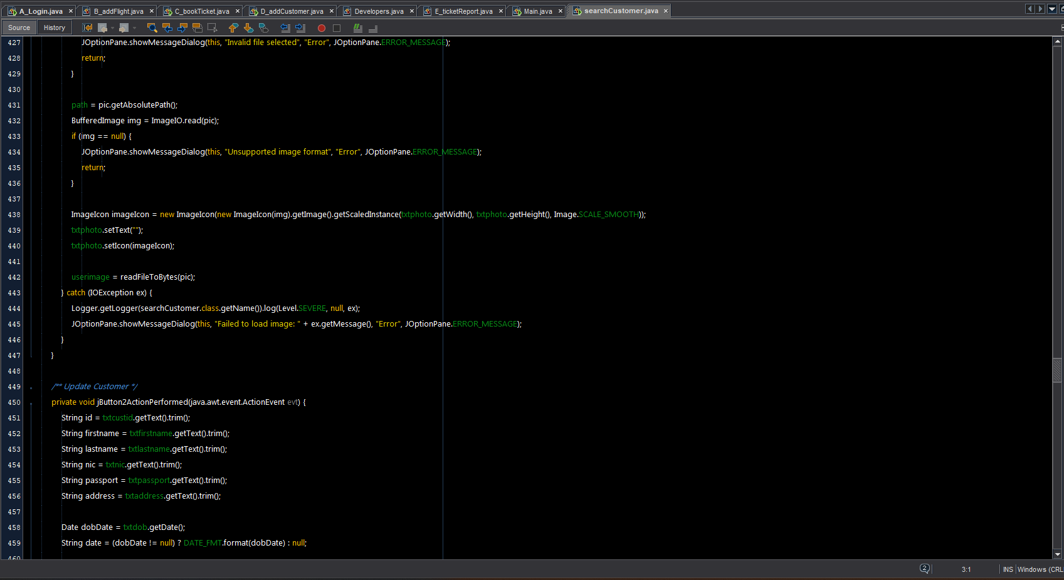

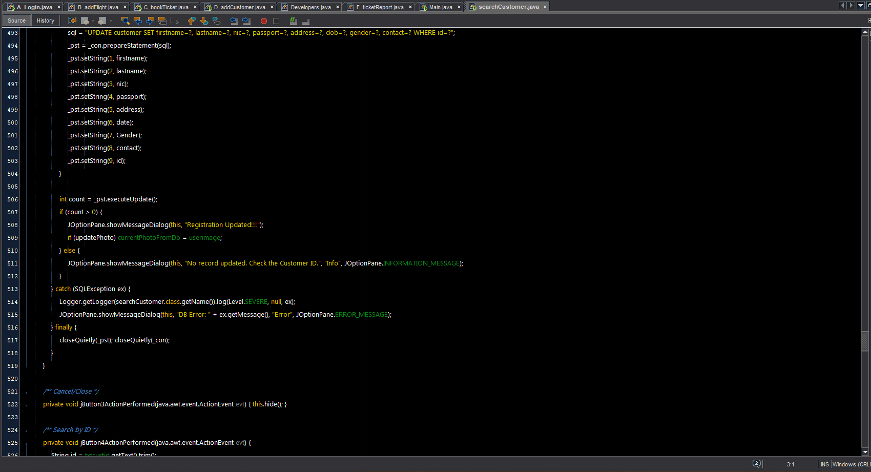

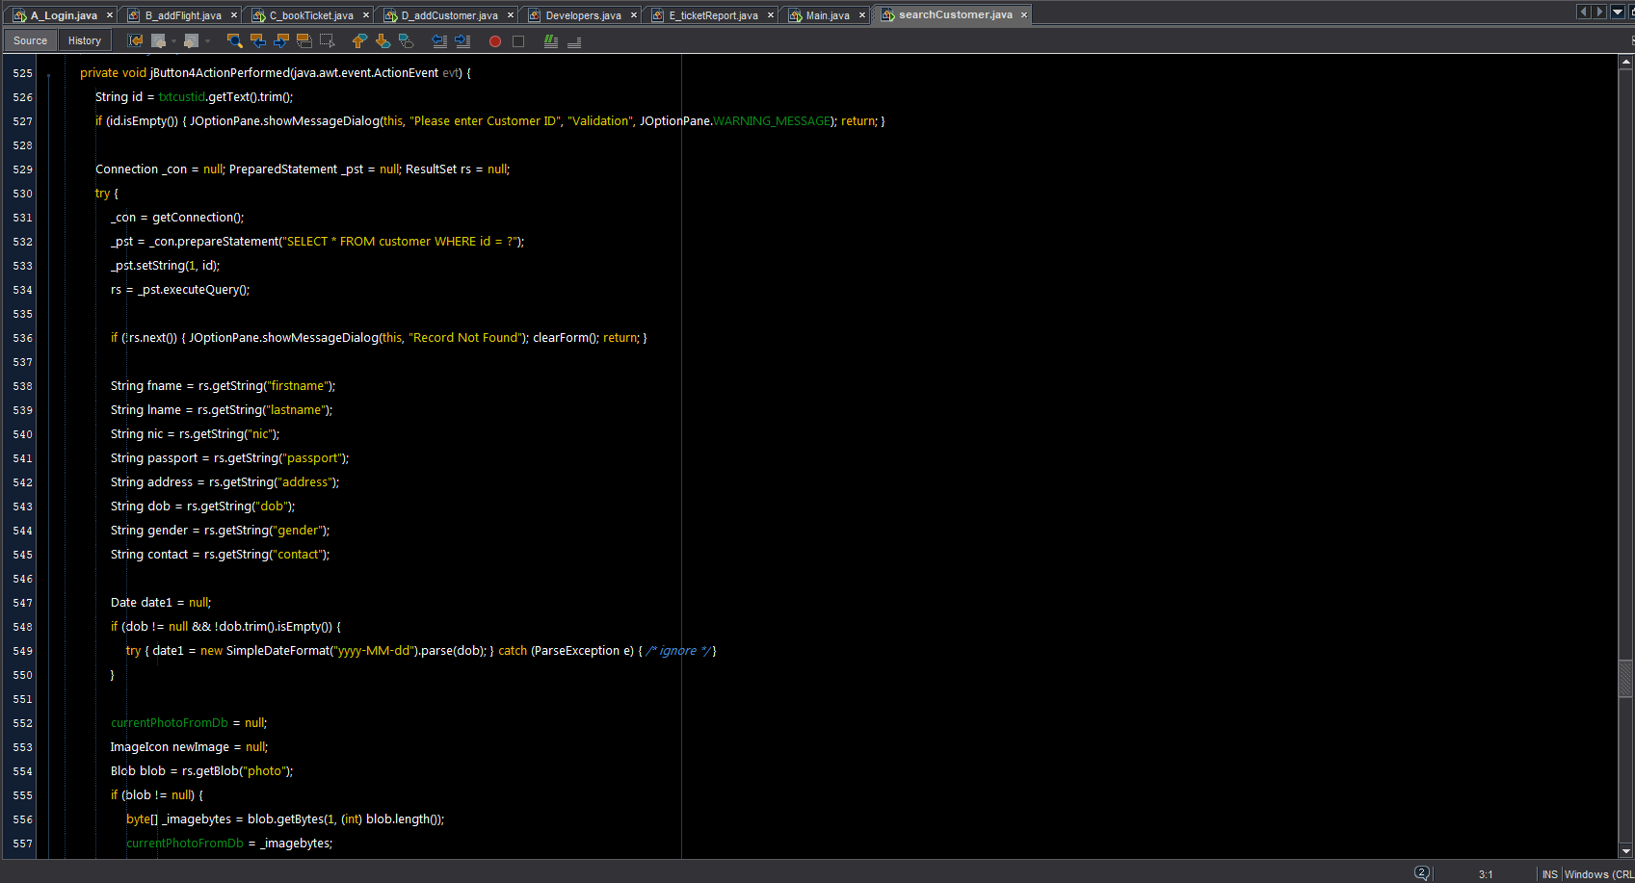

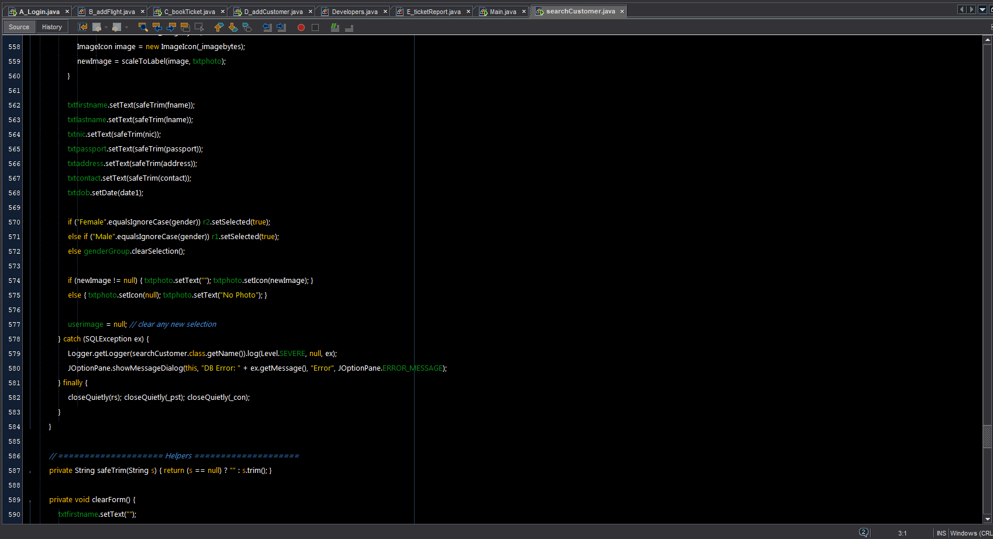

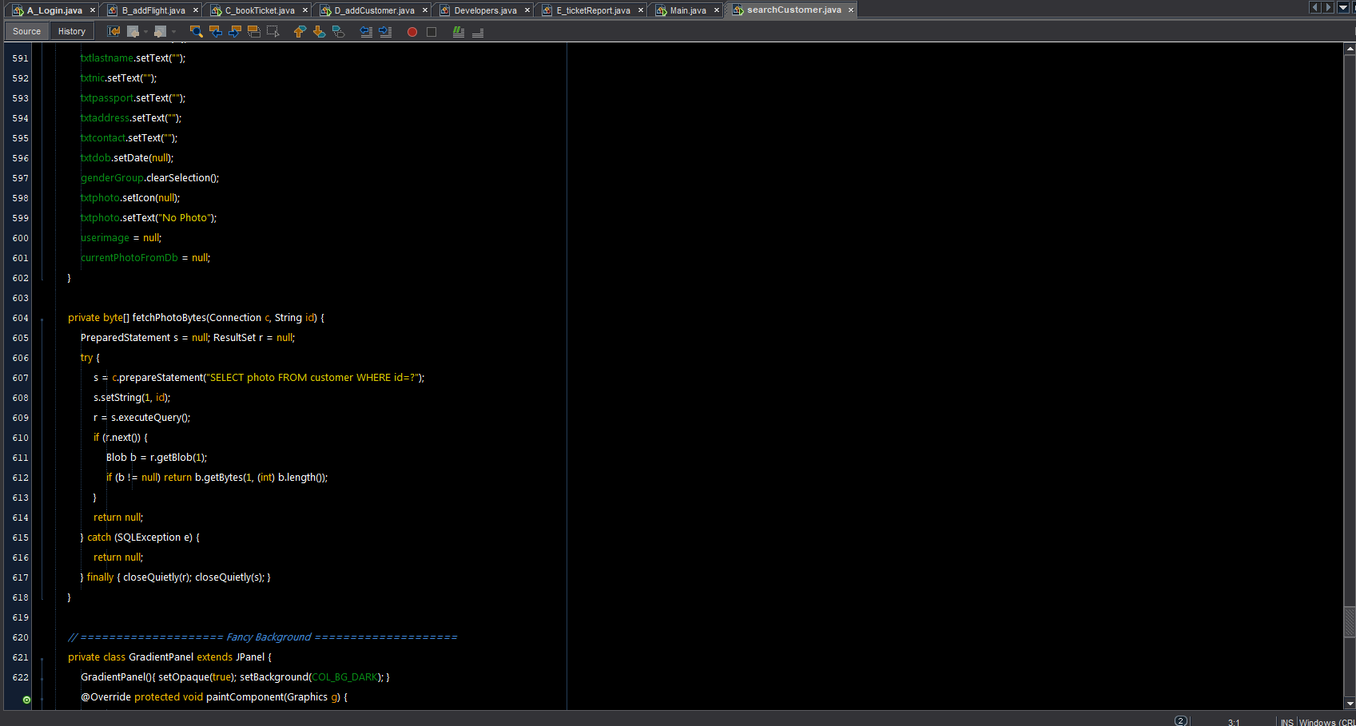

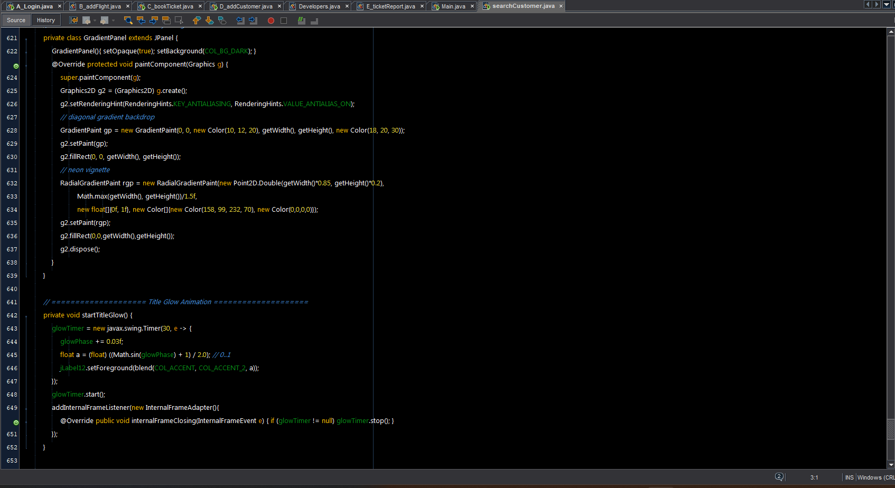

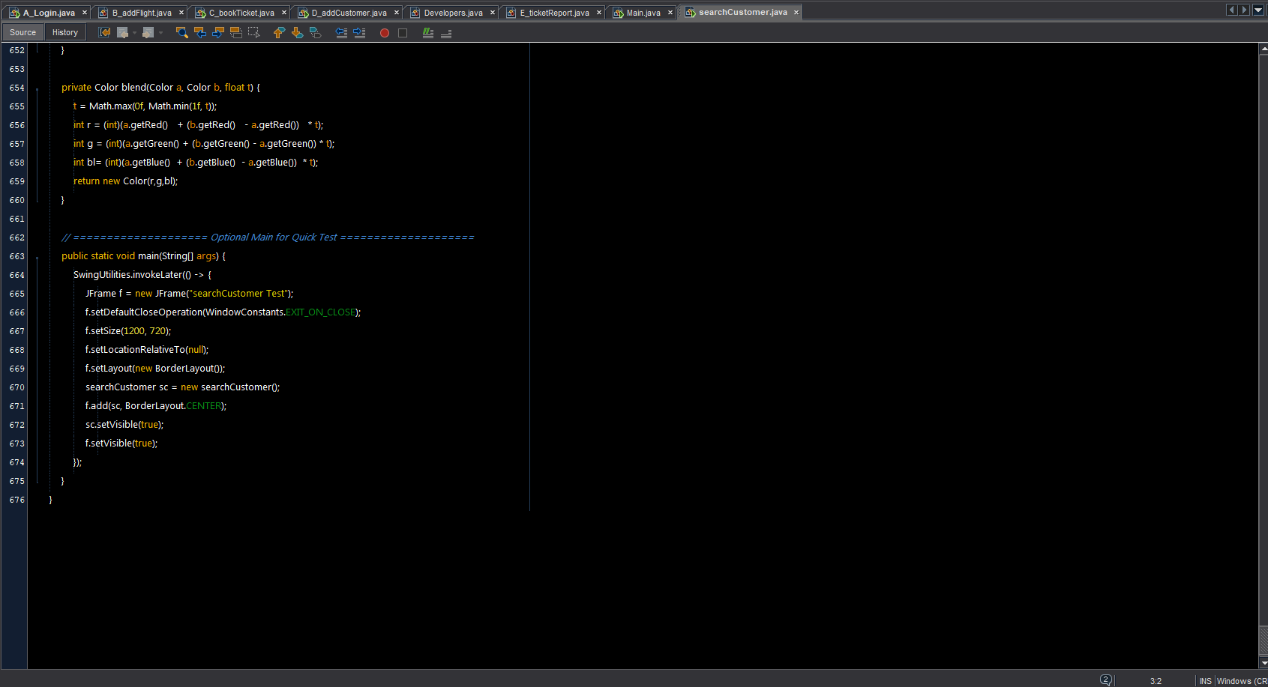

How to Run the Project:

1. This is a Java desktop application developed using NetBeans 12.6 and Java JDK 8. The application also requires the following libraries:
2. jcalendar-1.4
3. jgoodies-common-1.2.0
4. jgoodies-looks-2.4.1
5. junit-4.6
6. mysql-connector-java-8.0.23

Required Tools and Servers:

1. XAMPP Server (to run MySQL database)
2. MySQL Database (create the required database using the provided .sql file)
3. Apache Tomcat (if needed for any servlet or future web integration)

Steps to Run

1. Set up the database

Start XAMPP and run the MySQL server.

Import the provided .sql file to create the database

Update database credentials in the project if needed.

2. Run via NetBeans ID 12.6 E:

Open the project in NetBeans 12.6.

Make sure all required libraries are added to the project.

Compile the project.

Click Run to start the application.

3. Run via Command Line (Optional):

Navigate to the project folder containing .java files

Compile all files

javac *.java

Run the application:

java MainClassName A_login.java

Recognition

**✈️**

We extend our **deepest sense of gratitude** to our esteemed guide **Mr. Chirag Jadav**, whose constant support, patient guidance, and valuable insights have been the driving force behind the successful completion of this project. His unwavering encouragement, expert advice, and inspiring mentorship not only helped us overcome challenges but also motivated us to strive for excellence at every stage of development. His keen interest and belief in our abilities provided us with the confidence to transform our ideas into reality.

We are equally grateful to **Mr. Bharat Solanki (Faculty)** for his thoughtful suggestions, constructive feedback, and inspiring words of motivation. His valuable inputs, timely guidance, and enthusiastic support added immense value to the overall quality of this project and enriched our learning experience beyond the classroom.

Finally, we, the **development team – Belim Nizamudin, Aadil Khan, and Bhikari Adnan**, take immense pride and joy in presenting this project titled **“A.N. Wings Airline Management System – Your Sky, Our Wings.”** This project is not only a reflection of our hard work, dedication, and creativity, but also a testament to the priceless guidance and encouragement we have received from our respected mentors. We sincerely hope that our efforts will meet your expectations and serve as a meaningful contribution to the field of airline management solutions.

happy journey

